Tārerekautuku/Yarrs Lagoon Reserve
SCOPING REPORT
Prepared for Living Water

1 August 2017

Document Quality Assurance
Bibliographic reference for citation:
Boffa Miskell Limited 2017. Tārerekautuku/Yarrs Lagoon Reserve: SCOPING REPORT. Report prepared by Boffa Miskell Limited for Living Water .
Prepared by: | Katie Noakes  Graduate Ecologist  Boffa Miskell Limited
Scott Hooson
Principal/Senior Ecologist
Boffa Miskell Limited
Reviewed by: | Diana Robertson  Contract Ecologist  Boffa Miskell Limited
Status: DRAFT | Revision / version: 1 | Issue date: 1 August 2017
Use and Reliance
This report has been prepared by Boffa Miskell Limited on the specific instructions of our Client. It is solely for our Client’s use for the purpose for which it is intended in accordance with the agreed scope of work. Boffa Miskell does not accept any liability or responsibility in relation to the use of this report contrary to the above, or to any person other than the Client. Any use or reliance by a third party is at that party's own risk. Where information has been supplied by the Client or obtained from other external sources, it has been assumed that it is accurate, without independent verification, unless otherwise indicated. No liability or responsibility is accepted by Boffa Miskell Limited for any errors or omissions to the extent that they arise from inaccurate information provided by the Client or any external source.
Template revision: 20150331 0000
File ref: C16016_002a_Draft_Scoping_Report_20170811.docx

Cover photograph: Tārerekautuku/Yarrs Lagoon Reserve, photograph provided by Robin Smith, Living Water

CONTENTS

Acknowledgements 1
Executive Summary 2
1.0 Introduction 5
1.1 Background 5
1.2 Scope 5
1.3 Report Structure 6
2.0 Methods 8
2.1 Literature Review 8
2.2 Discussions with Stakeholders 8
2.3 Site Visit 8
3.0 Reserve History, Status and Existing Ecological Values 9
3.1 Location 9
3.2 History 9
3.3 Reserve Status 11
3.4 Adjoining Properties and Land-uses 11
3.5 Reserve Boundaries 12
3.6 Public Access 12
3.7 Ecological Context 13
3.8 Wetland Types 15
3.9 Vegetation Communities and Botanical Values 18
3.10 Birds 21
3.11 Lizards 22
3.12 Terrestrial Invertebrates 22
3.13 Aquatic Fauna 22
3.14 Ecological Significance 24
3.15 Ecological Importance 24
4.0 Management Issues 25
4.1 Site Restoration 25
4.2 Confirmation of Reserve Status 27
4.3 Reserve Boundaries 27
4.4 Formalisation of Public Access 28
4.5 Pest Plants 28
4.6 Animal Pests 34
4.7 Stock 35
4.8 Terrestrial Fauna 36
4.9 Aquatic Fauna 37
4.10 Hydrology 38
4.11 Water Quality 42
4.12 Drain Maintenance 43
4.13 Recreation Opportunities 45
4.14 Other Activities/Modifications 46
4.15 Research/Education Opportunities 48
5.0 Summary of Recommendations 49
References 51
Appendix 1: Plant Species Lists 54
Appendix 2: Taonga Species 57
Appendix 3: Historical Images of Tārerekautuku/Yarrs Lagoon 58
Appendix 4: Assessment of Ecological Significance 62

Acknowledgements

This report draws on, and gratefully acknowledges, the input of a number of people. Robin Smith engaged us to complete this report, on behalf of Living Water and provided background information and his own valuable personal knowledge of Tārerekautuku/Yarrs Lagoon and the Ararira/L11 catchment. Andy Spanton and Derek Hayes from the Selwyn District Council, Philip Grove and Mark Parker from Environment Canterbury, James Griffiths from DOC and Murray Tyson all provided useful input into various aspects of this report.

Executive Summary
Boffa Miskell Ltd was engaged by Living Water to prepare a scoping report to inform the development of a Reserve Management Plan for the ecological restoration of Tārerekautuku/Yarrs Lagoon Reserve.
Tārerekautuku/Yarrs Lagoon is a 76.9 ha reserve administered by the Selwyn District Council. It is located within the middle reaches of the Ararira/LII River between Lincoln township and Te Waihora/Lake Ellesmere.
Prior to human settlement, Tārerekautuku/Yarrs Lagoon was an area of open water surrounded by low-lying swamp that was a key mahinga kai (food gathering) site for Ngāi Tahu.
Following European settlement, the Ararira catchment, including Tārerekautuku/Yarrs Lagoon, was drained for agriculture and the development of townships. Land drainage practices, along with land clearance resulted in the lowering of the water table and the transformation of the open water ‘lagoon’ to a swamp-marsh wetland habitat. The vegetation of the reserve is now dominated by introduced grey and crack willow and the surrounding land is almost entirely cultivated paddocks and pasture.
Despite this modification, the Reserve is now one of the largest contiguous freshwater wetland habitats remaining in the Low Plains Ecological District. In relation to other freshwater wetlands on the Canterbury Plains, it is of high ecological value. It supports a high diversity of indigenous wetland plant species, provides habitat for nationally At Risk and locally uncommon plant, bird and lizard species and supports one of the largest remaining mānuka populations on the Canterbury Plains.
Given its high ecological values (and the potential for improving its recreational value) it is appropriate to prepare a Reserve Management Plan to guide this restoration. However, aspects of the ecological restoration and management of the Reserve are likely to be constrained by land drainage requirements and surrounding land-uses. Finding solutions to some of these issues may be challenging.
The key recommendations, and considerations, for the management of Tārerekautuku/Yarrs Lagoon Reserve, that should be considered during the development of the Reserve Management Plan are:
- That during public consultation (Stage 2) a long-term vision is developed for the Reserve, management issues and opportunities are discussed with stakeholders and the outcomes are incorporated into the Reserve Management Plan.
- The current legal status of the Reserve is confirmed and its classification is reviewed to determine whether it is appropriate.
- A Pest Plant Control and Surveillance Plan is prepared (or included in the Reserve Management Plan) to prioritise and guide willow and other weed control within the Reserve. A strategic, well managed approach to the control of willows, and other weed species will be crucial to the success of any weed control work.
- The options/methods for controlling willows are considered carefully, and that if willow control is undertaken, a commitment is made to continue follow-up control and associated restoration work.
- Until a willow control plan is developed, willow control continues as a high priority within the mānuka stands and the indigenous rushland area.
- The Reserve boundaries are fenced and all stock are excluded from the wetlands and waterways within the Reserve.
- The Reserve Management Plan is developed in collaboration with the Drainage Liaison Committee to ensure maintenance works minimise adverse impacts on biodiversity values within the Reserve and methods for ongoing drain maintenance are considered as part of the Reserve’s long-term restoration and management.
Other recommendations are that:
- Restoration planting is considered for wet pasture sites on the margins of the Reserve. This could be an important tool for engaging the community but should not be undertaken at the expense of higher priority work.
- The status of potential public access routes is confirmed and options for formalising public access are considered.
- Potential impacts on indigenous vegetation and fauna, including birds, lizards and invertebrates are considered during willow control operations.
- Monitoring is considered for birds, and potentially other fauna, to monitor the success of restoration work. This could include surveys for crake and bittern.
- Further monitoring of animal pests is considered, and if animal pest control is undertaken a plan is prepared to guide control work.
- Macroinvertebrate sampling, and surveys to confirm the presence of indigenous freshwater fish are considered to better inform restoration and management.
- The potential to better connect the Ararira/LII River and drains to the wetland area within the Reserve are explored. If any hydrological changes are considered, SDC should work closely with adjacent landowners, DLC and ECan.
- Living Water , ECan SDC and others continue to work with upstream landowners in the wider catchment to improve water quality.
- Additional areas of existing willow forest along drain margins are not sprayed until a plan, and the resources to carry out follow-up ground control are put in place as part of the wider Reserve Management Plan.
- Management options for encouraging increased recreational use of the Reserve are considered as part of its restoration.
- The appropriateness of duck shooting as a recreational activity within the Reserve is considered in relation to its future use and management.
- Local education providers are made aware of the potential for undertaking educational activities, including research, within the Reserve and educational opportunities are considered as part of the Reserve’s restoration.

Introduction
Boffa Miskell ecologists were engaged by Living Water (Department of Conservation (DOC) and the Fonterra Co-operative Group Limited (Fonterra)) to prepare a scoping report to inform the development of a Reserve Management Plan to guide the ecological restoration and management of Tārerekautuku/Yarrs Lagoon Reserve (referred to by this full title or the “Reserve” in this report).

Background
The Selwyn District Council (SDC) and Living Water signed a Memorandum of Understanding regarding the delivery of collaborative biodiversity projects within the Ararira/LII catchment. The Te Waihora/ Lake Ellesmere catchment is one of five catchments chosen by Living Water across New Zealand which aims to improve freshwater ecosystem health across these significant catchments.
One of the priorities for the catchment, identified under the Living Water Partnership, is the restoration of wetland habitat within Tārerekautuku/Yarrs Lagoon. Tārerekautuku/Yarrs Lagoon is a 76.9 ha reserve located within the middle reaches of the Ararira/LII River between Lincoln township and Te Waihora/Lake Ellesmere (Figure 1). It is administered by the SDC.
Where territorial authorities are the administering bodies of reserves classified under the Reserves Act (1977), they are generally required to develop reserve management plans. To help co-ordinate and plan the restoration of the Reserve, SDC, with support from Living Water , want to develop a comprehensive management plan for the Reserve that will become the guiding document for its future management. The development of a management plan for Tārerekautuku/Yarrs Lagoon Reserve was identified as an output of the SDC’s Open Space Strategy (SDC, 2015) and a site of high ecological importance for Living Water’s freshwater improvement focus.
The development of the Reserve Management Plan is a three staged approach:
- Stage 1: Preparation of a site assessment and feasibility/scoping report;
- Stage 2: Group facilitation / information gathering workshop; and
- Stage 3: Development of the Reserve Management Plan.
This scoping report is the first stage of this three staged approach.

Scope
This report focuses on Stage 1. In brief the purpose of the report is to:
- summarise the information relevant to the management of the Reserve;
- identify management issues and opportunities; and
- provide recommendations and options for the management, protection and enhancement of the Reserve’s values.
Stages 2 and 3 of this project are outside the scope of this report.
The focus of the report is on the ecological restoration of the Reserve. However, to a lesser extend the report also considers other values, opportunities and issues that are relevant to the management of the reserve. Other management issues and opportunities on adjoining land and in the wider Ararira/LII catchment are also considered where they have the potential to contribute to the effective management of the values of the Reserve.

Report Structure
This report is divided into the following sections:
- Section 2 describes the desktop and field-survey methods;
- Section 3 summarises information relevant to the Reserve and its management including its history, current status and existing values;
- Section 4 discusses management issues and provides recommendations and options for the management of the Reserve; and
- Section 5 provides a summary of the recommendations from this report.

Insert Figure 1

Methods

Literature Review
Background research involved a review of the published and unpublished literature relating to Tārerekautuku/Yarrs Lagoon and the Ararira/LII catchment, including previous site studies and reports, aerial images and databases to obtain existing information on the Reserve. Information was gathered on the site’s history, cultural values and taonga species, land ownership, vegetation communities, ecological significance, threats, hydrology and recreational and educational opportunities.

Discussions with Stakeholders
Prior to the preparation of this report we attended a site visit to Tārerekautuku/Yarrs Lagoon with representatives from various agencies including Living Water, SDC, the LII Drainage Liaison Committee (DLC) and Environment Canterbury (ECan). Aspects of the Reserve’s management were discussed during this site visit.
During the preparation of this report we also contacted, or spoke with, a number of people, including:
- Robin Smith - Senior Ranger, Operations - Living Water
- James Griffith - Scientist, DOC
- Murray Tyson – Drainage Contractor
- Andrew Spanton – Biodiversity Co-ordinator, SDC
- Derek Hayes, - Policy Planner, SDC

Site Visit
Carol Jensen (Tussocklands) and Katie Noakes (Graduate Ecologist, Boffa Miskell) surveyed the Reserve on 11, 16 and 23 May 2017. Scott Hooson (Principal/Senior Ecologist, Boffa Miskell) and Robin Smith (Senior Ranger, Operations - Living Water Department of Conservation) were also present on the first day of the survey.
During the survey the vegetation communities, plant species, fauna and any management issues were recorded. Photographs were taken and a handheld Garmin Global Positioning System (GPS) was used to mark features of interest.
This survey was undertaken in winter, which is not a preferred time for vegetation surveys of wetland ecosystems. Some plant species, and in particular spring annuals, orchids and small summer flowering plants may not have been visible.
Access within the Reserve is difficult and time consuming so a comprehensive survey of the whole Reserve was not possible in the time available. Time did not allow adequate coverage of the north-eastern part of the Reserve and a large area south-west of the eastern mānuka block was not traversed. The rushland on the western side of the Reserve also needs to be more thoroughly surveyed, preferably in summer.
High resolution drone imagery of the reserve was acquired by Corey Murray (CAD / 3D Visualisation, Boffa Miskell) on 2 May 2017.
Where possible, common names for plants and animals have been used in this report. Where a species does not have a common name, or its common name cannot be used to identify the species without ambiguity, its scientific name has been used. The common and scientific names of the plants mentioned in this report are provided in Appendix 1 (Tables A1.1 and A1.2).

Reserve History, Status and Existing Ecological Values
This section of the report provides a summary of the information relevant to the Reserve and its management including its location, history, administration and ownership, adjoining properties and land-uses, public access, ecological values and significance, plant and animal pests, hydrology, water quality, recreational values, research and education potential and other activities of relevance.

Location
Tārerekautuku/Yarrs Lagoon Reserve is on the Canterbury Plains west of Christchurch and the Port Hills, approximately 850 m west of Springston South and 3.6 km south-south-west of Lincoln. Te Waihora/Lake Ellesmere is approximately 2.7 km south of the Reserve. The Selwyn River flows approximately 1.9 km to the south-west of the Reserve at its closest point (Figure 1).
The Reserve sits within a block of land bounded by Goodericks Road, Englishs Road, Carters Road, Yarrs Road, Pannetts Road and Powells and Days Roads.

History

Maori History
Tārerekautuku is the traditional name of Yarrs Lagoon. The area was a key mahinga kai (food gathering) site for Ngāi Tahu, and in particular the local hapū of Ngāi Te Ruahikihiki based at Taumutu. In English, Tārerekautuku has a number of possible meanings, for example ‘rere’ can be translated to waterfall and ‘kautuku’, when translated, is the name of the brown bittern, an indigenous bird that lives in swamps. Bittern now have a conservation status of Threatened - Nationally Critical.
In 1880 Wiremu Te Uki described Tārerekautuku as ‘a village, a place of food production and a proper fortification’. He listed the following mahinga kai species: tuna (eel), koareare (the edible rhizome of raupō/bullrush), koukoupara (bullies), mawehe (kōaro), and birds: pārera (grey duck), pūtakitaki (paradise duck), pākura (pukeko), whio (blue duck), kaaha (shag) and aruhe (bracken fern root) (Taiaroa H.K, 1880)
As well as being an important mahinga kai area, Tārerekautuku/Yarrs Lagoon was also the site of a former kāinga or settlement, which linked to a network of other settlements and mahinga kai sites across both Kā Pākihi Whakatekateka o Waitaha / the Canterbury Plains and Te Pātaka o Rākaihautū / Banks Peninsula. This included those along the Ararira / LII, Waikirikiri / Selwyn and Huritini / Haslwell Rivers, as well as those around Te Waihora/Lake Ellesmere and within Whakaraupō / Lyttelton Harbour.
Tārerekautuku, sometimes also referred to as ‘Springston South’ following European settlement, was one of two key wetland sites (or lagoons) within the Ararira / LII catchment. The other key wetland site, Makonui or Clay Bar Lagoon, was located further towards Lincoln and also known as ‘Springston North’. Both of these sites were significant for the mahinga kai species they provided and linked to a wider network of food gathering and settlement sites stretching from Taumutu into Ōtautahi/Christchurch.
The Ararira/LII River was also of importance. Originally the Ararira/LII was sourced from a spring known as Te Kohaka-a-wao and flowed towards Makonui/Clay Bar Lagoon where it entered an extensive raupō and harakeke wetland before flowing into a second larger water-body (Tārerekautuku/Yarrs Lagoon). From here, the Ararira flowed towards the lake, entering just east of the Waikirikiri / Selwyn River Mouth (Craig Pauling unpubl. information).
Tārerekautuku/Yarrs Lagoon supports a number of plant and bird species that are toanga to Ngāi Tahu. These species are listed in Appendix 2.

European History
Along with much of the Te Waihora/Lake Ellesmere catchment, following the arrival of European settlers around 150 years ago the Ararira catchment, including Tārerekautuku/Yarrs Lagoon, was drained for agriculture and the development of towns (Taylor, 1996) and the indigenous grasslands and shrublands were cleared (Golder Associates 2015).
The construction of the extensive drainage network in the catchment began around the 1850’s (Singleton 2014) to drain the lower lying areas in the catchment for farming. Mechanical dredging of the Ararira/LII began in the 1940’s (Parker and Grove 2013) and has continued to the present day. Land drainage practices, along with land clearance has resulted in extensive lowering of the water table and has resulted in the transformation of Tārerekautuku/Yarrs Lagoon from an open water ‘lagoon’ to a swamp-marsh wetland habitat (Parker and Grove 2013) surrounded by farmland.
Historical aerial images from Canterbury Maps (Appendix 3) show the changes over time at the Reserve since the 1940s. The earliest aerial image available (Appendix 3, Figure A3.1) dates back to 1940-1944. It shows wetland vegetation covering a more extensive area than the present day coverage, particularly to the south-west and north-east of the Reserve. This image also shows that the area covered by willows is minimal, with only a few small patches of trees along the southern boundary of the Reserve and a few trees at the eastern end.
By 1960-1964 (Appendix 3, Figure A3.2) the development of farmland is more defined particularly to the north-east. By 1970-1974 (Appendix 3, Figure A3.3) the north/north-eastern part of the Reserve has been further developed with the farmland boundaries closer to the Ararira/LII River than in 1960-1964. By this time, willows are widespread throughout the Reserve. The only exceptions appear to be the north-eastern and western corners. By 1980-1984, the land surrounding the south-western end of the Reserve has been cleared and cultivated and areas that previously supported wetland vegetation were predominantly cultivated grassland. During this time willows continued to spread and infill areas of lower wetland vegetation within the Reserve.
In the 1990-1994 image the extent of willow cover is similar to today with willows covering the majority of the Reserve. Some willow clearance is evident above the north-eastern boundary of the Reserve and along the true left bank of the Ararira/LII River from the eastern end into the middle of the Reserve (Appendix 3, Figure A3.5). Between 1995-1999 and 2000-2004 a pond was excavated on the TL side of the Ararira/LII River near the Reserve boundary. There is no noticeable change in the willow cover or vegetation between 1990-1994 and 2000-2004 except that the margins of all the major drains have been cleared or sprayed.

Reserve Status
Tārerekautuku/Yarrs Lagoon was originally reserved as a sanctuary for native and imported game species in 1905, but in 1957 its Wildlife Sanctuary status was revoked and it was vested under the Springs County Reclamation and Empowering Act 1915 in the Ellesmere County Council. The Reserve (RES3706) is now administered by the SDC and it is thought to remain subject to the Reserves Act (1977) as a Local Purpose Reserve. However, it appears from communication between DOC and SDC that confirmation of the status of the Reserve is not straight forward as it involves an interpretation of the original gazette notice and specific legislation which isn’t unequivocal. The original gazette notice vests the land with the SDC, but doesn’t say whether it is as a reserve, or a fee simple title.

Adjoining Properties and Land-uses
The Tārerekautuku/Yarrs Lagoon Reserve is predominantly surrounded by privately owned land (Figure 2). There are 14 different private properties that border the Reserve (comprised of 16 different land parcels). There are another five land parcels in public ownership including two unformed paper roads, the LII River Conservation Area and two areas of riverbed along the Ararira/LII River (up- and downstream of the Reserve).
The land surrounding the Reserve is almost entirely cultivated paddocks with pasture used for grazing domestic stock, including dairy cows, beef cattle and sheep. Some of the properties are lifestyle blocks and there are a number of residential dwellings. There are two small wood lots on a property on the north-eastern boundary of the property, and one property on the north-eastern boundary has willow forest, that is continuous with the willow within the Reserve, as well as two constructed ponds. Willow forest extends onto several other properties in a number of locations around the boundary of the Reserve.

Reserve Boundaries
The boundaries of the Reserve do not follow the boundary of the current extent of the wetland (Figure 2). There are areas where parts of the Reserve are cultivated pasture that are farmed by adjoining landowners, while in other places parts of the wetland are outside the Reserve boundary.
Areas of the wetland that are on private land are largely along the northern and western boundaries of the Reserve. They include some areas of very high ecological value including part of the indigenous rushland on the western side of the Reserve and part of the eastern mānuka stand.
At the southern end of the Reserve, approximately 9.1 ha of land within the Reserve boundary is cultivated and farmed by the adjoining landowners (Figure 2). From aerial images (Canterbury Maps) it appears that the largest area of cultivated pasture within the Reserve boundary (on the true left side of the Ararira/LII) was once wetland that was progressively drained and converted to pasture between 1960-64 and 1975-1979.
Another area on the true right of the Ararira/LII is grazed as part of the Brook Farm. This paddock contains approximately 2 ha of bog rush which is possibly the largest known bog rush wetland on the Canterbury Plains (Jensen pers. comm. 2017). Although it is outside the Reserve it is worthy of protection.

Public Access
Tārerekautuku/Yarrs Lagoon Reserve is largely bounded by private land. Access across private land into the Reserve requires landowner permission. There are, however, four potential access points through public land into the Reserve (refer to Figure 2):
- A paper road between the southern side of Goodericks Road and the northern boundary of the Reserve. A vehicle track, which is only partly within the paper road, follows the true right bank of Goodericks Drain to the Reserve boundary.
- A second paper road, east of the paper road described above, also between the southern side of Goodericks Road and the northern boundary of the Reserve. This paper road is on the true right side of another drain. There is no formed route or vehicle track and there is no obvious public access.
- The LII River Conservation Area (conservation unit M36506). A narrow strip on the true right side of the Ararira/LII River between Englishs Road and the eastern boundary of the Reserve. This Conservation Area is administered by DOC. On the southern boundary of this Conservation Area is a strip of public riverbed that roughly follows the Ararira/LII River from Englishs Road to the Reserve boundary.
- At the southern end of the Reserve there is a strip of public riverbed on both sides of the Ararira/LII River between Pannetts Road and the southern boundary of the Reserve. There is an unformed vehicle track on the true left side of the Ararira/LII River from Pannetts Road into the Reserve.

Ecological Context
Tārerekautuku/Yarrs Lagoon Reserve is within the Low Plains Ecological District (ED) and the Canterbury Plains Ecological Region (ER).
Prior to human settlement much of the lower Canterbury Plains was swampland, where species such as raupō, rushes and cabbage trees dominated, with podocarp forests, comprised of matai, kahikatea and totara, in the drier areas (Williams 2005).
The area of wetland surrounding Tārerekautuku/Yarrs Lagoon was once part of this large area of low-lying swamp (approximately 4,000 ha) between the Rakaia and Waimakariri outwash fans (Parker and Grove, 2013). At this time Tārerekautuku/Yarrs Lagoon was an area of open water (refer to Figure 3).
The original (pre-human) vegetation surrounding Tārerekautuku/Yarrs Lagoon was likely to have been freshwater wetland vegetation characterised by sedgeland, rushland, raupō reedland, and lowland flax with small-leaved shrubs and kahikatea forest. In the wider area, kahikatea forest probably grew in poorly drained areas with deeper soils, while stable gravels would have supported kanuka forest, kowhai and cabbage tree treeland, matagouri shrubland and silver tussockland. Danthonia grassland is thought to have occupied more recently-deposited gravels (Stevens and Meurk 1996).
Following Polynesian settlement, the forests surrounding Tārerekautuku/Yarrs Lagoon were burned and cleared to encourage bracken growth and to create open areas for hunting. The wetland areas were colonised by harakeke, raupō and sedgeland and drier areas were colonised by tussock grassland and shrubland (Williams 2005).
Following European settlement, the vegetation of the Low Plains ED was substantially depleted by fire and land clearance for agriculture and settlement. The Canterbury Plains ER is now among one of the most modified regions in New Zealand (McEwen 1987, Leathwick et al. 2003). Nearly all of the ecological district is intensively farmed; most soils have been cultivated and many areas are irrigated (Harding 2009). Only 0.5% of the Low Plains ED is still covered in indigenous vegetation (Ecroyd and Brockerhoff 2005).

Insert Figure 2
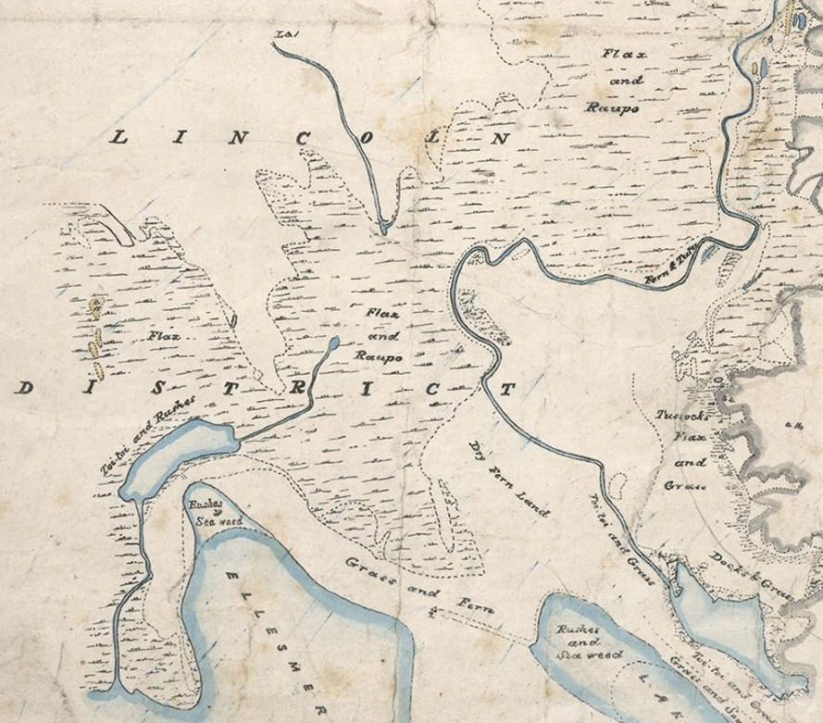
Figure 3: 1850 map showing Tārerekautuku/Yarrs Lagoon as an open body of water surrounded by wetland. Sourced from the 1850 trigonometrical survey of Christchurch.

Wetland Types
The wetland types within and surrounding the Reserve were described, and mapped (Figure 4), by (Parker and Grove, 2013) following the classification system of Johnson and Gerbeaux (2004). Approximately 66.6 ha of the wetland is classified as palustrine wetland, 21.8 ha is riverine wetland and 2.5 ha is terrestrial (dry) land. The wetland is predominantly palustrine and riverine swamp with smaller areas of riverine and palustrine marsh. The swamp habitats support forest, treeland and scrub while the areas of marsh generally support rushland and wet exotic pasture. Terrestrial (dry) land occurs along the margins of the Ararira/LII River and the larger drains and supports exotic grassland (Parker and Grove, 2013).

Insert Figure 4

Insert Figure 5

Vegetation Communities and Botanical Values

Vegetation Communities
Tārerekautuku/Yarrs Lagoon Reserve supports a range of vegetation types, which have been mapped by Parker and Grove (2013) (Figure 5). Despite the extensive cover of exotic crack and grey willow trees that dominate the canopy (Figure 6), the understory still supports a diverse range of indigenous plants, including a relatively diverse number of indigenous fern species. The vegetation types are described below (adapted from Parker and Grove (2013)). A full list of the species recorded within the Reserve, including additional species recorded by Jason Butt (J. Butt, unpubl. data), and species recorded by Parker and Grove (2013) is provided in Table A1.2 (Appendix 1).
Crack willow forest and treeland
Exotic crack willow trees 10-15 m high are dominant in the canopy but grey willow is also often present. Sub-canopy species include cabbage tree, mingimingi, karamu, kōhūhū, raupō and exotic gorse. Ground cover is mostly indigenous with swamp kiokio, Carex secta, C. maorica, duckweed, water fern, Isolepis distigmatosa and exotic plants including blackberry, jointed rush, buttercup, lotus and Yorkshire fog. Blackberry is especially abundant near the forest edge.
Grey willow forest and treeland
Grey willow trees 5-10 m in height form the canopy cover. Sub-canopy and groundcover species are similar to those listed for crack willow above, but are generally less abundant. Patches of baumea are sometimes present. In one location there are many sapling self-established indigenous trees including matai, kahikatea, red matipo, karamu, C. crassifolia, C. propinqua and lemonwood. The presence of some of these species, such as kahikatea and matai, is notable. Spanish heath and blackberry are also present in isolated patches and blackberry appears to be invading.
Mixed willow forest
Crack and grey willow trees, mostly 5-10 m tall, are co-dominant in the canopy and scattered cabbage trees are also present. Sub-canopy and groundcover is variable, depending on inundation depth/frequency and grazing history, but includes swamp kiokio, which is dense in places, as well as purei, swamp sedge, Maori sedge and blackberry.
Mānuka-grey willow scrub
Mānuka and grey willow (Figure 7) are co-dominant in a 3-4m tall canopy at two different sites. The western site, classed as near-permanent swamp, has occasional cabbage trees in the canopy and a dense understorey of swamp kiokio, with mingimingi, lowland flax, purei, and Maori sedge also common. There are also several patches of baumea and oioi. Spanish heath was common and blackberry is becoming established. There are lots of mānuka seedlings in places especially on drier, raised mounds. The eastern site, classed as marsh, has a dense mānuka canopy in places with mingimingi and swamp kiokio common in the understorey. There is an occasional cabbage tree and flax and patches of baumea. Occasional gorse and Spanish heath were also present.
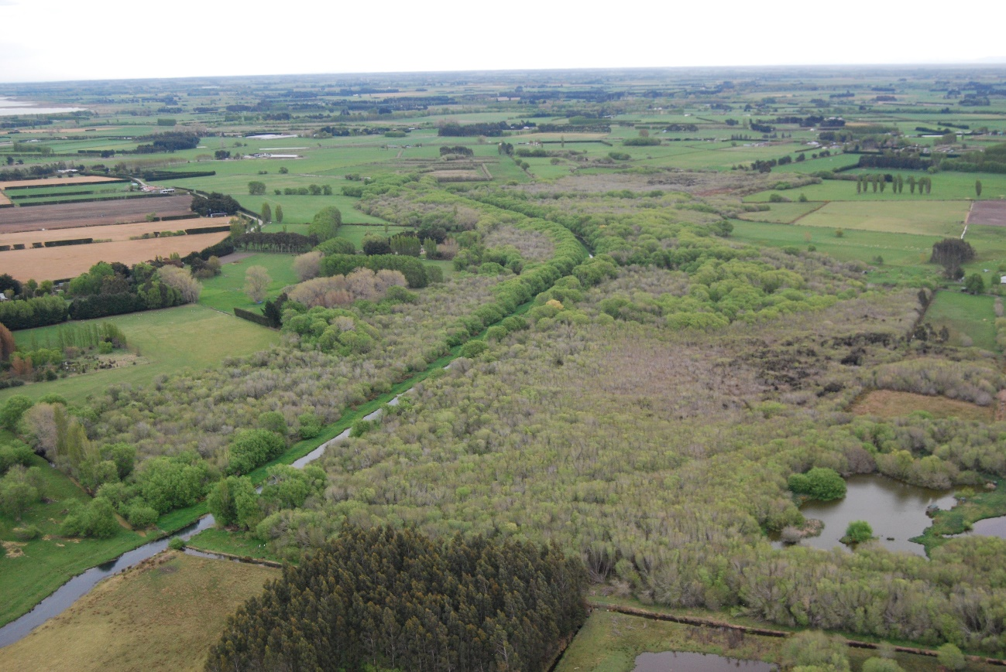
Figure 6: The extensive cover of grey and crack willow within Tārerekautuku/Yarrs Lagoon Reserve
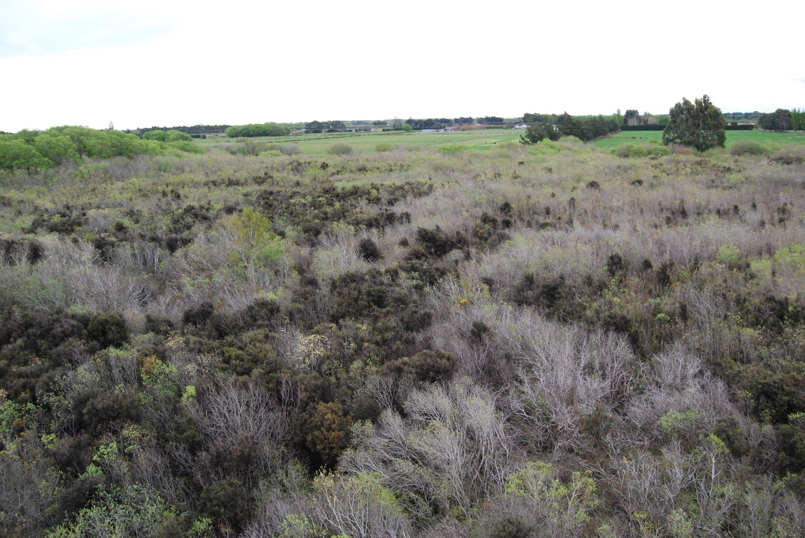
Figure 7: The eastern mānuka stand. The mānuka is the darker coloured vegetation. Source: Robin Smith.
Rushland
The rushland sites are dominated by indigenous spike sedge, wiwi and baumea, with an understorey of introduced jointed rush, buttercup, lotus, Yorkshire fog and a few mānuka seedlings. Carex flaviformis, Viola lyallii, silverweed, swamp buttercup and centella are all present. Rushland areas are being invaded by grey willow and gorse shrubs.
Wet exotic grassland
These grasslands are dominated by tall fescue, Yorkshire fog and cocksfoot, with lotus, red clover, white clover, jointed rush, Carex flaviformis and C. coriacea.
Terrestrial exotic grassland
Mown access strips are dominated by exotic grasses, with scattered gorse, blackberry and exotic herbs.
Open water
Open water areas include ponds, drains and areas of shallow surface water. Patches of the indigenous swamp nettle are locally common on the banks of drains and the LII/Ararira River within the Reserve. Exotic aquatic herbs such as monkey musk and watercress are abundant on the river margins and in shallow drains.

Botanical Values
Tārerekautuku/Yarrs Lagoon Reserve is an important habitat for several species that are either nationally, or locally rare. These include:
- Swamp nettle, which has a conservation status of At Risk – Declining (de Lange et al. 2012). The Reserve is an important habitat for this species which is restricted to lowland swamps, lakes and river margins.
- Swamp buttercup, which is classified as Data deficient (de Lange et al. 2012).
- Mānuka, which is present in two main sites within the Reserve, with many seedlings spreading into surrounding areas. Tārerekautuku/Yarrs Lagoon supports one of the largest remaining populations of mānuka on the Canterbury Plains (Parker and Grove 2013).
- Baumea, which is rare in the Canterbury Region. This species is close to its southern distributional limit here.
- A number of other species, including sapling matai, kahikatea and other indigenous broad-leaved and hardwood tree species that are uncommon on the Canterbury Plains.
- The spike sedge-wiwi-baumea rushlands, which are an uncommon vegetation type in the ED, support a number of indigenous wetland species including Carex flaviformis, Viola lyallii, silverweed, swamp buttercup and centella that are also rare in the ED.

Birds
At least 26 bird species utilise habitats at Tārerekautuku/Yarrs Lagoon. Table 1 lists the species recorded during our site visit, by Bowie and Hutson (2016) and Parker and Grove (2013). Of the bird species recorded, 12 are indigenous and 14 are introduced. Three species have a conservation status of nationally At Risk; marsh crake, South Island pied oystercatcher (both At Risk - Declining) and black shag (At Risk – Naturally Uncommon) (Robertson et al. 2017).
Table 1: Indigenous birds recorded at Tārerekautuku/Yarrs Lagoon during this study, by Bowie and Hutson (2016) and Parker and Grove (2013). Sorted alphabetically by common name. Taonga species, as listed in Schedule 97 of the Ngāi Tahu Claims Settlement Act (1998), are listed in Appendix 2.
Common Name | Scientific Name
Indigenous species
Australasian shoveler | Anas rhynchotis
Black shag | Phalacrocorax carbo novaehollandiae
Grey teal | Anas gracilis
Grey warbler | Gerygone igata
Kingfisher | Todiramphus sanctus
Marsh crake | Porzana pusilla
New Zealand scaup | Aythya novaeseelandiae
Pukeko | Porphyrio melanotus
Silvereye | Zosterops lateralis
South Island fantail | Rhipidura fuliginosa
South Island pied oystercatcher | Haematopus finschi
Spur-winged plover | Vanellus miles
Swamp harrier | Circus approximans
Welcome swallow | Hirundo neoxena neoxena
White-faced heron | Egretta novaehollandiae
Introduced species
Australian magpie | Gymnorhina tibicen
Blackbird | Turdus merula
Chaffinch | Fringilla coelebs
Common pheasant | Phasianus colchicus
Dunnock | Prunella modularis
Goldfinch | Carduelis carduelis
Greenfinch | Carduelis chloris
House sparrow | Passer domesticus
Mallard | Anas platyrhynchos
Mute swan | Cygnus olor
Redpoll | Carduelis flammea
Song thrush | Turdus philomelos
Starling | Sturnus vulgaris
Yellowhammer | Emberiza citrinella

Lizards
Bowie and Hutson (2016) found and photographed four skinks in rushland within the Reserve. From the photographs included in their report, they have been identified as southern grass skinks (M. Lettink pers. comm. 2017), an At Risk – Declining species (Hitchmough et al. 2016). The only other lizard species likely to occur within the Reserve is McCann’s skink, which has a conservation status of Not Threatened.

Terrestrial Invertebrates
The fauna, including the terrestrial invertebrates, of Tārerekautuku/Yarrs Lagoon Reserve was studied by Bowie and Hutson (2016) who used a range of sampling techniques during the summer months of 2016. Their monitoring methods included pitfall traps, light trapping, Malaise traps, wooden discs, weta motels, litter collection and tracking tunnels. The terrestrial invertebrate fauna included weevils, beetles, spiders, snails, millipedes, flatworms, earthworms, ants, house flies and cave weta (a comprehensive list of the species recorded are provided in the appendices of Bowie and Hutson’s (2016) report).
Eight species of carabid were collected from within the Reserve and seven of these were within willow habitats. The discovery of Megadromus ensyi is of particular note, if the identification is correct, because this would be the most eastern record for this species. The authors concluded that, despite the dominance of exotic vegetation in the Reserve, it still provides habitat for a diverse terrestrial invertebrate community that is typical of wetland habitats.

Aquatic Fauna

Freshwater Fish
The Ararira/ LII River and the drains within the Reserve have not been surveyed, so existing information on the aquatic fauna of the Reserve is limited. However, there is information on the freshwater fish in the wider catchment.
The Ararira/ LII catchment has a reasonably diverse range of fish fauna with 12 species recorded (Table 2) (Golder Associates 2015). Nine of these species are indigenous and three are introduced. Of the indigenous species, one (lamprey) has a conservation status of Threatened – Nationally Vulnerable and three others are classified as At Risk – Declining.
Historically, species such as longfin eel and other mahinga kai species were very abundant in the surrounding catchment. However, due to extensive habitat modification, a large decline in species abundance has been observed (Golder Associates, 2015).
Considering the close proximity to Te Waihora/Lake Ellesmere, habitat conditions of the waterways within the reserve and the importance of the Ararira/ LII River for maintaining fish populations, particularly longfin eels (Jellyman and Graynoth, 2010), it is likely that a range of fish species occur within the Reserve. These waterways, in particular the Ararira/ LII River, provide an important ecological linkage between Te Waihora/Lake Ellesmere and the waterways in the upper Ararira/ LII catchment.
No fish species are listed as taonga species in Schedule 97 of the Ngāi Tahu Claims Settlement Act (1998), but a number are important mahinga kai species.
Table 2: Fishes recorded in the wider Ararira/LII River catchment - sorted alphabetically by common name. Source: Golder Associates (2015).
Common Name | Scientific Name | Threat Classification
Indigenous species
Black flounder | Rhombosolea retiaria | Not threatened
Common bully | Gobiomorphus cotidianus | Not threatened
Common Smelt | Retropinna | Not threatened
Inanga | Galaxias maculatus | At Risk – Declining
Lamprey | Geotria australis | Threatened – Nationally Vulnerable
Longfin eel | Anguilla dieffenbachii | At Risk-Declining
Shortfin eel | Anguilla australis | Not threatened
Torrentfish | Cheimarrichthys fosteri | At Risk – Declining
Upland bully | Gobiomorphus breviceps | Not threatened
Exotic Species
Brown trout | Salmo trutta | Introduced and naturalised
Goldfish | Carassius auratus | Introduced and naturalised
Rudd | Scardinius erythrophthalmus | Introduced and naturalised

Aquatic Invertebrates
Information on the aquatic invertebrates of the Reserve is scarce. Macroinvertebrate sampling was undertaken by Rutledge (1981) in 1980 and 1981, within the Ararira/LII River between Englishs and Wolfes Road bridges. This sampling showed that the macroinvertebrate communities were dominated by pollution tolerant taxa such as amphipods, snails and chironomid midges. Sensitive, clean water EPT taxa were also recorded, but in low abundances (Rutledge 1981). Sampling of the upper catchment of the Ararira/LII River was undertaken by EOS Ecology in 2013/2014. This showed that the invertebrate communities were generally in ‘poor’ ecological health and were also dominated by pollution tolerant invertebrates and EPT taxa were absent (Golder Associates, 2015).
Golder Associates (2015) found low numbers of koura/ freshwater crayfish and kakahi/ freshwater mussels in the wider catchment, which aligns with the observations of Murray Tyson, a local drain maintenance contractor (Murray Tyson pers. comm. 2017). However, no formal surveys for these two species have been undertaken. Both are classified as ‘At Risk – Declining’ species (Grainger et al. 2014).
Further sampling of the aquatic invertebrate communities within the Reserve is recommended, not only to provide up-to-date information on the ecological health of the waterways, but to provide a baseline for potential restoration efforts.

Ecological Significance
Parker (2013) assessed the ecological significance of Tārerekautuku/Yarrs Lagoon against the significance criteria developed for the Proposed Canterbury Regional Policy Statement (CRPS) (Wildland Consultants Limited, 2011. Using these criteria, they assigned the wetland an overall ecological significance ranking of High. However, these criteria differ from those in the now operative CRPS.
An evaluation of the wetland against the criteria for determining significant indigenous vegetation and significant habitat of indigenous biodiversity, listed in Appendix 3 of the operative CRPS (ECan 2013) is provided in Appendix 4 of this report. The draft guidelines for the application of the CRPS criteria (Wildland Consultants, 2013) were used to assist interpretation of the criteria. Following Policy 9.3.1 (3) a site is considered to be significant under the CRPS criteria if it meets one or more of the criteria.
Under these criteria, Tārerekautuku/Yarrs Lagoon Wetland is ecologically significant because it meets the criteria for representativeness (criteria 1 and 2), rarity/distinctiveness (criteria 3, 4 and 5), diversity and pattern (criteria 7) and ecological context (criteria 8, 9 and 10).

Ecological Importance
The Canterbury Plains are one of the most modified regions in New Zealand. As noted in Section 3.7, it is estimated that the Low Plains ED, within which Tārerekautuku/Yarrs Lagoon is situated, has only 0.5% indigenous vegetation cover). This is reflected in the Threatened Environment Classification. The Reserve is on an ‘Acutely Threatened’ land environment (a land environment where <10% indigenous vegetation cover remains, nationally) (Walker et al. 2015).
In addition, wetlands have been greatly reduced in extent nationally. It is estimated that only 10% of the pre-European extent of inland palustrine wetlands now remain (Ausseil et al. 2011). In the Canterbury region, wetlands have been reduced to 10.6% of their original extent (Ausseil et al. 2008).
Protecting indigenous vegetation on land environments with <20% indigenous vegetation cover and protecting wetlands are two of the Government’s four national priorities listed in the Statement of National Priorities for Protecting Rare and Threatened Indigenous Biodiversity on Private Land (DOC and MfE 2007). They are also priorities in the Canterbury Biodiversity Strategy (ECan 2008).
Tārerekautuku/Yarrs Lagoon is now one of the largest contiguous freshwater wetland habitats remaining within the area of the former Central Plains Swamp (Parker and Grove 2013). Although highly modified by drainage and the invasion of introduced plants, and in particular willow, the wetland is representative of a freshwater swamp and marsh wetland in relation to other freshwater wetlands in the Low Plains ED.
It supports a moderate diversity of wetland and habitat types and a high diversity of indigenous wetland plant species. It provides habitat for one nationally At Risk and one Data Deficient indigenous plant, at least two plants that are uncommon on the Canterbury Plains, three nationally At Risk bird species, one nationally At Risk lizard species and an indigenous ground beetle at its eastern distributional limit (if the identification is correct). It also supports one of the largest remaining mānuka populations on the Canterbury Plains.
In the context of the Canterbury Plains, and the Low Plains ED, Tārerekautuku/Yarrs Lagoon is of high ecological value.

Management Issues
This section of the report identifies the key issues relevant to the management of Tārerekautuku/Yarrs Lagoon Reserve. Where relevant, options and recommendations for their management are also discussed.

Site Restoration
Because of the ecological and cultural importance of Tārerekautuku/Yarrs Lagoon restoration of the site is strongly recommended. The following sections of this report discuss the issues that need to be considered and, where appropriate, provide recommendations and options for achieving this.
It is recommended that SDC work with adjacent landowners, the local community, other groups and relevant government agencies during Stage 2 of this work (group facilitation and information gathering) to develop a vision for the long-term restoration of the site.
From an ecological perspective, an appropriate long-term vision for Tārerekautuku/Yarrs Lagoon Reserve could be to restore the former indigenous vegetation and ecosystems that would once have occurred there, that is freshwater wetland vegetation characterised by sedgeland, rushland, raupō reedland, and lowland flax with small-leaved shrubs, mānuka and kahikatea forest. However, during group facilitation and information gathering workshops, other ideas, such as recreational and cultural elements of the site’s restoration could also be incorporated into this vision.
Willow control is likely to be pivotal to the restoration of the site, and the approach to restoration is likely to be dependent on the strategy used to control willows within the Reserve.
The protection and management of the existing indigenous remnants is a higher priority than undertaking restoration plantings, unless plantings are undertaken to suppress weed growth following willow control. Currently, high priority areas for ecological restoration are the areas with more intact wetland vegetation communities, and particularly:
- The indigenous rushland;
- The two mānuka stands; and
- Areas of dense indigenous wetland vegetation under the existing willow canopy.
The management issues outlined in the following sections of this report should be considered, and discussed further during Stage 2 of this work (group facilitation and information gathering). The key management issues and actions should then be incorporated into the Reserve Management Plan which will be the primary source and reference for the future management of Tārerekautuku/Yarrs Lagoon.
Recommendations:
It is recommended that:
- Stakeholders consider a vision for the long-term restoration of the site, and that this be discussed and developed further at workshops during the group facilitation and information gathering stage of this work.
- The management issues outlined in the following sections of this report be considered, and discussed further during Stage 2 of this work (group facilitation and information gathering).
- The key management issues and actions identified by stakeholders are incorporated into the Reserve Management Plan.

Restoration planting
In terms of the restoration of the Reserve, the protection and enhancement of the existing indigenous values within the Reserve, and in particular weed control, should be the highest priority. Restoration planting is a lower priority, unless it is undertaken to assist weed suppression, for example planting kahikatea immediately after willow control (James Griffiths pers. comm. 2017).
Restoration planting of indigenous kahikatea-matai forest could be considered for wet pasture sites on the margins of the Reserve. In particular, the areas of cultivated, farmed land at the southern end of the Reserve would be obvious areas for planting in indigenous species, but any proposals for restoration of these areas should be communicated to affected landowners first (refer to Section 4.3). Initial planting could focus on planting a corridor along the Ararira/LII River, which in time could be extended to the Reserve boundaries. Changes to the hydrology of this area could also be considered to recreate wetland habitats as long as this does not cause drainage problems on the adjoining private land.
Restoration planting provides a good opportunity to get people involved in local restoration projects. If a Tārerekautuku/Yarrs Lagoon Landcare Group is formed, as is proposed by the SDC, this could be a good project to get people involved in.
Any restoration planting that is undertaken should use locally sourced species that are appropriate to the site and adapted to local conditions.
Recommendations:
It is recommended that:
- Restoration planting of indigenous kahikatea-matai forest is considered for wet pasture sites on the margins of the Reserve, but only once other higher priority restoration work is completed.
- Restoration planting is seen as an opportunity to foster involvement and engagement in the restoration of the Reserve.
- Restoration planting uses appropriate, locally sourced plants.

Confirmation of Reserve Status
The Reserve is thought to remain subject to the Reserves Act (1977) as a Local Purpose Reserve. However, the status of the Reserve remains unclear.
Recommendations:
It is recommended that:
- The status of the Reserve as a Local Purpose Reserve, and whether or not it is subject to the Reserves Act (1977) is confirmed.
- Once the status of the Reserve has been confirmed, the Reserve’s classification is reviewed, to determine whether its classification is appropriate.

Reserve Boundaries
The boundaries of the Reserve do not follow the wetland boundary. Parts of the Reserve are cultivated pasture, while in other areas the wetland margin, including some habitats with very high ecological values, are outside the Reserve on private land.
Recommendation:
It is recommended that:
- Adjacent landowners with managed cultivated land within the Reserve boundaries are made of aware of the location of the Reserve boundary.
- Adjacent landowners with wetland habitats on their properties are made aware of the wetlands’ ecological importance. More formal protection of some of these would be beneficial with landowner agreement.
- Opportunities for restoring areas of cultivated pasture within the Reserve boundary, particularly at its southern end, are explored and any proposals for restoration are communicated with affected landowners.

Formalisation of Public Access
Four potential public access points into the Reserve have been identified in this report; two paper roads between the southern side of Goodericks Road and the northern boundary of the Reserve, the LII River Conservation Area (conservation unit M36506) and public riverbed between Englishs Road and the eastern boundary of the Reserve, and public riverbed between Pannetts Road and the southern boundary of the Reserve.
Improving public access to the Reserve could be considered further as part of the management plan. Formal confirmation of the potential public access routes identified in this report is required. During Stage 2 of this project, the potential for, and pros and cons of improving access to the Reserve and providing more recreational opportunities within the Reserve should be discussed with adjoining landowners, the local community, existing users (e.g. duck hunters, fishermen) and other interested recreation groups.
Once the status of public access routes is confirmed, it is recommended that the SDC consult with landowners to select the most suitable access routes with the aim of formalising and improving access to the Reserve (in tandem with, or following work to improve access and recreational opportunities within the Reserve).
If agreement is reached on providing improved public access, other considerations include, but are not limited to:
- Signage
- Vehicle access or walking access?
- Construction of a formed road or walking track
- Provision of a carpark (if vehicle access is provided)
- If public access should be restricted to sensitive areas (for example to minimise disturbance in areas that provide important habitat for indigenous fauna).
Recommendation:
It is recommended that:
- The status of the potential public access routes (identified above) is confirmed.
- The SDC work with adjoining landowners, the local community, existing users other interested recreation groups and relevant agencies to consider options for formalising public access, and what this may look like.

Pest Plants
There are a number of introduced pest plant species within the Reserve. The species that are considered to be the worst environmental weeds are listed in Table 3.
Table 3: Plant pests recorded at Tārerekautuku/Yarrs Lagoon
Common name | Scientific name
Trees
Alder | Alnus glutinosa
Crack willow | Salix fragilis
Elder | Sambucus nigra
Grey willow | Salix cinerea
Hawthorn | Crataegus monogyna
Spindle tree | Euonymus europaeus
Shrubs
Gorse | Ulex europaeus
Spanish heath | Erica lusitanica
Sweet briar | Rosa rubiginosa
Climbers
Blackberry | Rubus fruticosus
Ivy | Hedera helix
Ferns
Male fern | Dryopteris filix-mas

Willows
Willows are the most abundant plant pest in the Reserve and they are the dominant canopy cover. Both crack willow and grey willow are present. Crack willows are largely distributed along the margins of the Ararira/LII River and the drains within the Reserve. Grey willow forest covers a larger area of the Reserve and is currently invading the few remaining areas of mānuka scrub and indigenous rushland within the Reserve.
Willows are ‘transformer’ species because they can transform lower stature wetland communities into treeland and forest, shade out and out-compete lower growing indigenous species, alter wetland hydrology and encourage the invasion of dryland species. For these reasons, willows are the most serious threat to the ecological values of the Reserve. Willows can also cause blockages, flooding and structural changes in waterways.
Crack willows in New Zealand are unable to produce seed, and spread by suckering and stem fragments that re-sprout. Grey willow produces large numbers of wind dispersed seed and is capable of spreading rapidly. Grey willow is the main threat to the Reserve’s ecological values and the highest priority for management.
To keep the willows back from the Arariri/LII River and drains, in 2013, the DLC contracted aerial (helicopter boom spraying) of a 10m band of willows along the true right bank of the LII and along the true left banks of the larger lateral drains. In mid-April 2017, further aerial spraying was carried out along the true left bank of the river, both sides of the river in the southern part of the Reserve, and the true right side of one of the main lateral drains on the northern side of the Ararira/LII River (Spanton, 2017). Glyphosate was used in both spraying operations.
Willow control is likely to be a key component of the restoration of the Reserve, and has been identified as a high priority for its future management. Preparation of a Pest Plant Control and Surveillance Plan will be vital to prioritise and guide willow control within the Reserve.
Grey willow control within the mānuka stands and indigenous rushland has previously been identified as a high priority (e.g. Parker and Grove 2013). Living Water has funded some willow control within the western rushland, the western mānuka-grey willow scrub and along waterway margins where willow canopy has previously been aerially sprayed. . Wai-ora Forest Landscapes was contracted to control grey willow in the western mānuka-grey willow scrub using the drill and fill method (Wai-ora Forest Landscapes, 2016) and Keystone Ecology was contracted in early 2017 to trial methods for removing regenerating grey willow in the western rushland. They then used the cut and paste method (the most efficient method trialled) to clear further grey willow. In total, Keystone Ecology cleared grey willow from an area of approximately 880 m² (Keystone Ecology, 2017). It is recommended that control of grey willow in these areas continue while a strategy to control willows in the remainder of the Reserve is developed.
There are several options for willow management within the Reserve:
- Do nothing;
- Control all grey willow in highest priority areas only and selective removal of female grey willows from the reminder of the Reserve;
- Ground-control, focussing first on removing female grey willow and then systematically removing the remaining willows in a staged manner;
- Aerial boom spraying using:
  - Glyphosate (but restricting spraying to areas with a continuous willow canopy)
  - Selective herbicides (such as Metsulfuron-methyl) that kill broad-leaved plant species but will not impact most monocotyledons (e.g. grasses sedges, rushes and flax).
These methods are discussed in more detail below.
Do nothing
While doing nothing is an option, it is unlikely to align with the vision and management objectives for the Reserve. The remaining areas of mānuka scrub and indigenous rushland will rapidly be overtaken by willow, and most likely lost entirely if no control is undertaken.
Control grey willow in highest priority areas only
As identified by Parker and Grove (2013), grey willow is the most serious existing weed threat to the wetland. Control of this species within the two mānuka stands and the indigenous rushland community is currently the highest management priority within the Reserve.
Controlling grey willow in the two mānuka stands and the indigenous rushland community would prevent grey willow outcompeting these communities. Ground-based control is the most appropriate control method in these vegetation types, as aerial spraying will also affect the indigenous vegetation. Cutting and pasting smaller stems and drilling and filling larger trees is likely to be the most effective and efficient ground control method in these areas. Willow control should focus on open areas and radiate into the taller grey willow as fast as possible to ensure the survival of the remaining mānuka and indigenous rushland.
If this approach is taken, a programme of selective removal of female grey willows from the remainder of the Reserve is strongly recommended to prevent ongoing invasion of grey willow into these areas. If it is not undertaken, ongoing follow-up control of seedlings will be required which could be labour intensive.
Ground-control
Ground control of grey and crack willows has the advantage of having less impact on indigenous vegetation in the understorey as trees that are poisoned are left standing.
If ground control is undertaken, targeting female grey willow plants (i.e. flowering plants) first is recommended. A systematic approach to identifying, and controlling, female plants should be undertaken when they are flowering in early spring (September).
Once female grey willows have been poisoned, remaining willows should then be removed in a systematic, staged approach. The best way to undertake ground-control of grey willow is likely to be a combination of cutting and pasting smaller plants, and poisoning larger trees and leaving them to die standing to allow natural regeneration of indigenous vegetation.
Crack willows should also be removed, but these are a lower priority than grey willow. It is likely to be most cost effective to poison them at the same time as grey willow, but they could be left until last.
Ground control of willows in Tārerekautuku/Yarrs Lagoon will be very labour intensive, time consuming and costly. If this method is used, SDC will need to commit to a long-term project that will require ongoing resourcing and funding.

Aerial Spraying
Given the size of the willow infestation at Tārerekautuku/Yarrs Lagoon aerial boom spraying of herbicide using a helicopter (aerial spraying) offers a substantially cheaper control option than ground control. Approvals such as resource consent, may be required depending on the type of herbicide mix used. Aerial spraying may also have a greater impact on indigenous wetland vegetation, depending on the herbicide mix used, and the cover of the willow canopy.
Glyphosate
Glyphosate is frequently used to control a range of weed species, including willows, and kill rates are very high. However, Glyphosate is a non-selective herbicide and, particularly where the willow canopy is not continuous, it will impact indigenous wetland vegetation. However, following aerial Glyphosate application indigenous vegetation can recover rapidly (within 2 – 3 years) (James Griffith pers. comm. 2017). If aerial spraying using Glyphosate is considered as a control method, to reduce impacts on indigenous vegetation, it is recommended that it is only used to control willows in areas with complete canopy cover, and that spraying is undertaken when willows are in full leaf. Ground control methods are recommended in areas where the canopy cover is partial, and/or where there is indigenous vegetation of high ecological value, or that is vulnerable to spray damage (e.g. the mānuka stands and indigenous rushland).
Selective herbicides
Selective herbicides such as Metsulfuron-methyl have also been successfully used in aerial spraying operations, although their efficacy is not as high as Glyphosate. The advantages of selective herbicides are that they target broad-leaved plant species, and generally don’t kill monocotyledons such as grasses and sedges. This means that the impact on indigenous wetland species is likely to be substantially lower. However, existing broad-leaved species present within the wetland, such as mānuka and mahoe would still be affected if they were sprayed.
DOC have used selective herbicide mixes with Metsulfuron-methyl and Triclopyr to control willows in other areas. A specific Metsulfuron-methyl mix has been approved for use by DOC, however, its use at Tārerekautuku/Yarrs Lagoon may require separate approval from the Environmental Protection Authority, and a resource consent from ECan under the Canterbury Land and Water Regional Plan (for the discharge of an agrichemical in a circumstance where it may enter water).
If the use of a selective herbicide is considered further, it is recommended that areas with ecological values that could be impacted, such the mānuka stands, and areas with other indigenous broad-leaved species such as mahoe and swamp nettle be identified and excluded from the spray area. Ground control would be required in any areas excluded from the aerial spraying operation.
Following any aerial herbicide control, follow-up ground control will be required to kill any trees that have not been killed, and to control new seedlings. As with other control methods, other weed species will also need to be removed to prevent them from out-competing the indigenous wetland vegetation.
As with ground control, if aerial spraying is used, SDC will need to commit to a long-term project that will require ongoing resourcing and funding.
Recommendations and other considerations
Preparation of a Pest Plant Control and Surveillance Plan is vital to prioritise and guide willow control within the Reserve. This should consider the various options for controlling willows within the Reserve, and incorporate further advice from those with expertise in willow control and wetland restoration. Development of the plan should also consider the following:
- Control of willows in Tārerekautuku/Yarrs Lagoon will be very labour intensive, time consuming and costly. If this method is used, SDC will need to commit to a long-term project that will require ongoing resourcing and funding.
- There are several things to consider when deciding on the best approach for willow control, including the cost and effectiveness of the various methods, impacts on indigenous wetland vegetation and the wider environment, labour requirements and the level of commitment to ongoing control (of both willow and other exotic weeds).
- Consultation with local runanga, adjacent landowners and other interested stakeholders is recommended to determine which willow control methods are likely to be acceptable.
- SDC encourage community participation in willow and other weed control at the site as part of wider site restoration. Gauging community interest in participation in willow and other weed control first, is recommended.
- If willow control is attempted, collaboration with adjacent landowners will be crucial to ensure all willows (particularly grey willows) on adjoining properties are controlled to prevent re-invasion into the Reserve.
- Given the ability of grey willow to produce many widely dispersed seeds, controlling grey willow in the wider area prior to, or at the same time as, control within the Reserve is recommended to prevent re-invasion.
- If willow control is undertaken there must be a commitment to complete the control of established grey willow trees, and a commitment to control seedlings as they appear.
- Willow control will open up the existing canopy and increase light levels which will encourage fast growing exotic weed species such as blackberry. A separate programme to control these weed species will be required. Their control is likely to be very labour intensive and would need to be well resourced and planned.
- Following willow control, immediate planting of appropriate, locally sourced, shrub and tree species such as mānuka and kahikatea is recommended in areas that will support woody vegetation to assist in suppressing weed growth (James Griffiths pers. comm. 2017).

Other Existing Pest Plant Species
There are a number of other pest species within the Reserve including alder, elder, hawthorn, spindle tree, gorse, Spanish heath, sweet briar, blackberry, ivy and male fern that should be considered for control.
Alder occurs in localised places within the Reserve, and large trees are present in at least one location. Other weedy tree species that have established in the Reserve, probably through seed dispersal by birds, are hawthorn, elder and spindle tree, but these species are not common and are currently less of a concern.
Three exotic shrubs that are present within the Reserve are Spanish heath, gorse and sweet briar. Spanish heath is present in the western area of mānuka scrub and appears to be in the early stages of invasion. It should be controlled. Gorse is not common within the Reserve, but occurs occasionally on the margins, and within, and in the vicinity of the rushland in the western side of the Reserve where if left uncontrolled it is likely to overtop and outcompete the indigenous rushland vegetation. Control of gorse, alongside grey willow, in this area is a priority. Sweet briar is scarce, and is not a major concern.
Blackberry is widespread and common within the Reserve and appears to be actively invading the willow understorey. It is particularly abundant on the margins of the Reserve. In areas where willows have been previously removed, blackberry has colonised and formed thick, dense thickets. Currently, control of blackberry is a priority where it is invading areas with good indigenous vegetation cover and where it occurs in the western and eastern mānuka blocks. If willow control is undertaken, it is recommended that a strategy is also put in place to control blackberry which, if allowed to grow will make access and management of the Reserve difficult.
Ivy occurs in a small number of locations within the Reserve. It also has the potential to spread and compete with indigenous plants. It is not yet well established, and could be removed relatively easily.
The control of all these weed species should be considered in conjunction with willow control. Willow control will open up the existing canopy and increase light levels which will encourage fast growing exotic weed species, many of which have the potential to out-compete indigenous wetland vegetation and/or impede access for restoration work. Their control is likely to be very labour intensive and would need to be well resourced and planned.
Recommendations
It is recommended that:
- A Pest Plant Control and Surveillance Plan is prepared (or is included in the Reserve Management Plan) to ensure a well-planned, strategic approach to weed control, surveillance and monitoring.
- A monitoring strategy is incorporated into the plan to monitor the success of pest plant control operations, including monitoring the response of indigenous vegetation and fauna.

New Pest Plant Incursions
There is also the potential for pest plant species that are not already present to become established in the Reserve. Some species, such as purple loosestrife (Lythrum salicaria) and beggars’ ticks (Bidens frondosa), could be a significant concern to the restoration and management of the Reserve, as well as for other nearby wetlands, such as Te Waihora/Lake Ellesmere.
Recommendations
It is recommended that:
- Regular surveillance (at least annually) is carried out to identify any new pest plant incursions so these can be controlled before they establish and spread.

Animal Pests
Bowie and Hutson (2016) carried-out monitoring within Tārerekautuku/Yarrs Lagoon using tracking tunnels to determine the presence, and relative abundance, of mammal species. They recorded only possums and mice. However, a range of other animal pest species, including feral cats, mustelids (ferrets, stoats and weasels), rats (ship and Norway rats), mice, hedgehogs, hares and rabbits are also likely to be present, although some of these species may only be present from time to time. These introduced animals will be having an ongoing impact on the indigenous vegetation communities and faunal assemblages of Tārerekautuku/Yarrs Lagoon Reserve.
Further surveys could be undertaken to confirm the presence and relative abundances of the animal pest species present within the Reserve. This information would be useful for determining the likely impact these species are having on indigenous vegetation communities and faunal assemblages, and informing decisions relating to animal pest control, such as; determining the most appropriate control methods, the level of effort required, whether specific species should be targeted, and to what extent control of some species could affect populations of other animal pest species.
While controlling animal pests to low densities is likely to be beneficial, it is important to carefully consider what the expected benefits of pest control are likely to be (for example which fauna species could benefit), and whether the cost of achieving this is acceptable. Due to the small size of the site, re-invasion rates are likely to be high. Further, to be successful, an intensive, long-term ongoing commitment would be required.
Options for animal pests at the site (generally) include:
- Trapping (a combination of trap lay-outs and trap and bait types may be required depending on which species are targeted);
- Night shooting (especially for possums and cats), but only if this is a safe option, given the proximity of neighbouring dwellings;
- Poison deployed in bait stations;
- A combination of the above methods.
Recommendations
It is recommended that:
- Further monitoring is considered to confirm the presence and relative abundances of the animal pest species present within the Reserve to inform decisions around animal pest control.
- If predator control is to be implemented, it is recommended that an Animal Pest Control and Monitoring Plan is prepared (or included in the Reserve Management Plan) to ensure a well-planned, strategic approach to animal pest control and monitoring that aligns with the broader objectives of restoring the Reserve.

Stock
Although most of the boundaries between private land and the Reserve are fenced, some boundaries are unfenced. Stock, including cattle are currently able to access the Reserve in these unfenced locations and are having adverse effects on the ecological values of the wetland.

Recommendations
It is recommended that:
- A survey of the perimeter of the Reserve is undertaken to determine which boundaries require fencing.
- Once those areas that require fencing have been identified, the SDC work with adjacent landowners to complete fencing of the Reserve to keep out stock.

Terrestrial Fauna
There is some information on the birds that utilise the habitats within the Reserve, and good information on terrestrial invertebrates from the study undertaken by Bowie and Hutson (2016). The presence of southern grass skinks has also been confirmed within the Reserve.
Restoration and enhancement of the Reserve is likely to benefit indigenous birds, invertebrates and lizards. If an animal pest control programme was implemented, this could also be beneficial for indigenous fauna by reducing predation and improving the condition of the vegetation communities.
More formal monitoring for birds and lizards could be considered, particularly to monitor the success of restoration work and pest plant and/or animal control operations. Relatively straight forward monitoring methods, such as regular five-minute bird counts and the use of artificial cover objects (ACOs) for lizards, could be set-up so that counts could be undertaken by local community/landcare groups (where this can be done reliably and safely).
Specific surveys to confirm the presence/absence and abundance of marsh crake, spotless crake (both At Risk – Declining), and Australasian bittern (Threatened Nationally Critical) could also be considered. If undertaken, national protocols for monitoring these species should be employed. The results of the surveys could be useful to inform whether specific management actions, such as habitat creation, would be beneficial. Monitoring for Australasian bittern was also recommended by Bowie and Hutson (2016).
Bowie and Hutson (2016) found eight species of carabid beetle within the Reserve, with 95% of specimens, and 7 of the 8 species, captured from willow habitats. They recommended that the conservation and survival of these species should be considered if willows are to be removed.
Recommendations
It is recommended that:
- Monitoring is considered for birds and potentially other fauna, particularly prior to any substantial restoration work commencing, to monitor the success of restoration work and pest plant and/or animal control operations. This would be a good opportunity for community/land care groups to become involved.
- Specific surveys for crake and Australasian bittern, using national monitoring protocols, are considered.
- Potential impacts on indigenous fauna, including birds, lizards and invertebrates are considered during willow control operations.

Aquatic Fauna

Indigenous Fish
There is very little information available on the freshwater fish species within the Reserve, although nine indigenous freshwater fish species are known to occur in the wider Ararira/LII catchment (Golder Associates 2015). It is likely that some of these species also occur within the waterways in the Reserve. A survey of the waterways and drains within the Reserve boundaries for freshwater fish, is recommended to confirm which species are present and to inform management decisions.
While a specific survey for fish passage issues (i.e. perched culverts, dams) was not carried out during the site visit, none were observed in any of the waterways within the Reserve. Fish passage from the Ararira/LII River into the lateral drains is expected to be unimpeded, but whether or not there are impediments to fish passage upstream of the Reserve boundaries is unknown.
Drain maintenance results in significant disturbance to macrophytes and sediment that provide habitat for aquatic fauna within the Reserve and the waterways in the wider catchment. Digging out and removing sediment can remove fish from the waterway where they can be stranded on the banks and the re-suspension of sediment can suffocate fish within the waterways. Best practice fish salvage practices should be used when drain maintenance is undertaken to ensure that fish that are removed during drain maintenance are returned as soon as possible. ECan are currently working on fish salvage guidelines which should be considered for future drain maintenance, both within the Reserve, and in the wider catchment.
Recommendations
It is recommended that:
- A survey of the waterways, drains and wetland areas within the Reserve for freshwater fish species is undertaken.

Exotic Fish
Introduced brown trout, rudd and goldfish have been found in the wider Ararira/LII River catchment (Golder Associates 2015). These species can negatively impact indigenous fish fauna and aquatic communities, but the control or eradication of exotic fish species is difficult, and to be successful long-term, control methods must be undertaken at the catchment scale.
Ensuring no further exotic fish species, that are not already present in the catchment, are introduced is important, but is a catchment wide issue, rather than an issue that is specific to the Reserve and its management.

Aquatic Invertebrates
Information on aquatic invertebrates is limited, not only within the Reserve, but also in the wider catchment. However, surveys from the early 1980’s (Rutledge 1981) and more recently in 2013/2014 (EOS Ecology 2014), show the macroinvertebrate communities are in ‘poor’ ecological health and dominated by taxa considered typical of degraded, lowland Canterbury waterways. Macroinvertebrate communities provide an indication of water quality and ecological health which is important, particularly for providing baseline information for restoration efforts.
Koura/freshwater crayfish and kakahi/freshwater mussels are known to occur in the wider Ararira/LII catchment (Golder Associates 2015). There is, however, very little information available on the distribution and abundance of these species in the catchment.
Recommendations
It is recommended that:
- Macroinvertebrate sampling in the Ararira/LII River and the inflowing drains within the Reserve be considered to inform management decisions.
- A survey of the waterways and drains within the Reserve boundaries for koura /freshwater crayfish and kakahi/freshwater mussels, could be considered to confirm which species are present and to help inform management decisions.
- Completion of a survey of aquatic habitat conditions is also considered, largely for establishing baseline conditions to enable monitoring of post- restoration conditions.

Hydrology

The Hydrology of the Ararira/LII Catchment
There is extensive hydrological data available for the wider Ararira/LII catchment. This data includes meteorological data (with rainfall records dating back to 1881), flow data, water levels, groundwater levels and aquifer tests (Golder Associates 2015).
The catchment is underlain by Canterbury Plains gravels which is a large unconfined aquifer comprised of 100’s of metres of highly permeable gravel. The water within the aquifer is sourced from overflows from the Rakaia, Waimakariri and Selwyn Rivers as well as from rainfall (Kitto, 2010). Groundwater springs are the dominant source of flow in the Arariri/LII River, and many of the drains in the catchment. However, the groundwater resource is largely over allocated, and as a result, base flows in the Ararira/LII River have declined. Despite this, the Ararira/LII River is a major tributary of Te Waihora/Lake Ellesmere and contributes only slightly less annual volume than the Selwyn River (Golder Associates 2015).
Water levels in the Ararira/LII River are also impacted by the level of Te Waihora/Lake Ellesmere. When lake levels are high, water backs up the Ararira/LII River (Golder Associates 2015). Lake levels are managed by ECan and Te Waihora/Lake Ellesmere is mechanically opened once a year to align with fish migration periods and when required when pre-determined lake levels are breached (Waihora Ellesmere Trust 2009). The opening of Te Waihora/Lake Ellesmere to the sea lowers the water level in Te Waihora/Lake Ellesmere and the Ararira/LII River.
The Canterbury Plains Water Irrigation Scheme is expected to have significant effects on the catchment, with flow volumes in the Ararira/LII River modelled to increase by 30%. The actual effects of this scheme are currently unknown (Golder Associates 2015).

Hydrology of Tārerekautuku/Yarrs Lagoon
Tārerekautuku/Yarrs Lagoon was an area of open water at the time of European settlement – a low point amongst the extensive surrounding swamp that occupied much of the Ararira/LII River catchment. Early survey maps (e.g. Figure 3) show Tārerekautuku/Yarrs Lagoon as a distinct water body prior to regular lowering of the lake, which began in 1868 (Parker and Grove, 2013). At this time, prior to drainage, the lagoon and surrounding wetland would have played an important role in attenuating flood flows and maintaining water quality.
In the latter part of the nineteenth century, regular lake openings, and consequent reduction to lake level and extent, were accompanied by the construction of an extensive drainage network through the adjoining low-lying land. In Tārerekautuku/Yarrs Lagoon and other low-lying areas, drainage proved more difficult. It was not until mechanical dredging of the Ararira/LII River was carried out in the 1940s that drainage was completed here. These works resulted in a substantial lowering of the water table and made drainage over an area of 1,600 ha more effective (Taylor, 1996). As a consequence of these drainage works and on-going maintenance, the former open water ‘lagoon’ was transformed into swamp-marsh wetland habitat, while the surrounding former swamp is now developed farm land (Parker and Grove, 2013).
Drainage, abstraction of groundwater for agricultural use, modification of inflows and outflows, channelisation and installation of culverts within the wider catchment has substantially modified the natural hydrology of the Reserve. This has had, and is continuing to have, an adverse impact on the wetland habitats within the Reserve.
The hydrology of the Reserve is now dominated by the highly channelized Ararira/LII River and the drains that run through the Reserve. These include three large lateral drains and a number of smaller drains (Figure 8). Most of these are on the true right side of the Ararira/LII River. The installation of drains has hydrologically disconnected the wetland from the inflowing waterways, and water now largely passes through the Reserve and out the downstream end via the Ararira/LII River.
Reduced drainage and a better connection between the wetland and the Ararira/LII River would restore a more natural hydrological regime and improve the ecological functioning of the wetland. While re-connecting the Ararira/LII River to the wetland area within the Reserve could be considered further, it will be challenging to implement without causing flooding issues for adjoining landowners. Any effective solutions are likely to be complex, and will require hydrological and engineering expertise.
SDC would need to work closely with adjacent landowners, ECAN and the DLC if any hydrological changes, including modifications to water levels within the Reserve were to be considered.
Recommendations
It is recommended that:
- Methods to better connect the Ararira/LII River to the wetland area within the Reserve are explored.
- If any hydrological changes are proposed, the SDC work closely with adjacent landowners, DLC and ECan.

Insert Figure 8

Water Quality
Land-uses in the wider catchment upstream of the Reserve are the key determinant of water quality in the waterways within the Reserve. Intensive agricultural and urban development have provided both point and non-point source pollution of waterways in the catchment that have resulted in elevated nitrate, dissolved reactive phosphorus and E. coli levels (Golder Associates 2015). The tributaries to the Ararira/LII, particularly the smaller drains show ‘hotspots’ of elevated nutrients (Golder Associates 2015).
There has been no specific water quality monitoring within Tārerekautuku/Yarrs Lagoon Reserve, but ECan have a long-term monitoring site immediately downstream of the Reserve at Pannetts Road. Data from this site showed the average water temperatures were cool, at around 13ºC, which is below the Canterbury Land and Water Regional Plain (LWRP) freshwater limit of 20ºC, and average dissolved oxygen levels were high, around 85-90%, above the LWRP limit of 70% for spring-fed plains waterways (Golder Associates 2015).
Improving water quality in the Ararira/LII catchment and Te Waihora/Lake Ellesmere is a key objective for many agencies and organisations (e.g. ECan, Living Water ). However, as is discussed in Section 4.10.2., the hydrology of the Reserve is now dominated by the highly channelized Ararira/LII River and drains, which have hydrologically disconnected the wetland from the waterways that flow through it. In addition, the size of reserve in relation to the flow in the Ararira/LII River and the constraints around not flooding neighbouring properties mean solutions for improving downstream water quality within the Reserve are limited.
Planting along the riparian margins of inflowing waterways within the Reserve, and particularly along the exotic grassed margins, and allowing natural regeneration of wetland vegetation may play a minor role in improving water quality, but will also impede drainage clearance. Re-viewing current drainage management practices could also reduce pulses of suspended sediment and have a positive effect on the water quality of the waterways within the Reserve. However, to make meaningful improvements in water quality, catchment wide solutions are required. Catchment wide recommendations are included below.
Recommendations
Management actions that are recommended, which could be undertaken to improve water quality in the wider catchment, as well as the Reserve, include :
- Working with landowners of upstream properties to complete fencing of the Ararira/LII River and drains to keep stock out and maintain a vegetated riparian buffer.
- Encouraging further planting along the riparian margins of inflowing drains and waterways to establish buffers between the adjacent farm land and the waterways (planting could be undertaken by volunteer groups and paid for by biodiversity funding).
- Encouraging more landowners to prepare farm environment plans to reduce nutrient and sediment inputs and discharges of contaminants into waterways.
- Use drain maintenance methods that minimise disturbance of sediments.

Drain Maintenance
The drains in the catchment, including within the Reserve, are currently maintained and managed by the SDC, DLC and private landowners for the purpose of reducing water levels and improving drainage. As part of drain maintenance the DLC annually remove macrophytes (aquatic plants) from the two large lateral drains that flow into the northern (true right) side of the Reserve using a digger. Nearer their confluence with the Ararira/LII River, where the gradient levels out, sediment is also removed. Macrophytes are removed from the Ararira/LII River and the lower section of the western of the two large lateral drains using a boat with a weed cutter. This is usually carried-out between late-January and March each year (M. Tyson pers. comm. 2017).
Water level data from the Pannetts Road Bridge, immediately upstream of the Reserve boundary, shows the water level of the Ararira/LII River fluctuates within a 1.5m range, largely due to the periodic weed clearance in the river (Golder Associates 2015). Similarly, Parker and Grove (2013) observed an approximately 700 mm drop in the water level in the Ararira/LII River and a marked reduction in the water levels of the wetland areas following weed cutting in the LII River.
Drain maintenance results in disturbance to macrophytes and sediment that provides habitat for aquatic fauna within the Reserve and the waterways in the wider catchment. It also impacts water quality, decreases oxygen, increases turbidity, which can lead to suffocation, and physically removes fish from drains where they become stranded on the banks resulting in fish mortality. Best practice fish salvage practices should be considered when drain maintenance is undertaken to ensure that fish that are removed from the water during drain maintenance are returned as soon as possible. ECan is currently working on fish salvage guidelines which should be used for future drain maintenance, both within the Reserve, and in the wider catchment.
As part of the drain maintenance, access tracks for machinery are maintained along the true left bank of the Ararira/LII River, and the two larger lateral drains that flow through the northern side of the Reserve. These access routes are dominated by exotic grassland. Retaining access for drain maintenance and clearance is a key consideration for the DLC with regard to the future management of the Reserve (Murray Tyson pers. comm. 2017). This includes maintaining a clear track for digger access, but also the control or removal of willows that impede access and can fall into the drains. In order to maintain access to these waterways, and to ensure they remain free of willows that impede drain clearance works, the DLC contract aerial spraying of both sides of the Ararira/LII River, and the two larger lateral drains.
In 2013, and again in 2017 the DLC contracted aerial boom spraying to kill crack and grey willow growing along the margins of the Ararira/LII River and drains within the Reserve. Since the 2013 control work there has been strong regeneration of indigenous rushes, sedges, trees and shrubs where the willow has been killed (see Jensen 2017 for more information on the response of the vegetation). Follow-up ground control work to control any surviving willow re-growth and seedlings following the 2103 spraying was only begun in early 2017 and funded by Living Water, however, further willow control is needed to prevent reinvasion of the sprayed areas. Aerially re-spraying these areas that have previously been sprayed will result in significant damage to the regenerating indigenous wetland vegetation. It is therefore recommended that the willow in the sprayed areas is controlled using ground-based methods rather than repeat aerial spraying. This work should be incorporated into the Pest Plant Control and Surveillance Plan. It is also recommended that new areas of willow forest along the drains are not sprayed until a plan, and the resources to carry out follow-up ground control, are in place.
Solutions that do not require access to be maintained and have less impact on aquatic values, such as planting indigenous forest that provides shade and prevents macrophyte growth, or using alternative drain clearing methods are preferred from an ecological perspective and should be considered as part of the management plan process. In the meantime, however, the need to continue maintenance (and maintain access for this) will need to be incorporated into the management of the Reserve.
A shift towards managing the Reserve for its ecological and recreational values has the potential to create issues for drain maintenance, such as:
- Working around increased public access;
- Ensuring continued access is not impeded by walking paths or riparian planting;
- Negative public perceptions of drain clearance, and increased visibility of this.
- Leaving spoil alongside the drains may no longer be an acceptable practice.
These issues are likely to be relatively easy to resolve, but it is recommended that the DLC are involved in consultation in Stage 2 of the Reserve Management Plan to ensure the best outcomes for drain clearance and Reserve restoration.
Recommendations
It is recommended that:
- In the long-term, effective drain maintenance solutions that do not require machinery access to be maintained and minimise impacts on biodiversity values, should be considered as part of the management plan process.
- The management plan for the Reserve is developed in collaboration with the DLC to ensure that, in the meantime, drain maintenance is not impeded by the restoration or management of the Reserve, and that maintenance works minimise, as far as possible, adverse impacts on biodiversity values within the Reserve.
- Best practice fish salvage practices are used when drain maintenance is undertaken both within the Reserve, and in the wider catchment and that ECan’s fish salvage guidelines are adopted once they are complete.
- Ground control of willows that have been sprayed along the drain margins is undertaken in a timely manner and that these areas are not re-sprayed using aerial boom spraying.
- Additional areas of existing willow forest along the drains are not sprayed until a plan, and the resources to carry out follow-up ground control, are put in place as part of the wider Reserve Management Plan.

Recreation Opportunities
There is very little information available on the current recreational use of the Reserve, but it appears to be low. The Reserve is used by gamebird hunters who hunt both the open water of the Ararira/LII River and a man-made duck pond on the true left of the Ararira/LII River. The LII/Ararira River is also used by low numbers of fishermen and kayakers/paddlers who paddle along the river from time to time.
The recreational potential of the Reserve is yet to be fully realised because:
- There is limited public information on the Reserve;
- Access is not well known or sign-posted;
- Access within and around the Reserve is currently very difficult because of the dense willow forest, thick understorey, wet conditions underfoot and drains (many of which are unbridged);
- There are no existing facilities or walkways to encourage people to visit;
- The Reserve is divided in two by the Ararira/LII River which is unbridged;
- There are concerns regarding water quality;
- There is limited aesthetic appeal.
- The population in the local area is small;
There is, however, significant potential to increase the current level of recreational usage, particularly because the Selwyn District’s population is growing rapidly (at a rate of 33% compared to the national rate of 5.3% between the 2006 and 2013 census, (Espiner et al. 2017)). In addition to activities such as kayaking, boating and fishing in the Ararira/LII River, the Reserve could potentially also provide for walking, picnicking, photography and bird watching.
Management options for increasing the recreational use of the Reserve include:
- Improving the access to the Reserve. This could include a sign-posted, formed road and a car park in the currently cleared section at the end of the western most of the two paper roads between Goodericks Road and Reserve.
- Identifying routes and forming walking paths within the Reserve. This could include the construction of boardwalks through the wetland areas and formed walking tracks in drier areas. Bowie and Hutson (2016) suggested a loop track or series of loop tracks.
- Replacing the current bridge used to cross one of the inflowing drains and installing additional bridges to provide access to parts of the Reserve that are currently very difficult to access.
- Constructing a boat ramp for kayakers and boaties, particularly at English’s Road Bridge.
- Increasing public and community awareness of the Reserve, particularly if the appropriate infrastructure is put in place.
- Removing the willows and restoring the wetland’s indigenous vegetation which would increase the aesthetic appeal of the Reserve and its value for birdwatching etc.
Recommendations
It is recommended that:
- Management options for encouraging increased recreational use of the Reserve are considered.

Other Activities/Modifications
A shooting range has been constructed at the north-eastern corner of the Reserve (Figure 9). This range, and the associated vegetation clearance and earthworks extends approximately 50 m into the Reserve.
Sometime after 1995-1999 a man-made duck pond has been excavated within the Reserve on the true left of the Ararira/LII River (Figure 10) and several maimai have been built around its margins. Another larger pond has been excavated on private land at the north-eastern corner of the Reserve, but this extends into the Reserve.
During the gamebird hunting season, shooting will disturb other fauna in the Reserve.
Recommendations:
It is recommended that:
- The SDC discuss options for removing the shooting range from the Reserve with the relevant landowner.
- As part of the development of the Reserve Management Plan process, the appropriateness of duck shooting as a recreational activity within the Reserve is considered in relation to its future use and management. This should be discussed with stakeholders (including Fish and Game).
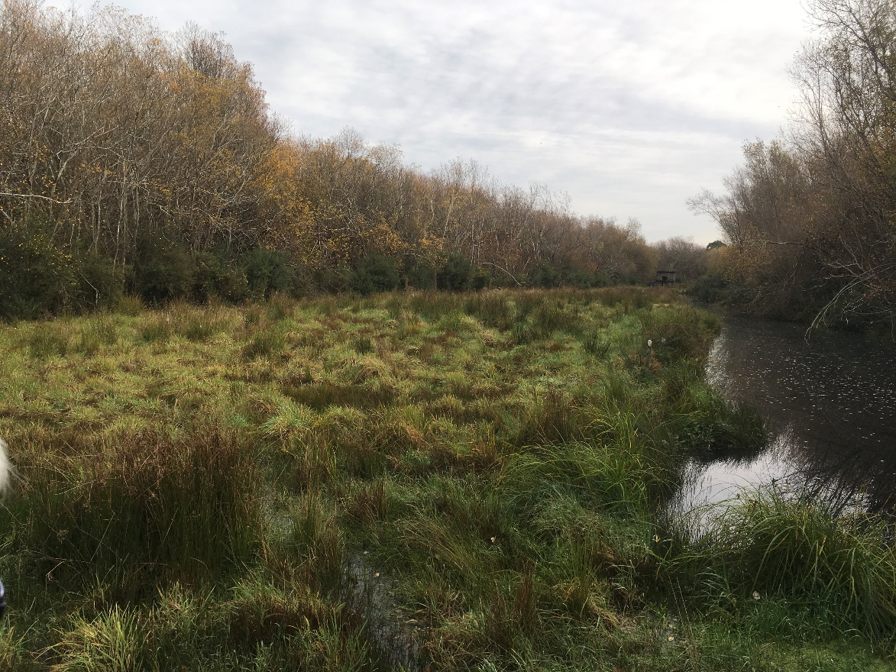
Figure 9: The shooting range that extends into the Reserve
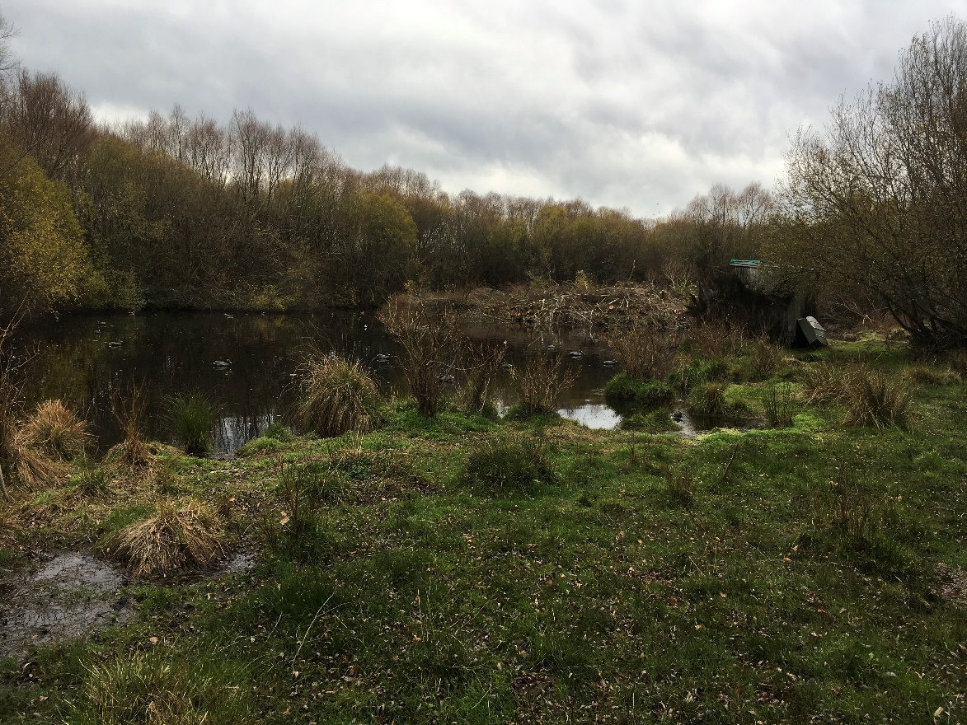
Figure 10: The man-made pond within the Reserve on the true left of the Ararira/LII River

Research/Education Opportunities
As far as we are aware, the only research project undertaken recently within the Reserve. was by Bowie and Hutson (2016) as part of a summer research scholarship funded by the Living Water . They carried out an investigation to determine which fauna (birds, mammals, lizards and invertebrates) were present within the Reserve for the purpose of guiding future restoration and conservation efforts.
Living Water has also funded the willow control trials (described in Section 4.5.1) to determine which grey willow control methods are likely to be most successful within the area of indigenous rushland (Keystone Ecology 2017).
The Reserve has also been considered as part of studies of the wider area. For example, the recreation study for the wider Te Waihora/Ellesmere catchment included a section on Tārerekautuku/Yarrs Lagoon Reserve (Espiner et al. 2017) and Golder (2015) undertook a comprehensive study of the hydrology, ecology and water quality of the Ararira/LII catchment for Living Water.
While few research projects have been undertaken in the area to date, there are opportunities for further research and education within the Reserve. The close proximity of Lincoln University in particular, but also Canterbury University and Ara Institute in Christchurch means the Reserve is relatively accessible to students carrying out tertiary research. In the short-term, research relating to the Reserve’s ecological restoration, including willow control methods, the response of indigenous flora and fauna, and the success of restoration methods could be encouraged.
If access to the Reserve is improved and walking paths are constructed, interpretation panels explaining the importance of the Reserve, and providing information on indigenous vegetation, plants and fauna could provide educational opportunities for school groups and the general public.
Recommendations
It is recommended that:
- Local schools and tertiary providers are made aware of the potential for undertaking research within the Reserve, and in particular, research relating to the Reserve’s restoration.
- The potential for providing educational opportunities for school groups and the general public within the Reserve is considered as part of its restoration.

Summary of Recommendations
The primary purpose of this report has been to inform the development of a Reserve Management Plan to guide the ecological restoration and management of Tārerekautuku/Yarrs Lagoon Reserve. With this purpose in mind, the key recommendations for the management of Tārerekautuku/Yarrs Lagoon Reserve are:
- That during consultation (Stage 2 of this work) a long-term vision is developed for the Reserve, management issues and opportunities are discussed with stakeholders and the outcomes are incorporated into the Reserve Management Plan.
- The current legal status of the Reserve is confirmed and its classification is reviewed to determine whether it is appropriate.
- A Pest Plant Control and Surveillance Plan is prepared (or included in the Reserve Management Plan) to prioritise and guide willow and other weed control within the Reserve. A strategic, well managed approach to the control of willows, and other weed species will be crucial to the success of any weed control work.
- The options/methods for controlling willows are considered carefully, and that if willow control is undertaken, a commitment is made to continue follow-up control and associated restoration work.
- Until a willow control plan is developed, willow control continues as a high priority within the mānuka stands and the indigenous rushland area.
- The Reserve boundaries are fenced and all stock are excluded from the wetlands and waterways within the Reserve.
- The Reserve Management Plan is developed in collaboration with the DLC to ensure that maintenance works minimise, as far as possible, adverse impacts on biodiversity values within the Reserve and the ongoing extent and methods for drain maintenance are considered as part of long-term planning for the restoration and management of the Reserve.
Other recommendations are that:
- Restoration planting is considered for wet pasture sites on the margins of the Reserve. This could be an important tool for engaging the community but should not be undertaken at the expense of higher priority work.
- The status of potential public access routes is confirmed and options for formalising public access are considered.
- Potential impacts on indigenous vegetation and fauna, including birds, lizards and invertebrates are considered during willow control operations.
- Monitoring is considered for birds and potentially other fauna, to monitor the success of restoration work. This could include specific surveys for crake and Australasian bittern.
- Further monitoring of animal pests is considered, and if animal pest control is undertaken a plan is prepared to guide control work.
- Macroinvertebrate and aquatic habitat sampling, and surveys to confirm the presence of indigenous freshwater fish are considered to better inform restoration and management.
- The potential to better connect the Ararira/LII River and drains to the wetland area within the Reserve are explored. If any hydrological changes are considered, the SDC would need to work closely with adjacent landowners, DLC and ECan.
- Living Water , ECan and SDC continue to work with upstream landowners in the wider catchment to improve water quality.
- Additional areas of existing willow forest along drain margins are not sprayed until a plan, and the resources to carry out follow-up ground control are put in place as part of the wider Reserve Management Plan.
- Management options for encouraging increased recreational use of the Reserve are considered as part of its restoration.
- The appropriateness of duck shooting as a recreational activity within the Reserve is considered in relation to its future use and management.
- Local education providers are made aware of the potential for undertaking educational activities, including research, within the Reserve and that the opportunities are considered as part of the Reserve’s restoration.

References
Ausseil A-G.E., Chadderton W.L., Gerbeaux P., Stephens R.T., Leathwick J.R. 2011. Applying systematic conservation planning principles to palustrine and inland saline wetlands of New Zealand. Freshwater Biology 56: 142–161.
Ausseil, A-G., Gerbeaux, P., Chadderton, W.L., Stephens, T., Brown, D., and Leathwick, J. (2008). Wetland ecosystems of national importance for biodiversity: Criteria, methods and candidate list of nationally important inland wetlands. Landcare Research Contract Report: LC0708/158. 174pp.
Bowie, M and Hutson, 2016. Yarrs Flat Wildlife Reserve & Yarrs Lagoon: An assessment of fauna present to guide future restoration and conservation of native species. Lincoln University Wildlife Management Report No. 58.
Butt, J. Unpublished checklist of Plant Species Recorded from Yarrs Lagoon.
Canterbury Maps: https://mapviewer.canterburymaps.govt.nz/?webmap=9ac1f8370dfe4a44808bec8fb1dccb24
de Lange, P.J., Rolfe, J.R., Champion, P.D., Courtney, S.P., Heenan, P.B., Barkla, J.W., Cameron, E.K., Norton, D.A., Hitchmough, R.A. (2013). Conservation status of New Zealand indigenous vascular plants, 2012. New Zealand Threat Classification Series No. 3. Department of Conservation, Wellington. 70 pp.
Department of Conservation and Ministry for the Environment. 2007. Protecting our Places: Information about the Statement of National Priorities for Protecting Rare and Threatened Biodiversity on Private Land. Ministry for the Environment, Wellington.
Ecroyd, C. E., Brockerhoff, E.G. 2005. Floristic changes over 30 years in a Canterbury Plains kanuka forest remnant, and comparison with adjacent vegetation types. New Zealand Journal of Ecology 29 (2): 279-290.
Environment Canterbury. 2008. A Biodiversity Strategy for the Canterbury Region. Report Number RO8/13. 85 p.
Environment Canterbury. 2013. Canterbury Regional Policy Statement 2013. Environment Canterbury.
EOS Ecology, 2014. Lincoln Integrated Stormwater Management Plan: Waterway Monitoring (Year 2). EOS Ecology, Christchurch, New Zealand. 40 p.
Espiner, S., Stewart, E., Lizamore, C. 2017. Recreation Demand Study: Te Waihora/Lake Ellesmere. A report prepared for the Department of Conservation - Te Papa Atawhai. Lincoln University.
Golder Associates Ltd, 2015. Ararira/LII Catchment: Hydrology, Ecology and Water Quality. Report prepared for The Department of Conservation/Fonterra Living Water Partnership
Grainger, N, Collier, K, Hitchmough, R, Harding, J, Smith, B, & Sutherland, D. 2014. Conservation status of New Zealand freshwater invertebrates, 2013. New Zealand Threat Classification Series 8. Wellington: Department of Conservation. Retrieved from www.doc.govt.nz.
Harding, M.A. 2009. Canterbury Land Protection Strategy. A Report to The Nature Heritage Fund Committee. Nature Heritage Fund, Wellington.
Hitchmough, R., Barr, B., Lettink, M., Monks, J., Reardon, J., Tocher, M., van Winkel, D., Rolfe, J. (2016). Conservation status of New Zealand reptiles, 2015. New Zealand Threat Classification Series 17. Department of Conservation, Wellington. 14 p.
Jellyman, D., Graynoth, E. 2010. The Importance of Tributary Streams of Te Waihora/ Lake Ellesmere in Maintaining Populations of Longfin Eels. NIWA report prepared for Environment Canterbury.
Jensen, C. 2017. Native Biodiversity and Drainage in Yarrs Lagoon: Recommendations for Willow Management to Enhance Native Biodiversity and Improve Drain Maintenance. Report prepared for Robin Smith, Department of Conservation.
Johnson P.N., Gerbeaux P. 2004. Wetland Types in New Zealand. Department of Conservation, Wellington. 184 pp.
Keystone Ecology. 2017. Tā‐rere‐kau‐tuku/Yarrs Lagoon Willow Control and Methodology Trial Report.
Kitto, S.G. 2010. The Environmental History of Te Waihora – Lake Ellesmere. Master’s Thesis, University of Canterbury.
Leathwick, J.; Wilson, G.; Rutledge, D.; Wardle, P.; Morgan, F.; Johnston, K.; McLeod, M.; Kirkpatrick, R. 2003. Land Environments of New Zealand. David Bateman. 184p.
McEwen, W.M. 1987. Ecological regions and districts of New Zealand (3rd revised edition), Sheet 3. NZ Biological Resources Centre Publication No. 5. Department of Conservation, Wellington.
Parker, M. 2013. Yarrs Lagoon Wetland Classification, Wetland Condition and Pressure Indicators. Unpublished data.
Parker, M., Grove, P. 2013. Tārerekautuku (Yarrs Lagoon): Wetland Condition, Threats and Significance Assessment. Environment Canterbury unpublished report.
Robertson, H.A., Baird, K., Dowding, J.E., Elliott, G.P., Hitchmough, R.A., Miskelly, C.M., McArthur, N., O’Donnell, C.F.J., Sagar, P.M., Scofield, R.P., Taylor, G.A. (2017). Conservation status of New Zealand birds, 2016. New Zealand Threat Classification Series 19. Department of Conservation, Wellington. 23 p.
Rutledge, M. 1981. Distribution and trophic relationships of the phytomacrofauna in three Canterbury Rivers. Unpublished B.Sc. Thesis, University of Canterbury.
Selwyn District Council. 2015. Open Spaces Strategy.
Singleton, G. 2014. Ellesmere the Jewel in the Canterbury Crown. Selwyn District Council, Rolleston.
Spanton, A, 2017. Report on the Aerial Spraying on Tārerekautuku Yarrs Lagoon. Unpublished Report.
Steven J.C., Meurk C.D. 1996. Low and High Plains Ecological Districts, Plains Ecological Region, Canterbury. Protected Natural Areas Survey Report (Draft Report). Department of Conservation and Landcare Research.
Taiaroa H.K. 1880. Hand written manuscript.
Taylor K.J.W. 1996. The Natural Resources of Lake Ellesmere (Te Waihora) and its Catchment. Canterbury Regional Council. 322p.
Wai-ora Forest Landscapes. 2016. Tā-rere-kautuku/Yarrs Lagoon Weed Control. Unpublished Report.
Waihora Ellesmere Trust, 2009. Opening Te Waihora/ Lake Ellesmere to the Sea: A Beginner’s Guide. Accessed from:
http://www.wet.org.nz/wp-content/uploads/2009/10/Beginners-Guide-to-opening-Te-Waihora-Lake-Ellesmere.pdf
Walker, S.; Cieraad, E.; Barringer, J. 2015. The Threatened Environment Classification for New Zealand 2012: a guide for users. Landcare Research, New Zealand Ltd, Dunedin.
Wildland Consultants. 2011. Guidelines for the application of ecological significance criteria for indigenous vegetation and habitats of indigenous fauna and wetlands in Canterbury. Wildland Consultants Contract Report No. 2289c. Prepared for Environment Canterbury.
Wildland Consultants. 2013. Guidelines for the Application of Ecological Significance Criteria for Indigenous Vegetation and Habitats of Indigenous Fauna in Canterbury Region. Report No. 2289i. Prepared for Environment Canterbury, June 2013.
Williams, K. 2005. Native Plant Communities of the Canterbury Plains. Department of Conservation, Christchurch. 66 pp.

Appendix 1: Plant Species Lists
Table A1.1: Plant species recorded at Tārerekautuku/Yarrs Lagoon. Listed by growth form and then alphabetically by scientific name.
Scientific Name | Common Name
Indigenous Species
Trees and shrubs
Coprosma crassifolia
Coprosma propinqua | Mingimingi
Coprosma robusta | Karamu
Coprosma virescens
Coprosma xcunninghamii
Dacrycarpus dacrydioides | Kahikatea
Griselinia littoralis | Broadleaf
Leptospermum scoparium | Mānuka
Melicytus ramiflorus | Mahoe
Myrsine australis | Red matipo
Pittosporum eugenioides | Lemonwood
Pittosporum tenuifolium | Kohuhu
Prumnopitys taxifolia | Matai
Climbers
Muehlenbeckia australis | Pohuehue
Muehlenbeckia complexa | Small-leaved pohuehue
Forbs
Centella uniflora | Centella
Hydrocotyle novae-zeelandaie
Hypericum pusillum
Lemna disperma | Duckweed
Potentilla anserinifolia | Silver weed
Ranunculus glabrifolius | Waoriki
Ranunculus macropus | Swamp buttercup
Senecio glomeratus | Fireweed
Senecio minimus | Fireweed
Urtica perconfusa | Swamp nettle
Viola cunninghamii | Mountain violet
Viola lyallii | Violet
Monocots
Apodasmia similis | Oioi
Astelia fragrans | Bush lily
Carex coriacea | Cutty grass
Carex flagellifera | Glen Murray tussock
Carex flaviformis | Yellow sedge
Carex geminata | Cutty grass
Carex maorica | Maori sedge
Carex secta | Purei
Carex sinclairii | Sinclair’s sedge
Carex virgata | Swamp sedge
Cordyline australis | Cabbage tree
Eleocharis acuta | Sharp spike sedge
Isolepis distigmatosa
Isolepis prolifer
Isolepis reticularis
Juncus edgariae | Wiwi
Juncus planifolius | Grass-leaved rush
Lepidosperma australe | Square sedge
Machaerina rubiginosa | Baumea
Phormium tenax | Lowland flax
Potomageton cheesemani | Red pondweed
Schoenus moschata
Schoenus pauciflorus | Bog rush
Triglochin striata | Triglochin
Typha orientalis | Raupō
Orchids
Microtis unifolia | Onion-leaved orchid
Ferns
Asplenium appendiculatum | Ground spleenwort
Asplenium flabellifolium | Necklace fern
Asplenium flaccidum | Drooping spleenwort
Asplenium gracillimum
Azolla rubra | Red azolla
Blechnum minus | Swamp kiokio
Blechnum penna-marina | Little hard fern
Blechnum procerum | Small kiokio
Histiopteris incisa | Water fern
Hypolepis ambigua | Pig fern
Microsorum pustulatum | Hounds tongue fern
Polystichum vestitum | Punui
Pteridium esculentum | Bracken
Exotic species
Trees and shrubs
Alnus glutinosa | Alder
Crataegus monogyna | Hawthorn
Erica lusitanica | Spanish heath
Euonymus europaeus | Spindle tree
Rosa rubiginosa | Sweet briar
Salix cinerea | Grey willow
Salix fragilis | Crack willow
Sambucus nigra | Elder
Ulex europaeus | Gorse
Climbers
Hedera helix | Ivy
Forbs
Calystegia silvatica | Convolvulus
Cardamine sp.
Cirsium arvense | Californian thistle
Elodea canadensis | Canadian pondweed
Lotus pedunculatus | Lotus
Mentha x piperita* | Mint
Erythranthe guttata | Monkey musk
Myosotis laxa subsp. caespitosa | Water forget-me-not
Nasturtium officinale | Watercress
Persicaria hydropiper | Water pepper
Potamopogon cripus | Curly pondweed
Prunella vulgaris | Selfheal
Ranunculus repens | Buttercup
Rorippa sylvestris | Creeping yellow cress
Rubus fruticosus | Blackberry
Rumex crispus | Curled dock
Rumex obtusifolius | Broad-leaved dock
Solanum dulcamara | Bittersweet
Trifolium pratense | Red clover
Trifolium repens | White clover
Monocots
Agrostis stolonifera | Creeping bent
Carex demissa | Yellow sedge
Dactylis glomerata | Cocksfoot
Holcus lanatus | Yorkshire fog
Juncus articulatus | Jointed rush
Juncus effusus | Soft rush
Schedonorus arundinaceus | Tall fescue
Ferns
Dryopteris filix-mas | Male fern

Table A1.2: Plants mentioned in the text but not recorded at Tārerekautuku/Yarrs Lagoon
Scientific Name | Common Name
Discaria toumatou | Matagouri
Kunzea erocoides | Kanuka
Poa cita | Silver tussock
Rytidosperma spp. | Danthonia
Sophora microphylla | Kowhai
Typha orientalis | Raupō

Appendix 2: Taonga Species
Taonga plant and bird species, as listed in Schedule 97 of the Ngāi Tahu Claims Settlement Act (1998), recorded at Tārerekautuku/Yarrs Lagoon.

Common Name | Scientific Name
Plants
Karamu | Coprosma robusta
Kahikatea | Dacrycarpus dacrydioides
Broadleaf | Griselinia littoralis
Mānuka | Leptospermum scoparium
Red matipo | Myrsine australis
Lemonwood | Pittosporum eugenioides
Kohuhu | Pittosporum tenuifolium
Glen Murray tussock | Carex flagellifera
Cabbage tree | Cordyline australis
Lowland flax | Phormium tenax
Bracken | Pteridium esculentum
Birds
Australasian shoveler | Anas rhynchotis
Black shag | Phalacrocoraxcarbo novaehollandiae
Grey teal | Anas gracilis
Grey warbler | Gerygone igata
Kingfisher | Todiramphus sanctus
South Island fantail | Rhipidura fuliginosa

Appendix 3: Historical Images of Tārerekautuku/Yarrs Lagoon

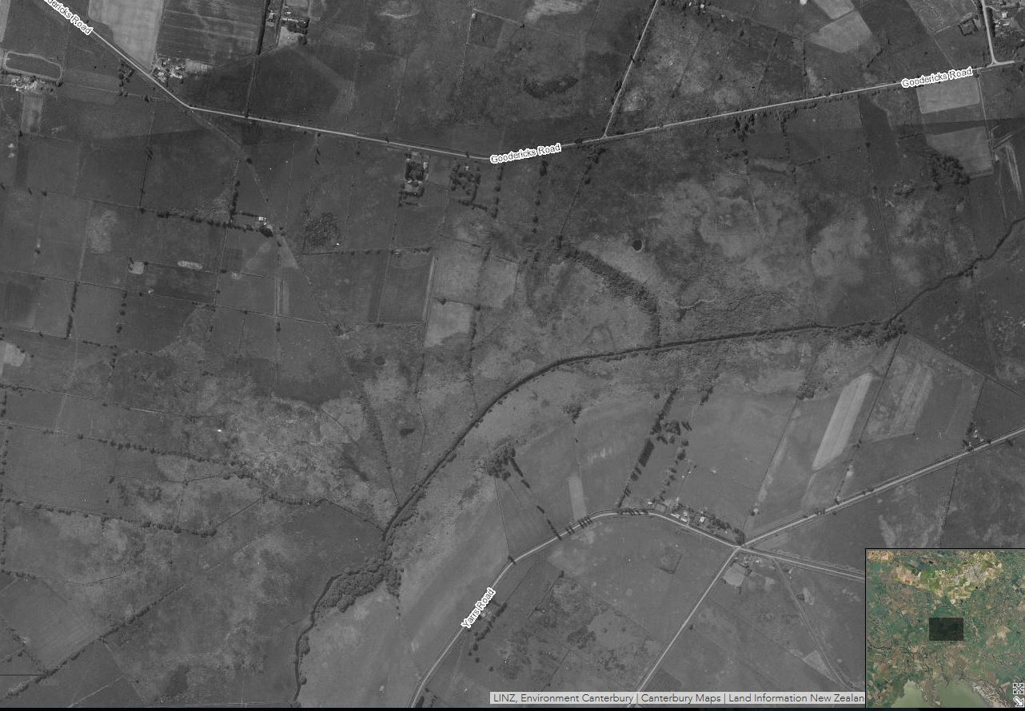
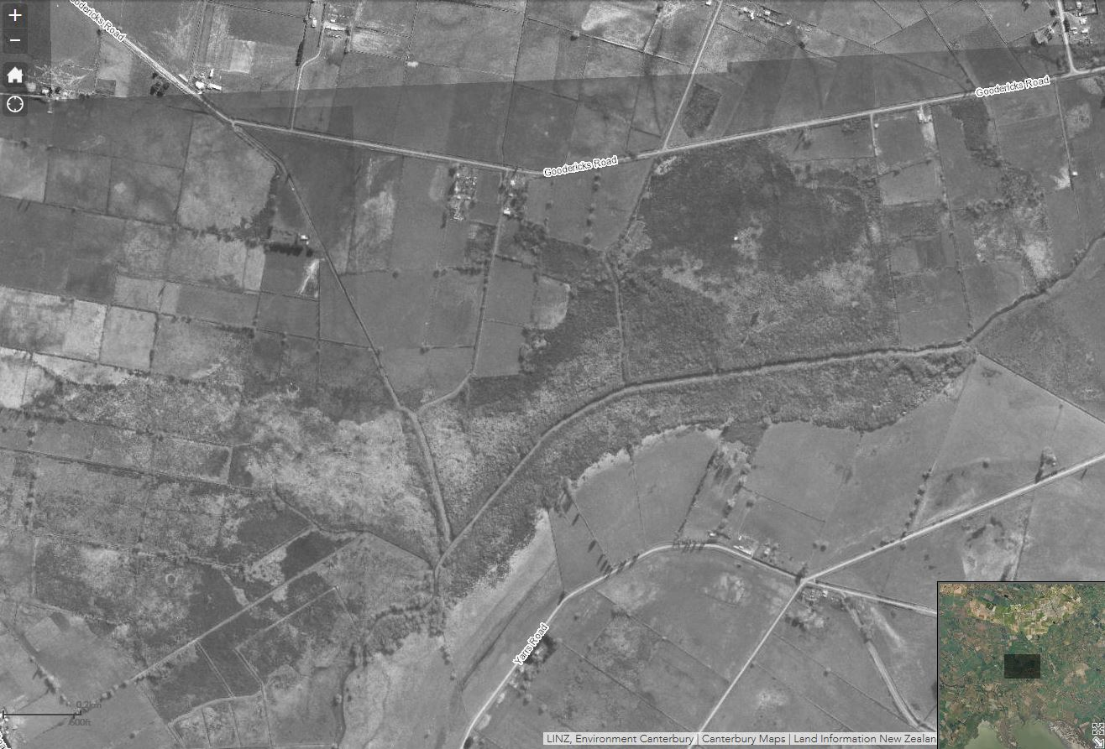
Figure A3.1 and A3.2: Aerial imagery of Tārerekautuku/Yarrs Lagoon during 1940-1944 (top) and from 1960-1964 (bottom). Imagery sourced from Canterbury Maps.

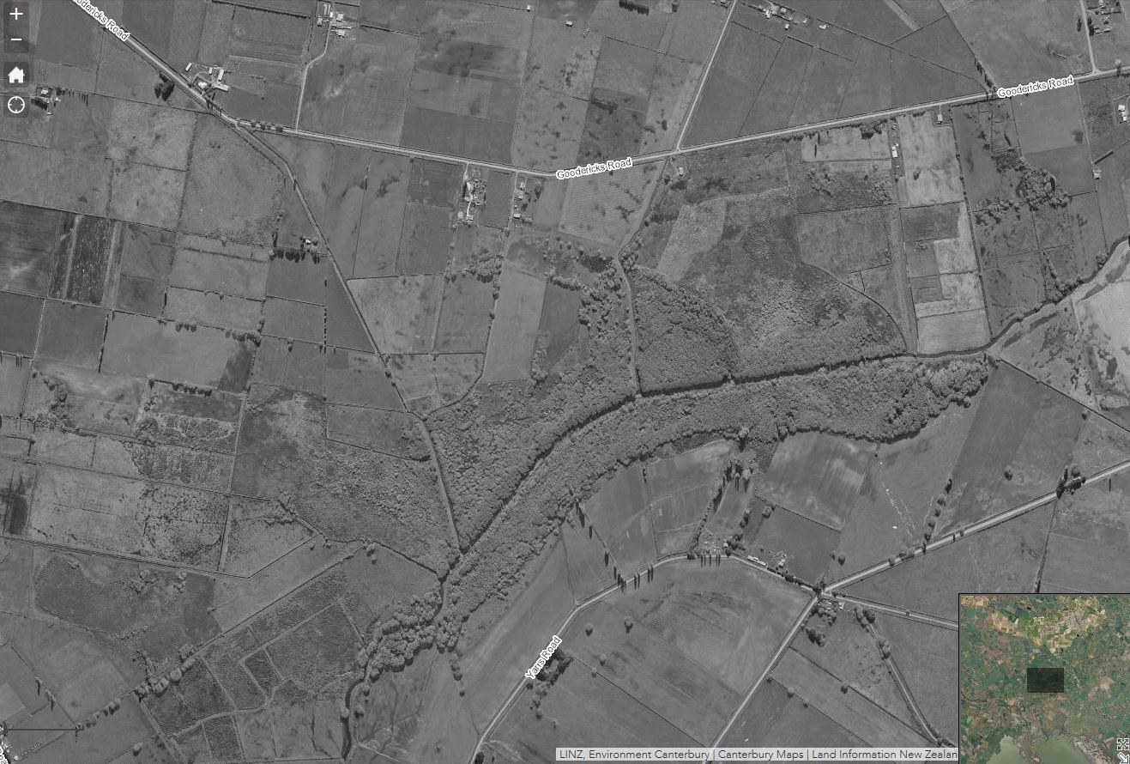
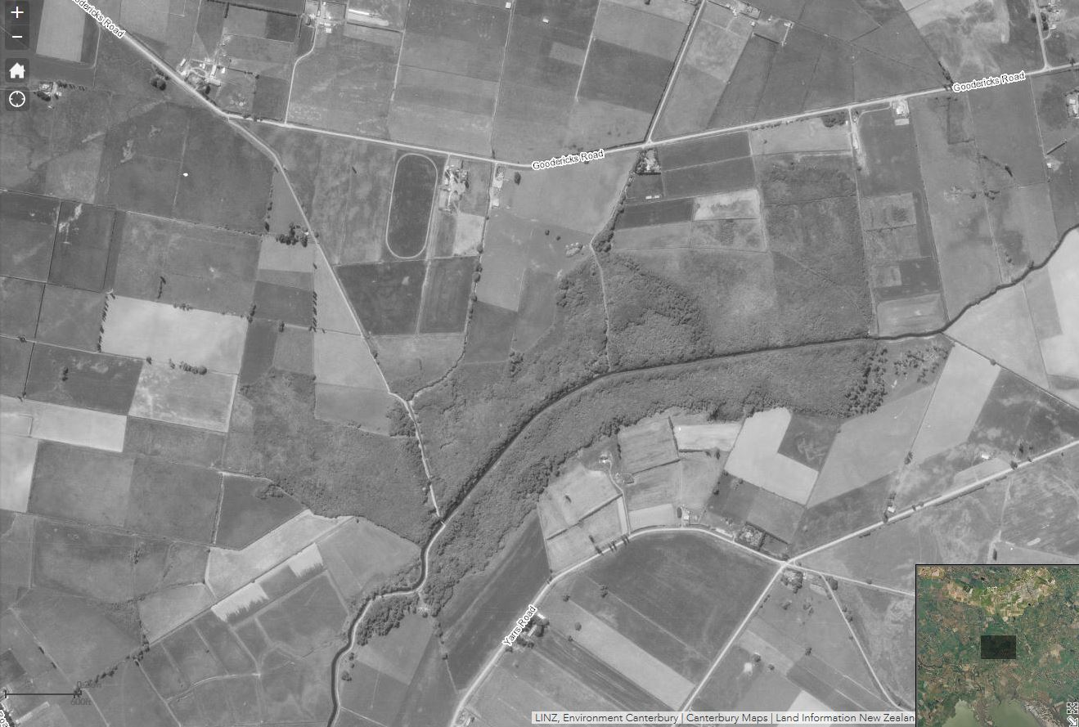
Figure A3.3 and A3.4: Aerial imagery of Tārerekautuku/Yarrs Lagoon during 1970-1974 (top) and from 1980-1984 (bottom). Imagery sourced from Canterbury Maps.
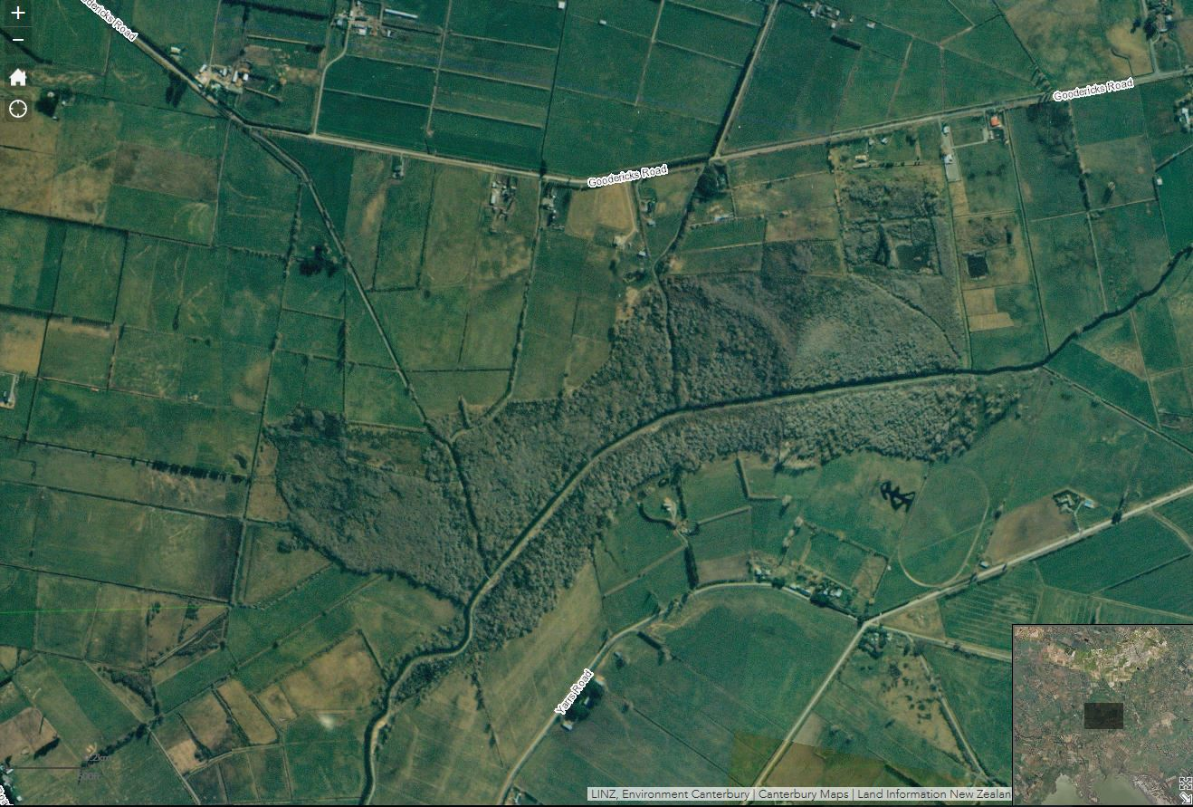
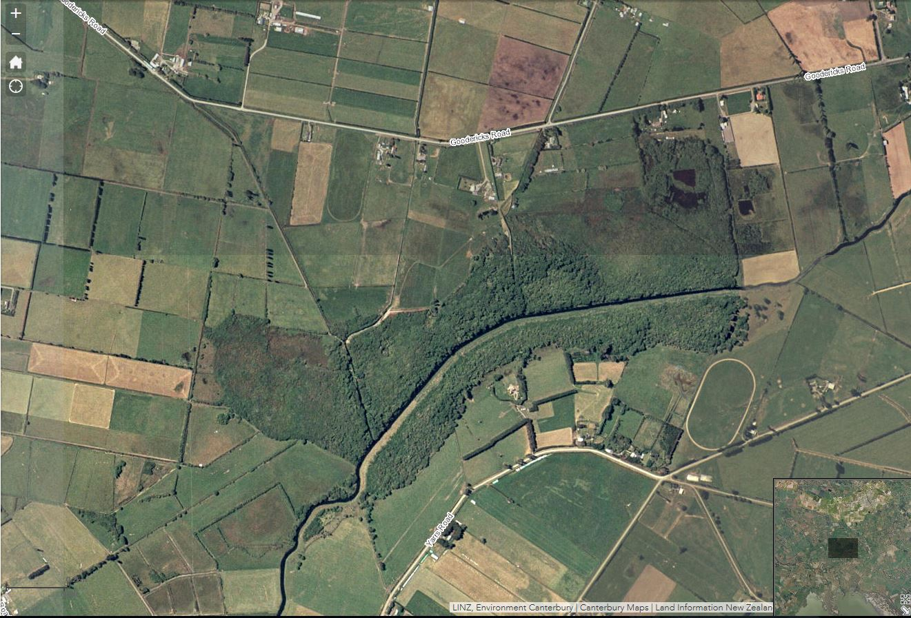
Figure A3.5 and A3.6: Aerial imagery of Tārerekautuku/Yarrs Lagoon during 1990-1994 (top) and from 2000-2004 (bottom). Imagery sourced from Canterbury Maps.

Appendix 4: Assessment of Ecological Significance
Assessment of Tārerekautuku/Yarrs Lagoon Wetland against the Canterbury Regional Policy Statement (ECan 2013) criteria for determining significant indigenous vegetation and significant habitat of indigenous biodiversity. Italicised text is from Appendix 3 of the Canterbury Regional Policy Statement.
Criteria | Criteria met? | Explanation
Representativeness
1. Indigenous vegetation or habitat of indigenous fauna that is representative, typical or characteristic of the natural diversity of the relevant ecological district. This can include degraded examples where they are some of the best remaining examples of their type, or represent all that remains of indigenous biodiversity in some areas. | Yes | Although highly modified by drainage and the invasion of introduced plants, and in particular willow, in the context of other freshwater wetlands in the Low Plains ED the site is representative of a freshwater swamp and marsh wetland. It retains some woody vegetation (i.e. mānuka scrub), supports a high cover and diversity of indigenous wetland plant species in its understorey, provides habitat for a representative assemblage of water and wetland birds and retains its ecological function.
2. Indigenous vegetation or habitat of indigenous fauna that is a relatively large example of its type within the relevant ecological district. | Yes | It is a relatively large freshwater wetland in the Low Plains Ecological District.
Rarity/Distinctiveness
3. Indigenous vegetation or habitat of indigenous fauna that has been reduced to less than 20% of its former extent in the Region, or relevant land environment, ecological district, or freshwater environment. | Yes | At the ED level, the wetland is a rare freshwater wetland remnant in the Low Plains ED where only 0.5% indigenous cover remains.  At the regional and freshwater biogeographic unit scales Ausseil et al. (2008) estimate that wetlands have been reduced to 10.6% of their original extent in the Canterbury Region and 7.0% in the Canterbury freshwater biogeographic unit.  At the land environment scale, the wetland is situated on a land environment that is an Acutely Threatened (i.e. where <10% indigenous vegetation is left on this land environment nationally (Walker et al., 2015)).
4. Indigenous vegetation or habitat of indigenous fauna that supports an indigenous species that is threatened, at risk, or uncommon, nationally or within the relevant ecological district. | Yes | The wetland supports several nationally At Risk species, and species that are uncommon within the ED. Species that are At Risk species nationally are: swamp nettle, southern grass skink, marsh crake, South Island pied oystercatcher (all At Risk - Declining) and black shag (At Risk – Naturally Uncommon). Baumea and mānuka are both uncommon in the Low Plains ED.
5. The site contains indigenous vegetation or an indigenous species at its distribution limit within Canterbury Region or nationally. | Yes? | If the identification of the carabid beetle Megadromus ensyi is correct, the wetland is eastern most record for this species.  Baumea is close to its southern distributional limit here.
6. Indigenous vegetation or an association of indigenous species that is distinctive, of restricted occurrence, occurs within an originally rare ecosystem, or has developed as a result of an unusual environmental factor or combinations of factors. | No | The site does not support indigenous vegetation or an association of indigenous species that is distinctive, of restricted occurrence, occurs within an originally rare ecosystem, or has developed as a result of an unusual environmental factor or combinations of factors.
Diversity and Pattern
7. Indigenous vegetation or habitat of indigenous fauna that contains a high diversity of indigenous ecosystem or habitat types, indigenous taxa, or has changes in species composition reflecting the existence of diverse natural features or ecological gradients. | Yes | The wetland contains a moderate diversity of wetland and habitat types including exotic willow forest with an indigenous understorey; mānuka – grey willow scrub with an indigenous understorey, indigenous rushland and open water. It contains a high diversity of wetland plant species relative to other freshwater wetlands in the ED.
Ecological Context
8. Vegetation or habitat of indigenous fauna that provides or contributes to an important ecological linkage or network, or provides an important buffering function. | Yes | It is a large area of wetland habitat directly connected to the Ararira/LII River and Te Waihora/Lake Ellesmere (including Yarrs Flat and Selwyn Wildlife Reserves) that is likely to provide an important ecological network for indigenous fauna, and particularly waterfowl and wetland birds and freshwater fish.  Because it has large drains running through it, it is unlikely to play a role in buffering downstream aquatic values from flood flows, suspended sediment etc.
9. A wetland which plays an important hydrological, biological or ecological role in the natural functioning of a river or coastal system. | Yes | Although the wetland is upstream of Te Waihora/Lake Ellesmere, installation of large drains through the Reserve means it is no longer strongly hydrologically connected to the Ararira/LII River. However, as a large wetland adjacent to Te Waihora/Lake Ellesmere and surrounded by highly modified agricultural land, it does play an important ecological role in the natural functioning of the wider area.
10. Indigenous vegetation or habitat of indigenous fauna that provides important habitat (including refuges from predation, or key habitat for feeding, breeding, or resting) for indigenous species, either seasonally or permanently. | Yes | The wetland provides important habitat for waterfowl and wetland birds and terrestrial invertebrates.

This depends on the classification of the Reserve.
This imagery is available from Robin Smith (Living Water Partnership) and Boffa Miskell.
This includes the three landowners that border the paper road along part of the northern boundary of the reserve.
Bowie and Hutson (2016) recorded an un-identified shag. A black shag was recorded within the reserve in the Ararira/LII River during our site visit.
A marsh crake was observed by Bowie and Hutson (2016) along the vehicle track between Goodericks Rd and the reserve. Although this sighting was outside the reserve, it is very likely this species (which has a conservation status of At Risk – Declining) also occupies suitable habitat within the reserve.
One line of 10 tracking tunnels spaced 50 m apart was run along part of the northern boundary of the reserve.

