MONITORING METHODOLOGIES FOR FOUR LEPIDOPTERA TAXA OF SOUTHERN
AOTEAROA/NEW ZEALAND

R5429
DOC-6371817

MONITORING METHODOLGIES FOR FOUR LEPIDOPTERA TAXA OF SOUTHERN AOTEAROA/NEW ZEALAND

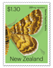
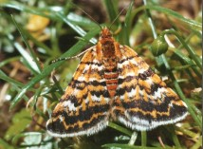
The Foveaux daphne moth, Notoreas casanova, is a diurnal geometrid, discovered in 1982 and described in 2010. It is only known from three southern coastal sites: Fortrose Spit, Three Sisters sand dune, and on Tiwai Peninsula. The male and female are alike in terms of size and colour pattern. The inset is a February 2020 set of daphne moth stamps issued by New Zealand Post.

Contract Report No. 5429

June 2020

Project Team:
Brian Patrick - Report author
William Shaw - Peer review

Prepared for:
Department of Conservation
Murihiku
Invercargill

CONTENTS

1. INTRODUCTION 1
2. Foveaux daphne moth 2
3. Remuremu looper moth 5
4. Foveaux pink underwing moth 8
5. Tiwai boulder copper butterfly 10
6. SUMMARY 13
ACKNOWLEDGMENTS 13
REFERENCES 14

APPENDIX

1. Fact Sheet: Three south coast lepidoptera 16

Reviewed and approved for release by:

_______________________
W.B. Shaw
Director/Principal Ecologist
Wildland Consultants Ltd

© Wildland Consultants Ltd 2020

This report has been produced by Wildland Consultants Ltd for the Department of Conservation. All copyright in this report is the property of Wildland Consultants Ltd and any unauthorised publication, reproduction, or adaptation of this report is a breach of that copyright.

INTRODUCTION

The southern coast of Aotearoa/New Zealand’s South Island features a range of natural habitats - including rocky shores and tall sand dunes - both of which have associated herbfields, wetlands that include large estuaries and moss bogs, and mixed grassland-shrubland on gravel spits. These communities in rugged environments on the northern coast of Foveaux Strait provide habitats for a diverse assemblage of indigenous plants and insects, including many that are endemic to this area, making this coastline of national significance for indigenous biodiversity and conservation (Barker et al. in Darby et al. 2003).

Tiwai Peninsula is notable not just for the large and conspicuous aluminum smelter, but also for its significant natural grassland-shrubland habitat and adjacent saltmarsh with its assemblage of indigenous plants and fauna, some of which are the largest populations of south coast endemics (Patrick 1983 and 1994). Most of Tiwai Peninsula, which is in Waituna Ecological District, is within the Tiwai Peninsula Conservation Area that is managed by the Department of Conservation.

A feature of the insect fauna is the number of species, particularly moths and butterflies, which are ecological specialists, being confined to only one of the habitats present, with many of the moth and butterfly species linked inextricably to a single plant species to complete their life history (Patrick 1983 and 1994).

Some of these moth and butterfly species are threatened with extinction (Hoare et al. 2017) in their diverse natural habitats and are subject to conservation management by the Department of Conservation. This includes the four moth and butterfly species which are the subject of this report. These four southern coast moth and butterfly species, which are all range restricted, have significant populations on Tiwai Peninsula and on the southern coastline 20 kilometres south of Invercargill, so this is a key site for their conservation management. Population monitoring has been initiated for three of the species, to help with that management (Wildland Consultants 2017 and 2019a). The four Lepidoptera species and their current threat status (Hoare et al. 2017) are:

- Foveaux daphne moth (Notoreas casanova): Threatened-Nationally Vulnerable.
- Remuremu looper moth (Asaphodes frivola): Threatened-Nationally Critical.
- Foveaux pink underwing moth (Meterana n.sp.): Threatened-Nationally Endangered.
- Tiwai boulder butterfly (Lycaena n.sp.): Not Threatened.

An illustrated factsheet “Three South Coast Lepidoptera” featuring the three listed species with threat rankings was produced for the Department to help with species recognition as part of their ongoing conservation (Wildland Consultants 2019b; (Appendix 1). The Tiwai boulder butterfly, although not currently classified as Threatened, is considered by BP to qualify as “Threatened” and will be assessed for potential inclusion in the list for the first time by the Department’s expert Lepidoptera panel in 2020.

The Department commissioned Wildland Consultants to document methods used to monitor these four special Lepidoptera on the Tiwai Peninsula.

Foveaux daphne moth

Background

The genus Notoreas - the daphne moths - is endemic to New Zealand with 20 named taxa that collectively define New Zealand from the coast to the high alpine zone, with a different mix of species in each biogeographic area (Patrick et al. 2010). There are an additional 15 unnamed daphne moths, six of which are currently receiving formal descriptions under a contract commissioned by Department of Conservation.

While South Island alpine areas can have up to six species flying together, in all of the coastal habitats where they are found, there is just one species. Approximately 10 daphne moth species dot the New Zealand coastline, in isolated places, with generally small populations (Patrick 1998). Nine of the species nationwide, all coastal, are of conservation concern (Hoare et al. 2017).

At the suggestion of BHP, New Zealand Post issued a set of six stamps featuring daphne moths in February 2020. The Foveaux daphne moth was included in this set of stamps (Frontispiece), so has been exposed to a broad audience (Patrick 2020a and b).

The Foveaux daphne moth is one member of the diverse geometrid moth genus Notoreas that occurs throughout Aotearoa/New Zealand, from coastal margins to the highest alpine habitats, and from the northern cliffs of the Far North (in Northland), to the Tin Range in southern Rakiura/Stewart Island (Patrick 2019).Their larvae are specialist feeders on the two daphne genera that occur in Aotearoa/New Zealand (Patrick 2020b): Kelleria and Pimelea (Thymelaeaceae). It is classified as Threatened-Nationally Vulnerable in the latest Department of Conservation’s threat rankings for moths and butterflies (Hoare et al. 2017).

Identification

The attractive diurnal Foveaux daphne moth Notoreas casanova was described by Patrick and Hoare (Patrick et al. 2010). They are an attractive diurnal (i.e. day-flying) moth in the Family Geometridae, with similar-looking males and females (Plates 2 and 3). In terms of identification, adult moths are unmistakable.

Distribution

It is endemic to the South Island’s southern coastline where it is known from three sand dune and stony grassland-shrubland sites: Tiwai Peninsula (Plate 1) where it was discovered in February 1982 (Patrick 1983); Three Sisters sand dune to the west and Fortrose Spit to the east (Patrick 1994).

Plate 1: Tiwai Peninsula habitat for the Foveaux daphne moth, pink underwing moth,
and Tiwai boulder butterfly, looking west to Bluff Hill with the aluminum smelter
chimney visible beyond indigenous short tussock grassland and shrubland.
Plates 2, 3, and 4: Foveaux daphne moth Notoreas casanova, showing the underside and topside wing colour pattern, which is the same for both sexes (upper), and its mature
larva on the larval host plant on Tiwai Peninsula, Pimelea prostrata (lower).

Ecology

On the consolidated sand dunes at Fortrose Spit and Three Sisters sand dune, the larvae feed on the foliage of the sub-shrub Pimelea lyallii, whereas on the consolidated gravels at Tiwai Peninsula, in short tussock grassland - shrubland, its larvae feed on the sprawling Pimelea prostata, which is locally abundant there.

Interestingly, its sister species Notoreas edwardsi, which is only known from Big Sandhill at Mason Bay on Rakiura/Stewart Island, also has caterpillars which feed on sand daphne Pimelea lyallii (Patrick et al. 1989 and Patrick et al. 2010).

Adult Foveaux daphne moths fly close to the ground, particularly around the larval host plants where they take nectar and breed, and sunbath on adjacent bare ground. They distinctively vibrate their wings constantly even when resting momentarily to take nectar from flowers or to sunbath on bare sand or foliage.

Females lay one millimetre cream-coloured eggs singly on the under-surface of the outer-most leaves of the host plant. Larvae are distinctive in terms of both shape and colouration (Plate 4) and hide amongst the host plant foliage or in the associated leaf litter when not feeding.

The Foveaux daphne moth has two generations each year (duration approximately 120 or 245 days) with the first adults and eggs from late October to early December, which in turn produce a second generation with adult emergence between late January and early April.

Monitoring Methodology

Patrick et al. (2010), in their description of the Foveaux daphne moth, suggested that population-level monitoring should be instigated to observe the population trend for this species, which is confined to a specialised and threatened habitat.

The best time of year to monitor the species is between mid-November and mid-March when adult numbers have built up sufficiently for the species to be conspicuous and the count data will then be meaningful. Additionally, it is important that monitoring is carried out in a consistent way and at a similar time of year, so that it can be used in valid comparisons.

It is imperative that counts are undertaken on days with suitable weather - sunny, calmish and warm - and at the time of the year when adults are flying. Additionally, it is important that if the monitoring is to be carried out by new personnel, that they familiarise themselves with the target species in the field on the day of the monitoring, prior to initiating counting.

Monitoring of the Foveaux daphne moth was instigated in February 2019 (Wildland Consultants 2019a). An appropriate monitoring site was chosen based on the availability and abundance of both its larval host plant and adjacent bare ground. This centrepoint was marked and the grid reference was recorded. Each monitoring event needs to have a centrepoint based on host plant abundance.

Five 10-minute counts were undertaken during the warmest part of the day. Counts were made by walking slowly through the open habitat where the species was active around and close to its host plant (Pimelea species) and were also ‘sunbathing’ on the adjacent bare ground. Care was taken not to disturb the target species and to limit the counts to within a radius of 30 metres of centrepoint.

Now that this monitoring has been set up, it should be repeated every three years. Initially this would be to assess any changes in the numbers of the species, which could reflect habitat changes or other factors that need to be managed to maintain this threatened species and its habitat.

Monitoring process:

- Identify a centrepoint in the middle of excellent host plant habitat. Record grid reference for this point.
- Undertake five 10-minute counts of adults (males and females, as they are identical) within a 30 metre radius of this centrepoint and record numbers. Minimise disturbance of the moths while walking over their habitat.
- Monitor the species at the same sites annually until reasonably consistent counts are achieved.

Remuremu looper moth

Background

The remuremu looper moth (Asaphodes frivola; Geometridae) is one of 46 moth taxa in a genus that is distributed from the high alpine zone to coastal habitats, with specialist species in a variety of natural habitats from snowbanks, through tall tussock communities, forest edges to coastal herbfield and estuarine habitats.

Many alpine members of this genus also exhibit female flightlessness. This is an interesting trait that allows the female to have a larger abdomen and carry more eggs as she doesn’t have to fly. It is a trade-off between mobility and the need to produce additional offspring. While the female can’t fly, they are nevertheless very agile and can run surprisingly quickly with their long legs.

Patrick (2014) and Wildland Consultants (2014 and 2015) illustrated both the male and female and described its coastal estuarine habitats. The adult moths are distinctive in this habitat and are active at dusk but easily disturbed and identified on sunny days, whereas the female is difficult to locate.

Identification

Adults are sexually dimorphic with winged, dull-coloured males and much smaller short, sharp-winged, flightless females (Plates 5 and 6. It is a medium-sized moth with a male wingspan of 22-26 mm. Only the males are to be monitored.

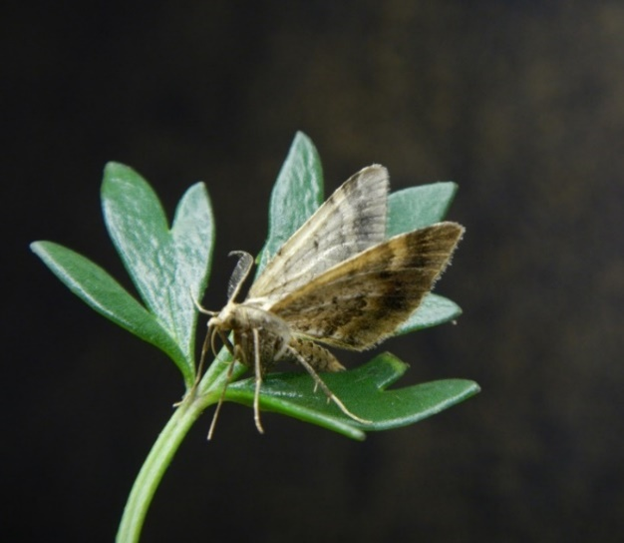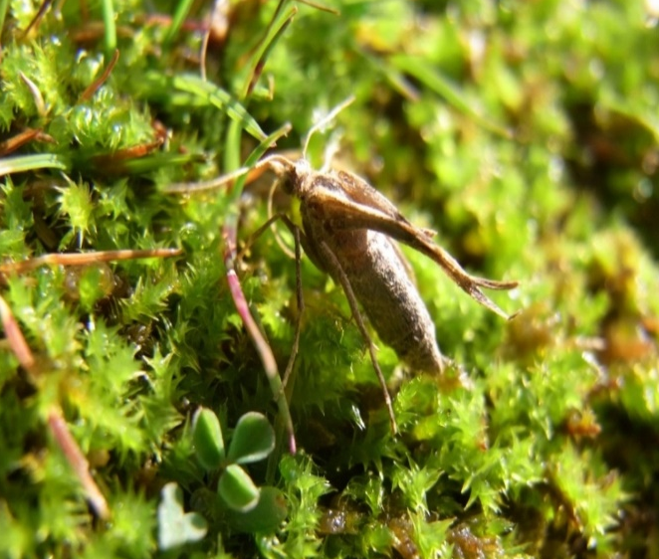
Plates 5 and 6: Remuremu looper moth. Winged male (left) and
short-winged, flightless female (right).

Distribution

The Remuremu looper moth is endemic to the Invercargill area, where it is known from just eight localities (Figure 1). These are all estuarine habitats with margins of tall grasses and sedges. The female’s flightlessness perhaps partially explains its restricted distribution.

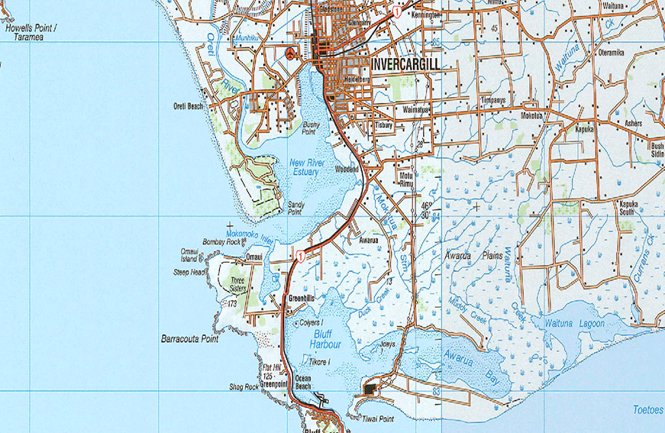
Figure 1: Sites south and east of Invercargill (blue stars) where eight known populations of the remuremu looper moth occur in estuarine habitats (from Wildland Consultants 2017).

Ecology

Remuremu looper moth is part of a suite of South Island moths that emerge in autumn. This fauna is particularly well-developed in upland parts of Otago and Southland, but elements of this fauna group extend to sea level around the Southland coastline (Patrick 1994).

One generation of adults is produced annually, with the adult flight period from mid-March to late April.

As its common name implies, caterpillars of the remuremu looper moth feed on the foliage of remuremu (Selliera radicans), a common plant of coastal saltmarsh, both in Southland and nationally.

Monitoring Methodology

Based on its conservation status and the limited number of known localities, a monitoring programme was instigated on 20 April 2017 for the Awarua Bay population at the base of Tiwai Peninsula (Wildland Consultants 2017). Monitoring was repeated on 25 April 2018 and showed a slight decrease in moth numbers, which may or may not be significant.

Night-time light-trapping and daytime counting methodologies were considered, but the ease of daytime counting and its repeatability were deciding factors. Light-trapping requires excellent weather conditions and lighting equipment that is not widely available.

The method used was to walk slowly using a stick or net to disturb the saltmarsh edge vegetation and count the distinctive male moths disturbed. Four counts of ten minutes were made, at three places, with a total of 120 minutes of counting. Saltmarsh vegetation was monitored on both sides of the road at one site, with no overlaps between the monitoring sites. Typical habitat of the remuremu looper moth where the monitoring was carried out is shown in Plates 7-9, and any monitoring of the species should be undertaken in good habitat.

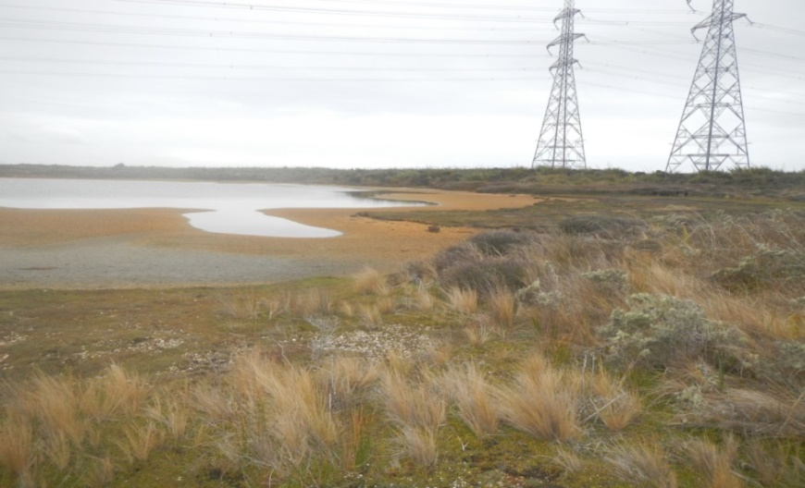
Plate 7: Estuarine habitat for remuremu looper moth at the base of Tiwai Peninsula,
showing its naturalness despite the electricity transmission infrastructure for the
Tiwai aluminium smelter in the background.

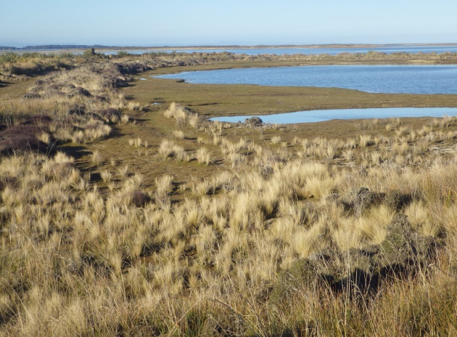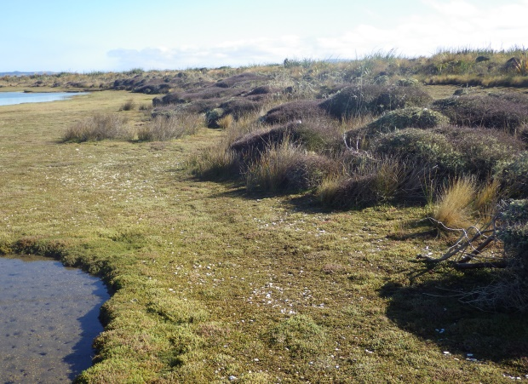
Plates 8-9: Examples of estuarine habitats where the remuremu looper moth is
found in the Tiwai Peninsula - Seaward Moss area, with short tussockland
shrubs and local of saltmarsh ribbonwood.

Monitoring should be repeated annually, as was done in 2017-2018. It would be useful to re-monitor in April 2021, and evaluate the population trend.

Foveaux pink underwing moth

Background

The Foveaux pink underwing moth is an undescribed Meterana species in the Noctuidae Family. Elsewhere in Aotearoa/New Zealand there are two similar species of Meterana which have been described formally which, like the Foveaux pink underwing moth, have caterpillars that feed solely on sub-shrubs of Pimelea (Thymelaeaceae). These three closely-related species are:

- Meterana pictula - northern pink underwing moth, distributed in alpine areas of the North Island, and western South Island coastal areas from northwest Nelson to Fiordland
- Meterana meyricci - alpine pink underwing moth is distributed in montane and alpine areas of the South Island, mainly on the eastern side of the Main Divide
- Meterana new species - Foveaux pink underwing moth (see Plate 10: adult and caterpillar) is known to occur in sand dunes at Mason Bay on Rakiura/Stewart Island, on Whenua Hou/Codfish Island to the west of Rakiura/Stewart Island, and in three places along the southern coast of the South Island at Tautuku Beach, Three Sisters sand dune, and Tiwai Peninsula.

Identification

The Foveaux pink underwing moth has a wingspan of 35-38mm. Males and females are identical. The forewings are dark greenish with a whitish patch while the hindwings are a distinctive pink shade (Plate 10). Caterpillars are fat and bright green with three yellow and white dorsal strips and a white lateral line with a thin red line below it. The adult moths are unmistakable with no look-alikes in the area.

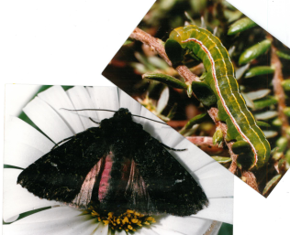
Plate 10: Foveaux pink underwing moth is an undescribed noctuid species in
the genus Meterana, with similar-looking male and females. Its elegant green
caterpillars feed only on subshrubs in the genus Pimelea, two species of which
are found along the southern South Island coastline.

Distribution

The Foveaux pink underwing moth was discovered in 1986 at Three Sisters sand dune on the western coastline between Invercargill and Bluff, (Patrick 1994) and has since been found at Mason Bay on Rakiura/Stewart Island (Patrick et al. 1989), at Tautuku Beach in the Catlins, at Sealer Beach on Whenua Hou/Codfish Island which lies west of Rakiura/Stewart Island, and more recently on Tiwai Peninsula (Patrick 1994). Typical habitat on Tiwai Peninsula is shown in Plate 1 above.

Ecology

The Foveaux pink underwing moth appears to have small populations at all of its known localities, probably reflecting that these sand dune systems have been reduced in extent and degraded since European settlement. At all these locations it is associated with the local Pimelea sub-shrub species on which its caterpillars have been found and, in some cases, successfully reared to produce adult moths (Plate 10). The daphne species involved are Pimelea lyallii (Tautuku Beach, Three Sisters sand dune, Whenua Hou/Codfish Island and Mason Bay), and P. prostrata (Tiwai Peninsula).

Eggs are laid in groups (six millimetre patches) anywhere on host plant foliage and Despite having bright coloration, the caterpillars are extremely well camouflaged, resting on their host plant during the day and feeding at night. If they are available, they will initially feed on the newly-formed buds of their host plant. The pupae form in a silk-lined cocoon just under the surface sand beneath the host plant. Adult moths have been found at these sites between November to April, perhaps indicating that two generations are produced each year. Like most other noctuid moths, the species is active at night, on the warmest, calm evenings. It has been seen taking nectar from both indigenous and exotic flowers and it is also attracted to lights, similar to other noctuid moths.
Monitoring Methodology

The Foveaux pink underwing moth is active at night, so a generator-powered light trap using a 160-watt ultra-violet bulb (Plate 11) is the most effective way to attract them and to effectively assess the number of active adults.

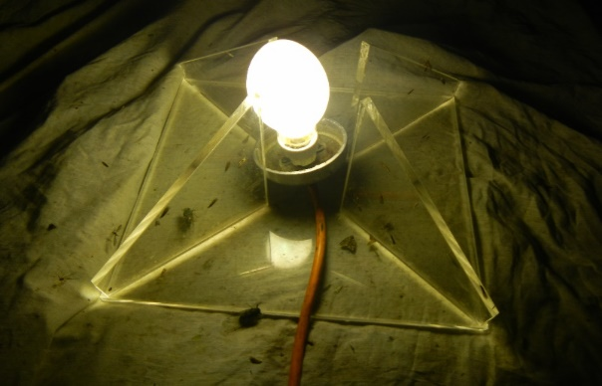
Plate 11: Light trap set-up which effectively attracts adults of the Foveaux pink underwing moth. The bulb is powered by a portable 240 volt generator.

Monitoring process:

- Choose a calmish, dry and warm night at the time of year that adult moths are active.
- Find a flat and bare sandy area amongst a good population of its host plant Pimelea. One site is sufficient.
- Set up light-trap system over a large white sheet (Plate 11), and wait patiently.
- Collect each target moth as it arrives and release them later. Keep in a cool dark place until released.
- Light-trap for one hour following the first capture.

Tiwai boulder copper butterfly

Background

A suite of boulder copper butterfly species in the genus Lycaena (Lycaenidae) are distributed around the New Zealand coastline in naturally-open habitats such as lowland grasslands, dune hollows, and river mouths. Elsewhere they are found in open montane areas up to the low alpine zone. Their main larval host plant is creeping pōhuehue (Muehlenbeckia axillaris), but they also utilise the much less common and sprawling M. ephedroides and Rumex flexuosus; all of which are in the Polygonaceae family.

The species was discovered on 3 November 1980 at Tiwai Peninsula (Plate 1) by the author who subsequently found it at two other south coast sites by 1984 (Patrick 1983 and 1994). It is morphologically and genetically distinct from its closest relatives, with white undersides on both the forewings and hindwings and white cilia (hairs) fringing the wings. These consistent characters distinguish it from other boulder copper butterflies, of which the closest geographically are in montane and alpine habitats in western and northern Southland (Patrick and Patrick 2012).

They are found in open gravel areas on Tiwai Peninsula amongst the predominantly indigenous short tussock grassland and shrubland habitat (Plate 1), where their host plant mat pōhuehue (Muehlenbeckia axillaris) grows in abundance. Adult butterflies are always relatively close to their larval host plant: mat pōhuehue.

The threat status of Tiwai boulder copper butterfly Lycaena new species will be evaluated at the next meeting of the specialist group to assess rankings for Lepidoptera in 2020.

Identification

Males are bright purple (Plates 12 and 14) and females are orange with brown lines on their veins (Plate 13), with both sexes having a wingspan of about 22 mm.

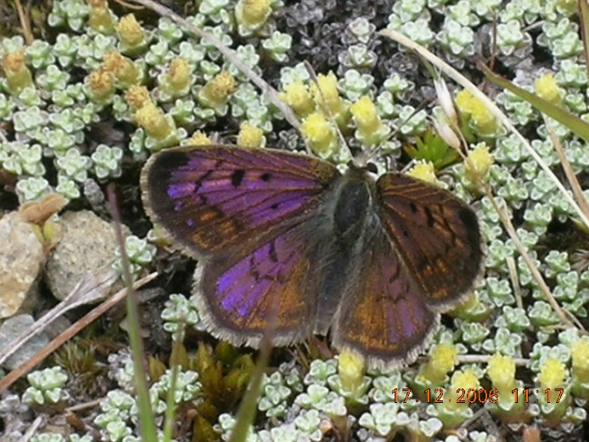 | 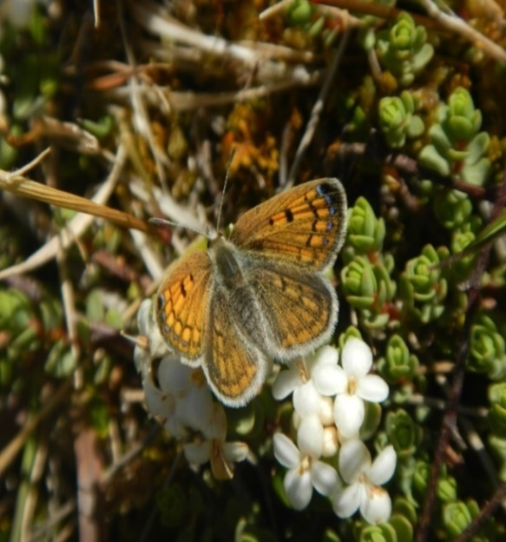
Plates 12 and 13: Male (left) and female (right) of the undescribed Tiwai boulder copper butterfly Lycaena n.sp. are often seen taking nectar from cushion plants such as Raoulia or from sub-shrub Pimelea prostrata.
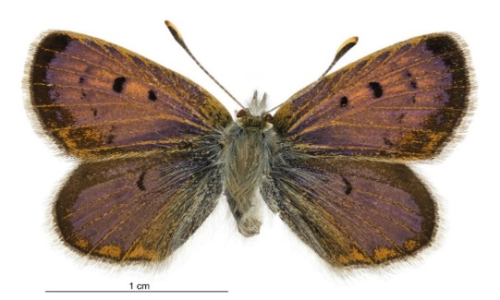
Plate 14: Male Tiwai boulder copper butterfly (Patrick and Patrick 2012).

Distribution

Tiwai boulder copper butterfly is one of New Zealand’s 10 recognised boulder copper butterfly species, six of which are undescribed. It is endemic to the southern Southland coast where it has been recorded at just three sites: Tiwai Peninsula (Plate 1), Waituna Lagoon, and a stony area behind the sand dunes at the northern end of Oreti Beach, all in close proximity (Patrick 1994, Patrick and Patrick 2012). Two other boulder copper butterfly species are present in coastal parts of southern Aotearoa/New Zealand with Chrystalls Beach in South Otago providing habitat for a very rare and localised undescribed species while Milford Sound is habitat to the very range restricted and Threatened Lycaena ianthina.

Ecology

Tiwai boulder copper butterfly is closely linked to the open habitat of its larval host plant, mat pōhuehue. Adults don’t stray far from the plant, sunbathing on it and adjacent bare ground, performing courtship in the same places, taking nectar from the host plant and other nearby flowering herbs, with the female returning to the host plant to deposit white one millimetre long eggs singly on the undersides of leaves.

Two generations are completed each year with adults first seen from late October to December and the second generation of adults from late December to late March.

On Tiwai Peninsula it can be locally abundant in the areas where its larval host plant is also common, with surrounding quartz gravels bare ground.

Monitoring Methodology

Monitoring of the Tiwai boulder copper butterfly was set up in February 2019 (Wildland Consultants 2019a). An appropriate start point was chosen based on the availability and abundance of its larval host plant (mat pōhuehue) and abundant adjacent bare ground. This point was marked and a grid reference was recorded. A different monitoring site may be chosen next time based on the availability of host plants.

Five 10-minute counts were undertaken in the warmest part of the day. Counts were made by walking slowly through the open habitat where the species was active over and close to its host plant and were also ‘sunbathing’ on adjacent bare ground. Care was taken not to disturb the target species and to limit the counts to a radius of 30 metres of the centrepoint.

Now that this monitoring has been set up, it should be repeated every three years. Initially this would be to assess any changes in the numbers of the species, which could reflect habitat changes or other factors that need to be managed to maintain this threatened species and its habitat.

Monitoring process:

- Chose a suitable fine, sunny and calm day within the flight season for species.
- Identify a central point for the monitoring site that is in the middle of excellent habitat for its host plant, mat pōhuehue. Record the grid reference for the central point.
- Undertake five 10-minute counts of adults within a 30 metre walking radius of this centrepoint and record numbers. Minimise disturbance of the moths while walking over their habitat.
- Monitor adult butterflies at the same or similar sites annually until adequate counts have been achieved.

SUMMARY

The south coast of Aotearoa/New Zealand’s South Island is habitat for a range of rugged natural communities that harbour a suite of distinctive and charismatic Lepidoptera species, some of which are endemic to this stretch of coastline.

To retain this assemblage of special indigenous biodiversity which is confronted by multiple threats - such as recreational use, corridors of infrastructure, adjacent industry, and exotic weeds and pests - conservation managers need to have a good understanding of population numbers and trends for key species.

Three moth species and one butterfly have been chosen for monitoring. These four species - representing three different families of Lepidoptera - include a diurnal moth and butterfly, a moth that is active in the early evening but easily disturbed by day, and a nocturnal moth. Monitoring of this variety of Lepidoptera, with their diverse life histories will provide useful information on the conservation status of the individual species and their habitats.

While there are differences in the detail of each monitoring regime, there are some general principles in common:

- Familiarisation with each species in the field by the personnel undertaking the monitoring, prior to starting the monitoring. This report and associated photographs is a good place to initiate familiarisation with each species and its habitat.
- Ensure that weather conditions and time of year are suitable for adult activity of the target species. Any compromises will inevitably produce results that will result in uncertainty rather than elucidation of the conservation status of the target species.
- Take comprehensive notes and use the same spreadsheets from previous monitoring.

ACKNOWLEDGMENTS

Sarah Crump of the Murihiku office of the Department of Conservation in Invercargill is thanked for providing encouragement and resources over the years to undertake surveys and monitoring of this suite of special south coast Lepidoptera.

REFERENCES

Barker M., Brett T., Darby J., Dugan J., Hubbard D., Johnson P., Mladenov P., Patrick B.H., Peake B., Probert K., Smith A., and Spenser, H. 2003c: The Coast. In: The Natural History of Southern New Zealand. Edited by John Darby, R. Ewan Fordyce, Alan Mark, Keith Probert, and Colin Townsend. Chapter 12; Pp 265-310. University of Otago Press. 387 pp.
Hoare R.J., Dugdale J.S., Edwards E.D., Gibbs G.W., Patrick B.H., Hitchmough R.A., and Rolfe J.R. 2017: Conservation status of New Zealand butterflies and moths (Lepidoptera). New Zealand Threat Classification Series 20. Department of Conservation, Wellington. 13 pp.
Patrick B.H., Hoare R.J.B., and Rhode BE. 2010: Taxonomy and conservation of allopatric moth populations: a revisionary study of the Notoreas perornata Walker complex (Lepidoptera: Geometridae: Larentiinae), with special reference to southern New Zealand. New Zealand Journal of Zoology 37: 257-283.
Patrick B.H., Rance B.D., Chisholm W.P., and Barratt B.I.P. 1989: Mason Bay - Entomological and Botanical Survey. Department of Conservation, Southland Conservancy Technical Series No. 2: 50 pp.
Patrick B.H. and Patrick H.J.H. 2012: Butterflies of the South Pacific. Otago University Press. 240 pp.
Patrick B.H. 1983: Moths of the Awarua Bay area. Forest and Bird No. 230: 14(8): 15-18.
Patrick B.H. 1994: The Lepidoptera of the southern plains and coast of New Zealand. Miscellaneous Series No. 17. Department of Conservation, Dunedin. 43 pp.
Patrick B.H. 1998: Coastal Moths: In Place of Butterflies. Forest and Bird No. 289: 24-27.
Patrick B.H. 2014: Life on the edge - the story of a southern geometrid moth Asaphodes frivola. Butterflies and Moths of New Zealand No. 9: cover image and Pages 4-5.
Patrick B.H. 2019: Notable Notoreas. Butterflies and Moths of New Zealand No. 31: 7.
Patrick B.H. 2020a: New Zealand’s native daphne moths. New Zealand Post Limited Edition, Collector’s Pack. 17 pp.
Patrick B.H. 2020b: Daphne moths - New Zealand Post Stamp Issue. Butterflies and Moths of New Zealand No. 32: 3-4.
Wildland Consultants 2014: Ecology and conservation of the rare moth Asaphodes frivola. Wildland Consultants Ltd Contract Report No. 3420a. 27 pp.
Wildland Consultants 2015: Conservation and ecology of the rare remuremu looper Asaphodes frivola. Wildland Consultants Ltd Contract Report No. 3420b. Prepared for Department of Conservation. 23 pp.
Wildland Consultants 2017: Ecology, conservation management, and monitoring of the Remuremu looper moth Asaphodes frivola. Wildland Consultants Ltd Contract Report No. 3420c. Prepared for Department of Conservation. 28 pp.
Wildland Consultants 2019a: Monitoring of two Lepidoptera species on Tiwai Peninsula, Southland. Wildland Consultants Ltd Contract Report No. 5032. Prepared for Department of Conservation. 7 pp.
Wildland Consultants 2019b: Factsheet: three South Coast Lepidoptera. Wildland Consultants Ltd. Prepared for Department of Conservation. One page colour factsheet.

APPENDIX 1

Fact Sheet: three south coast lepidoptera

