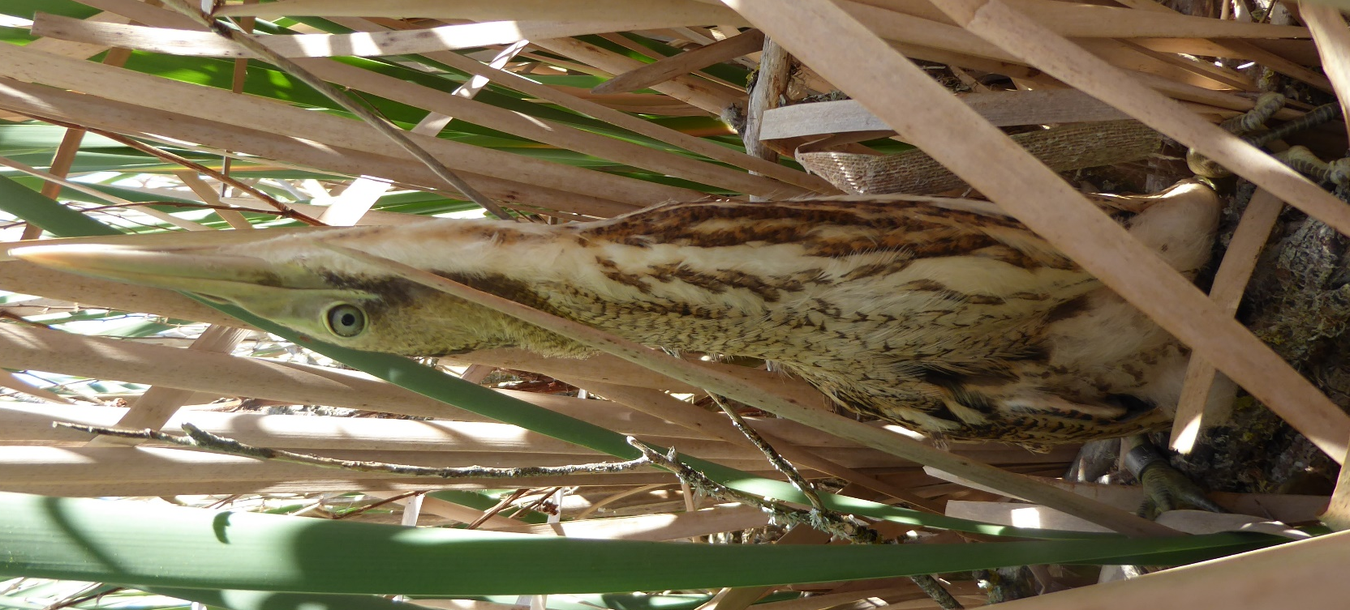 | Wairarapa Moana Bittern/Matuku Management Strategy  DRAFT 29/06/18  Dr Emma M. Williams  June 2018

Contract report to Department of Conservation
Cover picture
Juvenile female matuku blends perfectly into a raupō dominated habitat. Copywrite: Emma Williams

Acknowledgements
This document is the product of 10 + years of working on matuku in New Zealand. During this time, I’ve been fortunate to work with multiple passionate matuku-focused teams nationally and had regular contact with some inspirational bittern researchers internationally. I’m very grateful for the many in depth conversations I’ve had with coworkers and team members over the years, that have helped me to put observations and results into context. In particular, I’d like to acknowledge and thank (in no particular order): Colin O’Donnell, John Cheyne, Gail Cheyne, Hans Rook, Matthew Brady, Lynette Plenderleith, Elise Verschoor, Kevin Hutchinson, Shay Dean, Kaitlin Morrison, Bernie Kelly, Sarah Crump, Karl McCarthy, Matthew Herring, Gillian Gilbert; and my PhD supervisors Doug Armstrong and Phil Battley.
I’d also like to thank the Department of Conservation staff at Masterton (Briggs Pilkington, Anna Burrows and Tony Silbery) for giving me the opportunity to write this document and Ducks Unlimited for their additional insight into wetland conservation and Wairio wetland.

Summary
- Matuku or Australasian bittern is a critically endangered wetland bird. It is a top predator in wetlands and a key flagship species for wetland health.
- Matuku were once common around Wairarapa moana. Despite their numbers being reduced, the lake still supports a nationally important population. Because of the large size of remaining wetland areas, and widespread interest in a healthy lake system, the area has considerable restoration potential for matuku.
- More than most endangered species in New Zealand, matuku are threatened by a complex array of factors including habitat loss and degradation, loss of food supplies, poor water quality, unsuitable and often erratic water level regimes, predation by exotic mammals, weed encroachment and disturbance.
- Relatively little is known about the ecology and requirements of matuku because they are difficult to find and study. However, we know matuku have a range of specialist requirements including access to clear shallow water under reed-beds for feeding and breeding. Additionally, we know that home range sizes for the species are large, and most populations rely on extensive wetland networks to sustain themselves throughout their annual cycle.
- In addition, management practices are well developed for other bittern species overseas. These provide a baseline template for managing the species in New Zealand. To address knowledge gaps, management practices should be applied as a series of management experiments, under an adaptive management framework, so that the effectiveness of these practices can be determined at the same time as threats are being addressed.

- MANAGEMENT RECOMMENDATIONS:
The objective of managing matuku at Wairarapa moana should be to: (a) maintain and enhance matuku populations at 14 areas that have been identified as priority sites, and (b) to restore habitats at degraded wetlands around the remainder of the shoreline, as well as restore any other sites identified as suitable in the regional network.
Recovery will require an integrated approach to managing multiple threats and the involvement of the full range of stakeholders interested in managing Wairarapa moana. Management can be achieved by:
- Maintaining a mosaic of habitats with shallow water and tall, dense, reed-like vegetation. Based on current knowledge, recommended water levels for breeding range from 20-75 cm for nesting, while water depths of 15-25 cm appear optimal for feeding; Achieving this may require active profiling of wetland edges to achieve penetration of fish foods into shallow reed-beds;
- Enhancing feeding and breeding habitats by:
  - Managing spring water levels so that they provide shallow water in breeding habitats, then hold levels stable across the breeding season. Options for this include use of bunds, sluices and weirs on a site-by-site basis so that water levels can be managed specifically for matuku;
  - Removing problem weeds that encroach on matuku habitats;
  - Improving appropriate reedbed cover in suitable areas by encouraging regeneration or replanting.
  - Actively managing reed-beds to improve the shape and density to optimise for matuku.
- Controlling predators, particularly mustelids and feral cats, in all feeding and breeding habitats. This should include trapping in buffer areas in surrounding farmland to reduce the frequency of reinvasion.
- Encouraging research on the ecology and adaptive management of matuku to improve conservation activities over time, particularly studies into enhancing aquatic food supplies and optimal water level regimes by:
  - Determining ways to enhance food supplies, particularly freshwater fish populations;
  - Trialling different water level management practices to: (a) confirm optimum water levels, (b) confirm optimum timing of water level interventions; and (c) establish whether prolonged periods of high water levels in spring can increase the chances of double clutching of nests.
- Monitoring long-term responses to management so that management can be adapted and improved with increased knowledge by undertaking annual call count surveys (to detect male booming matuku) at: Boggy Pond, Matthews Lagoon, Wairio wetland, Barrage gates, Lake Pounui, Alsops Bay, Barton’s Lagoon, Tauherenikau River delta, Pierce Block, Dune Block, Sheep Hill Lagoon, Lake Onoke, Tauherenikau delta and Papatahi Neville Davies wetland.
- Minimising disturbance of feeding and breeding sites, including:
  - Moving high-noise sports away from priority matuku management areas (e.g. trail bikes, 4-wheel drive vehicles, motorised boats);
  - Establishing shooting-free areas in priority matuku habitats;
  - Careful location and management of passive-activities (walking, biking) including avoiding matuku breeding areas.
- Protecting and sustaining habitats by undertaking education and advocacy to reduce risks of human impact, including:
  - Ensuring fish passage and wetland connectivity, including using statutory advocacy and working with other management agencies and neighbours;
  - Protecting small pockets of wetlands in the surrounding catchment to encourage habitat linkages in the regional wetland network;
  - Developing drain maintenance guidelines to maintain values in surrounding habitat matrix;
  - Undertaking advocacy with adjoining landowners regarding sediment and nutrient management;
  - Working with regional and district planning authorities to ensure appropriate biodiversity protection rules in local plans;
  - Making appropriate RMA submissions if necessary regarding developments that impact on water and habitat quality;
  - Working with partners/neighbours/volunteers regarding riparian plantings and pest control and encouraging development of one or more local wetland care groups.
- Develop a long-term land purchase strategy to grow the size of management areas and buffer from external effects (e.g. climate change).
Table of Contents
ACKNOWLEDGEMENTS 2

SUMMARY 3

1.0 INTRODUCTION 9
1.1 Conservation status of matuku 9
1.2 Legislative status of matuku 9
1.3 Former distribution 10
1.4 Status of matuku at Wairarapa moana 10
1.5 Objectives of management strategy 11

2.0 IMPORTANT SITES FOR MATUKU AT WAIRARAPA MOANA 12
2.1 Historically important sites 12
2.2 Important habitat types 13

3.0 ECOLOGICAL REQUIREMENTS - CURRENT KNOWLEDGE 16
3.1 Matuku behaviours and habitat requirements during the breeding season 16
3.2 Food and feeding behaviours 17
3.3 Seasonal movements and habitat requirements 17
4.0 REASONS FOR DECLINE (THREATS) 19
4.1 Threats to food supplies and foraging restrictions 19
4.2 Water level extremes 20
4.3 Water quality, sedimentation and turbidity 21
4.4 Predation 22
4.5 Weed encroachment 22
4.6 Disturbance 22
4.7 Sea level changes, climate change and natural disasters 23
4.8 Interactions among threats 24

5.0 PLANNING MANAGEMENT 25
5.1 Adaptive management approach 25
5.2 Collaborations 25

6.0 POTENTIAL MANAGEMENT ACTIONS FOR MATUKU RECOVERY 26
6.1 Maintain and enhance wetlands specifically for matuku 26
6.2 Specific enhancements for breeding 27
6.3 Specific enhancements for feeding 29
6.4 Habitat outside of core breeding areas (wintering sites) 31
6.5 Managing problem weeds 31
6.6 Predator control 33
6.7 Managing recreational disturbances 34
6.8 Anticipating seas level rise and future considerations 35

7.0 REFERENCES 39

8.0 APPENDICES 40

1.0 Introduction
  - Conservation status of matuku
Australasian bitterns, (Botaurus poiciloptilus; hereafter matuku) are a cryptic, difficult to detect species that rely on wetlands to feed and breed. Found only in New Zealand and Australia, this species is classed as Endangered by the IUCN (BirdLife International 2014) and has recently been classed as Nationally Critical, New Zealand’s most severe threat classification (Robertson et al. 2017). Additionally, matuku is known to be the rarest of the bittern subfamily (Botaurinae; Williams 2016), and is categorised as being in ‘serious trouble’ by the Parliamentary Commissioner for the Environment (2017). Population estimates are less than 1000 per country and reduction in its range is known to be steep (> 90% in Australia; Buchanan 2009, > 50 % in New Zealand; O'Donnell & Robertson 2016).
Several parties are becoming concerned about matuku nationally, especially since the recent change in threat classification. These include: Department of Conservation, Regional councils, District councils, iwi/hapū and community groups. As a result, new matuku-focused projects are starting, with the objectives of identifying sites of importance, clarifying reasons for declines, and restoring habitats using adaptive management practices. Aside from the need to conserve matuku, the species also has an important role in wetland conservation as they share many characteristics of a good flagship or umbrella species (Simberloff 1997; E. Williams unpubl. data), something that is rarely available for many freshwater conservation programmes (Kalinkat et al. 2017).
Despite the seriousness of this species status, little is known about the precise nature of threats affecting the species and causes of decline (Kushlan 2007, O'Donnell 2011). However, several threats that are known to affect Botaurus species overseas also exist in New Zealand, suggesting a wide variety of factors could be contributing to population declines. Such threats include: habitat loss and degradation, loss of optimal food supplies, disturbance, poor water quality, unsuitable and often erratic water level regimes, weed encroachment and predation (O'Donnell 2011).
  - Legislative status of matuku
Aside from the conservation status of the species, matuku are ‘Absolutely Protected’ under the Wildlife Act 1953. This means that under Section 63 of the Act, it is an offence to kill, hunt, possess, molest or disturb the species without proper authority. However, although this legislation provides complete protection for matuku (and parts of matuku), this Act provides no protection for habitats that are essential for matuku survival. Radio-tracking studies conducted to date show that matuku often use a range of areas that do not have reserve status. The recognition of these habitats as sites of significance for matuku is possible through Section 6 c of the Resource Management Act (1991), but only if distributional data are available.
  - Former distribution
Historically, matuku were distributed throughout New Zealand, with key North Island strongholds being associated with Waikato, Northland and Auckland; while the stronghold for the South Island was Canterbury and the West Coast (O'Donnell & Robertson 2016). More recently, the population is known to have contracted, now representing < 50% of its former range (O'Donnell & Robertson 2016). Historical records show that Wellington was one of the earliest regions to experience a decline in matuku populations, with this decline shown to be particularly steep post-1970 (Stidolph 1939, Hill 1963, O'Donnell & Robertson 2016). Such a decline is no surprise given matuku have specialist habitat requirements and 90% of wetlands have been lost nationally (Ausseil et al. 2011), with the remaining 10 % being under threat (Cromarty & Scott 1995). This wetland loss has been particularly extensive within the Wellington region (97.7 %; Ausseil et al. 2008).
  - Status of matuku at Wairarapa moana
Wairarapa moana is one of the largest wetland complexes in the North island. Situated within the Wellington region, the site extends 10,300 hectares from Palliser Bay and Onoke spit on the coast, to Lake Domain, which is just South of Featherston (Figure 1). Despite its size, Wairarapa moana has experienced large habitat losses. The most substantial of these management interventions occurred in the 1960’s and 1970’s (Graeme & Dahm 2018) and included diverting the Ruamahanga River, draining over 1200 ha of wetlands; constructing a causeway; reducing the size of Lake Onoke, and habitat degradation of several upland streams and wetlands (Graeme & Dahm 2018). Since then, the wetland complex has suffered from poor water quality, poor water clarity, and occasional algal blooms (Graeme & Dahm 2018).
The effect of habitat loss on the matuku population occurred early on, with “20,000 acres” of bittern habitat reportedly removed from the area in the 1960’s (Hill 1963). Today, the Wairarapa Ecological District has only 13.2 % of the wetland vegetation that was present in the 1850’s (Beadel et al. 2000), and threats from eutrophication, the spread of invasive plants such as willow (Salix sp.), alder (Alnus glutinosa), tall fescue (Schedonorus arundinaceus) and Hornwort (Ceratophyllum demersum) are ongoing (Wildlands Consultants 2013). However, regardless of habitat losses, this wetland complex has acted as a rare and valuable remnant allowing matuku populations within the region to persist, perhaps in part because of its large size.

  - Objectives of management strategy
The objective of this document is to outline a strategy for addressing knowledge gaps and describe opportunities for managing and restoring matuku populations at Wairarapa moana wetlands. As matuku are a data poor species, the approach of this document is to examine what is known about matuku nationally and apply this to the context of Wairarapa moana. As Wairarapa moana is a wetland complex and matuku have yet to be studied there in detail, I will also outline the limitations of this approach and suggest ways to address these limitations to further our national knowledge of matuku. To do this, I summarise the following:
- The national significance of Wairarapa moana for matuku and the historical importance of sites within the Wairarapa moana complex.
- What is currently known about the reasons for decline (threats) in matuku populations.
- Potential management actions that are already available for use in an adaptive management framework to assist the recovery of matuku populations.
- Methods that are currently available to monitor population responses to management actions, and where and when to apply these methods.
- Existing knowledge gaps.

  - Important sites for matuku at Wairarapa moana
  - Historically important sites
Historical records show that since 1900, matuku have been found at a broad range of sites throughout the Wairarapa moana complex, with most records on the eastern and north-eastern shores (Figure 1; Department of Conservation National Bittern Database). These records indicate matuku use 14 key wetland areas around Wairarapa moana (boundaries highlighted in blue, Figure 1) and birds are present in the wetland complex across all seasons (Appendix 1).
Recent call count surveys (conducted within last 10 years) show male matuku regularly boom (and thus, at least attempt to breed) in five areas of Wairarapa moana (Boggy Pond, Matthews Lagoon, Wairio wetland, Barrage gates and Sheep hill lagoon (Figure 1) (2012 to 2016; Cheyne 2015). Cheyne (2015) showed that numbers increased slightly at Boggy Pond (2 to 4 booming males), Matthews Lagoon (1 to 2 booming males) and Wairio wetland (2 to 3 booming males) between 2012 and 2015 . Additional sites that have historically been utilised by matuku include Alsops Bay, Turner’s Lagoon, Barton’s Lagoon, Tauherenikau River delta, JK Donald Reserve, Pierce Block, Dune Block, Sheep Hill Lagoon, and Lake Onoke but I am unaware of any long-term breeding surveys at these sites. Hence, historical records support these sites as being of high regional importance for matuku, warranting further survey work (Figure 1).
  - Important habitat types
Sites where matuku have been recorded most frequently are in mosaics of open water and reedlands, dominated by raupō (Typha orientalis), Isolepis prolifer, Juncus spp., and Carex geminata with occasional willows (Salix spp.) (Plate 1 and 2, Appendix 2). Also present in matuku habitats, but less prevalent, are species such as Bolboschoenus fluviatilis, Schoenoplectus tabernaemontani, Apodasmia similis, and Festuca arundinacea (Appendix 2; Wildlands Consultants 2013). In general, most sites had both breeding and non-breeding season records, suggesting food sources may be sufficient at each site so that matuku do not need to move large distances seasonally (Appendix 1). Recent surveys confirm the importance of raupō reed-beds for breeding matuku, as most booming males were consistently found in these habitats during the breeding season (Cheyne 2015). The only exception was one booming male that was consistently found in an area of Apodasma similis/Isolepis sp. (Plate 3) (Cheyne 2015). National booming and breeding records also suggest Apodasmia similis is an important breeding habitat for matuku particularly in coastal regions (O'Donnell 2011; E. Williams pers obs).

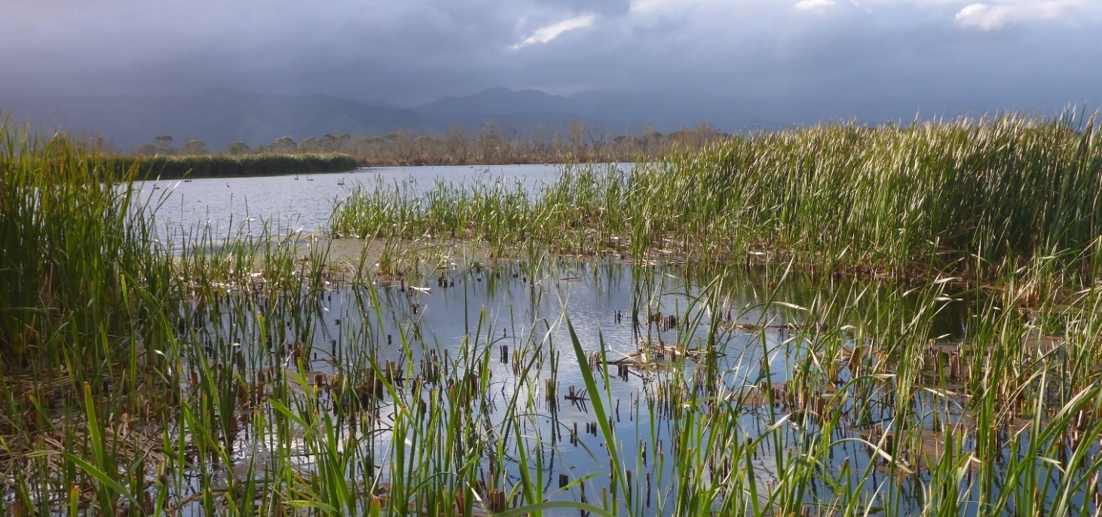
Plate 1: Matuku breeding habitat at Boggy Pond. Typha orientalis in the foreground with a mosaic of open water. Photo: E. Williams.
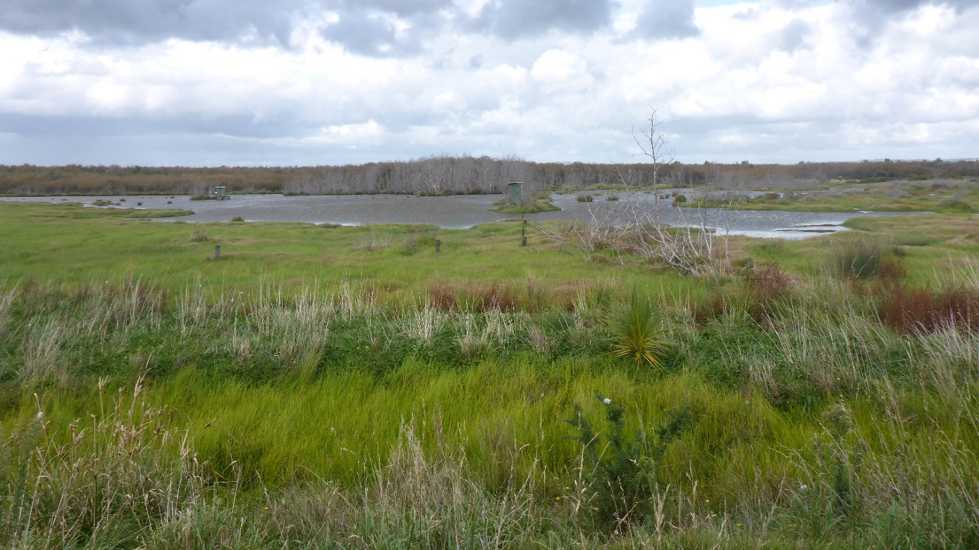
Plate 2: Matuku feeding habitat in the Tauherenikau River Delta. Isolepis sp. in the foreground with a mosaic of open water, Myriophyllum propinquum, Carex sp., and Festuca arundinacea in the background. Photo: E. Williams.
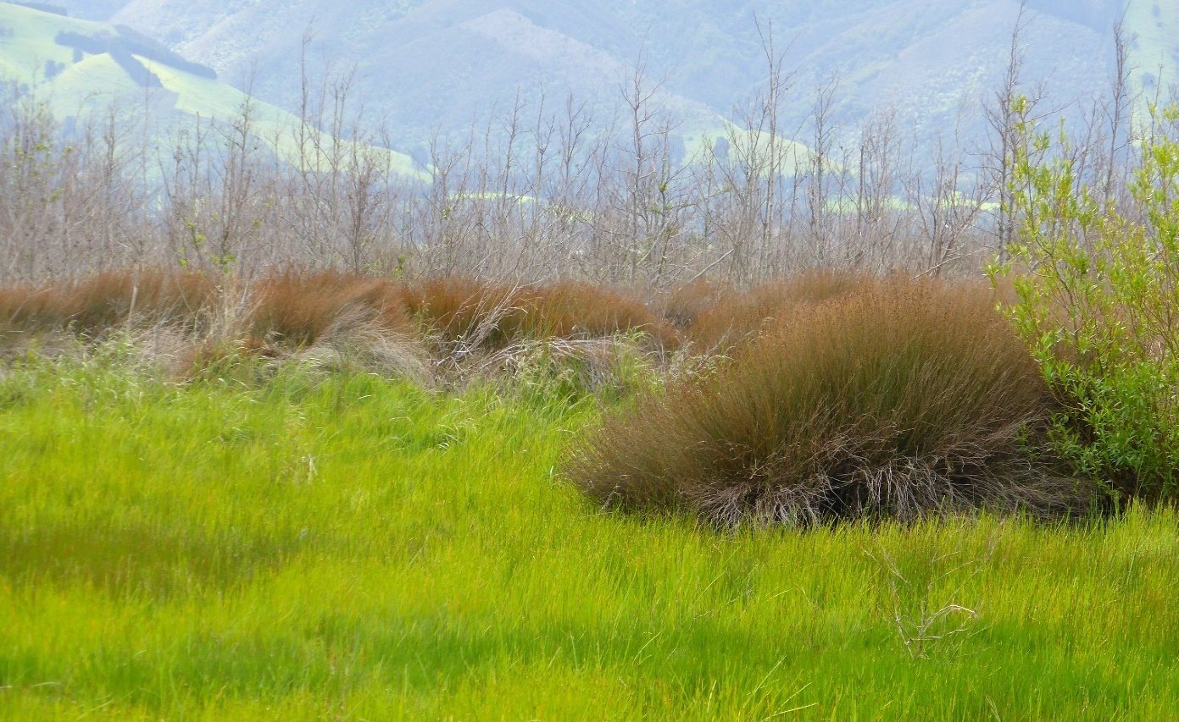
Plate 3: Matuku have also been known to boom and breed in areas of Apodasma similis/Isolepis sp. Photo taken at Wairio wetland, 2013 by Colin O’Donnell.

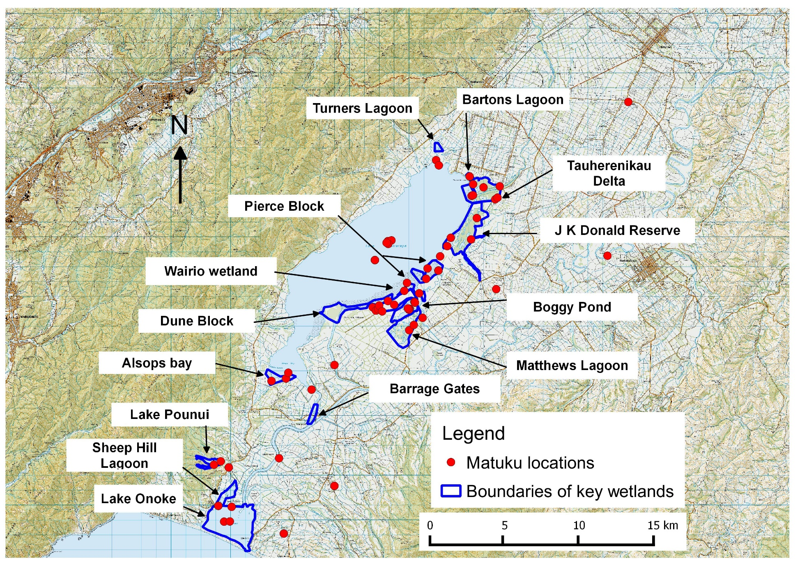
Figure 1: Historical matuku records in and around Wairarapa moana wetlands. Taken from the Department of Conservation National bittern/matuku database. Note records in the centre of Lake Wairarapa and Lake Onoke had insufficient locational information to plot accurately.

- Ecological requirements - Current knowledge
The Australasian bittern is one of the most understudied Botaurus species (Williams, 2016), and as such, has many behaviours and ecological requirements that are still not well understood. Despite this, the few studies that have been done to date suggest that internationally, Botaurus species share similar behaviours, ecological needs and threats (Teal 1989, Whiteside 1989, White et al. 2006, Williams 2016). This suggests that information can be inferred from closely related species, to allow management to commence in New Zealand, while knowledge gaps are being addressed through associated research programmes. However, for such an approach to work it is important that managers recognise the limitations of current knowledge and take care to apply management interventions under an adaptive managing framework. The importance of such an approach is discussed further in section 5.1. To assist mangers in designing adaptive management approaches, the section below outlines what is known about matuku and what is inferred from closely related species.
  - Matuku behaviours and habitat requirements during the breeding season
Research conducted to date shows that in New Zealand matuku breed during a short season in spring, laying eggs between September and December, and rearing chicks between October and February (chick rearing appearing to peak in December; O’Donnell, 2011). The earliest indication of breeding is the sound of male matuku booming, a low resonant call that is produced by all Botaurus species and is associated with mate attraction and territory defence (Teal 1989, Puglisi & Bretagnolle 2005, Polak 2006). Historical records show that booming can occur in any month of the year, but usually peaks from mid-September to mid-November (O'Donnell 2011, Williams et al. 2018a; hereafter referred to as the ‘booming season’). Within the booming season, calling is known to be predictable with optimum times and conditions for booming males being identified as 1 hour before sunrise or within the first 30 minutes after sunset, when there is no rain and moon visibility is highest (Williams et al. 2018a). Studies done to date, show that home range sizes of male matuku vary from 1.71 to 25.66 ha during the breeding season, with core booming areas being < 1.16 ha (Teal 1989, Williams 2016).
In more well studied Botaurus species, females are known to visit males early in the booming season and choose their mates based on boom quality/fitness and several habitat characteristics associated with breeding success (Poulin & Lefebvre 2003). In New Zealand, male matuku boom in dense beds of reeds/rushes, most frequently dominated by raupō or Bulboschoenus sp. Data from Whangamarino wetland, show matuku boom in mean water depths c. 5 cm (n = 5); and tall stem heights c. 80 cm (n = 5) (Williams & Cheyne 2017). Males are polygynous, and booming males have been known to have 0 – 5 nesting females within 200 m of their core booming areas (Teal 1989; E. Williams pers. obs). Limited nest records from New Zealand suggest female matuku build semi-floating nests in reed-beds with shallow water 20-60 cm deep (86%, n = 21 nests; O'Donnell 2011).
  - Food and feeding behaviours
In New Zealand, no formal foraging or dietary studies have been done on matuku, which is in part due to the cryptic and secretive nature of the species. Matuku often forage within or along the edges of thick vegetation, making feeding behaviours and prey items a challenge to observe. Despite this, much can be inferred from the anecdotal observations that do exist and dietary studies that have been done overseas. In general, matuku diets appear to be diverse, and opportunistic. A wide range of native or non-native prey items have been reported including fish, amphibians, small birds, rodents, lizards, large invertebrates, arachnids and crustacea (Reischek 1885; Oliver 1955; Moon 1967; Edgar 1972).
The most common component of their diet is reported to be medium-sized freshwater fish, particularly eels (Anguilla spp.) (Buller 1888; Potter 1950; Whiteside 1989; E. Williams pers. obs.), with lengths up to 20 - 60 cm reported (Buller 1888; Potter 1950; Whiteside 1989; E. Williams pers. obs.). Observations of introduced fish species being preyed upon by matuku in New Zealand include gold fish (Carassius auratus), mosquito fish (Gambusia affinis) and trout (Sp. unknown) (Edgar 1972; E. Williams pers. obs.). Sizes of non- aquatic prey species also support the notion that small to medium sized prey are taken, with rats (Rattus spp.) being the largest mammalian prey item recorded, and other commonly reported prey items including small species such as mice (Mus musculus), frogs and frog tadpoles (Reisheck 1885; Drew 1896; Soper 1958).
Most observations of foraging matuku suggest the species relies on the ability to stalk, sight and stab their prey in clear water (E. Williams, pers. obs.). For example, matuku are most often seen walking slowing along the edge of tall vegetation (reeds and rushes) with their necks out stretched looking for prey. They are rarely seen foraging out in the open and appear to favour areas where they can forage completely out of view or have the option to hide quickly if required.

  - Seasonal movements and habitat requirements
Results from two radio-tracking studies conducted in New Zealand to date, show that in general, males have high site fidelity within and across breeding seasons, but are more transient and have larger home ranges during the non-breeding season (Teal 1989, Williams 2016; E. Williams unpubl.). Preliminary radio tracking studies of 24 matuku in Hawkes Bay, Canterbury, Waikato and Bay of Plenty show that males tend to occupy breeding territories between July and December, then move to numerous non-breeding sites across the rest of the year. The longest distance moved to date was a rehabilitated juvenile female matuku from Canterbury (< 1 year old). After release, she moved c.145 km between the Waimakariri and Opihi Rivers over three months (E. Williams unpubl. data).
In Hawkes Bay region, radio-tagged male matuku visited a complex mosaic of > 9 wetlands outside of the breeding season. Most of these birds stayed within a c.20 km radius of their breeding site, feeding in habitats that included spring creeks, swamps, and farm dams, often with raupō present (7 out of 10 males radio-tagged; E. Williams unpubl. data). Any matuku that appeared to move beyond this radius (and therefore could not be followed across all seasons) returned for the booming season during the following spring. Nationally, only one radio-tagged matuku, occupying estuarine habitat in Bay of Plenty, has been sedentary over the 18 months it has been tracked to date (E. Williams unpubl. data).
Studies at Whangamarino wetland in Waikato, charactering seasonal habitat requirements, suggest that matuku movements are driven by changes in water levels, with mean water depths of c. 15 cm (± 6 SD) preferred for foraging (Williams & Cheyne 2017, Williams 2018). This study also shows that matuku utilise a range of vegetation types for foraging but rely on only a few plant species to breed, largely raupō and Bolboschoenus spp., suggesting daily and seasonal movement patterns may also be defined by whether breeding and feeding habitat are separate and fragmented, or continuous.

- Reasons for decline (threats)
Habitat degradation and loss is one of the most fundamental threats associated with matuku with (> 90 % wetlands drained since Europeans arrived in New Zealand (Ausseil et al. 2011). This is because matuku are habitat specialist birds, relying on wetlands to feed and breed (O'Donnell 2011). The effect of this habitat loss on matuku is likely to be high and the need for habitat restoration and creation self-evident if matuku populations are to recover. Additionally, the 10 % of wetlands that remain are known to be degraded and under threat (Cromarty & Scott 1995, Ausseil et al. 2011). Causes of this degradation, and therefore additional threats likely to impact matuku populations, include threats to food supplies and food accessibility, water level extremes, declining water quality, increased turbidity, predators, sedimentation, and weed encroachment.
  - Threats to food supplies and foraging restrictions
Starvation is of concern in relation to New Zealand’s matuku population. The matuku radio-tracking programme, starting in 2012, has shown that starvation is the most common cause of death of matuku (7 out of 17 birds monitored for > 12 months to date have died; of these mortalities 71.4 % starved (5), 14.3 % = unknown cause of death (1), 14.3 % = hit by car (1); E. Williams unpubl. data). This is no surprise given the extent of wetland loss and the degree of waterway modifications that have been known to disrupt fish supplies by altering community structure, increasing turbidity and reducing food supplies of aquatic vertebrates (e.g. Ryan 1991, Hayes et al. 1992, Rowe 2007). Despite the apparent importance of starvation, we still cannot say how it ranks in relation to other threats to matuku populations. The matuku radio-tracking programme is still in its infancy, and the majority of matuku that have starved are rehabilitated birds (57 % rehabilitated matuku starved, n = 4/7; 10 % of wild caught matuku starved, n = 1/10). However, given that most radio-tagged matuku have being monitored for < 2 years so far (74 % birds; 17 out of 23), insufficient time has passed to determine the long-term effects of starvation on the viability of the population. In the meantime, it’s clear that these cases need to be taken seriously and any potential factors that could affect prey availability, and prey accessibility should be addressed.
Habitat loss, fragmentation and subsequent depletion of food supplies, has also been identified as one of the principle causes of decline of the Eurasian Bittern (Tyler et al. 1998, Gilbert et al. 2003, Gilbert et al. 2005a, Gilbert et al. 2007). The diversity of prey items known to be taken by matuku would suggest they have a degree of robustness against starvation when food availability fluctuates. However, their lack of flexibility in relation to their foraging strategies and specific needs in terms of prey size could limit the species ability to feed in degraded wetlands.
The availability of fish of small to medium size classes is likely to be driven by the availability of their food sources and habitat quality, factors affecting fish recruitment (i.e. availability of spawning habitat and low fish harvesting pressures); and the presence of exotic fish species that prey on indigenous fish (i.e. perch, Perca fluviatilis).
The bulky size of matuku suggests large quantities of prey are required to sustain populations. Indeed, reports of gut content or regurgitate recorded in an individual’s stomach have included as many as: five rats (Reischek 1885); “a silver-eye (Zosterops lateralis), frog, five locusts, a large spider, two common sand-liguras and the remains of a small fish” (Drew 1896); five eels (up to 20 cm in length each); numerous invertebrates including two nursery web spiders (Dolomedes minor), five locusts and a common black field cricket (Teleogryllus commodus) (Whiteside 1989); and four frogs (nest regurgitate, Soper 1958). This does suggest that particularly small prey items that matuku are commonly seen feeding on; such as insects, mosquito fish and frog tadpoles, are unlikely to be able to sustain a matuku population long-term unless they are particularly easy to catch in large quantities. Despite this, such small prey items may still have a role as seasonal food sources that can bridge gaps in availability of preferred food items.
The stalk-stab foraging strategy is used by all species in the heron family, but unlike matuku, other heron species commonly feed in open wetland habitats and have a suite of foraging strategies that allow them to adapt as wetland environments change. In contrast, Botaurus species only have two foraging strategies: stand and wait, or walk slowly, which they almost always do in vegetation cover, making them one of the least adaptable species in the heron family (Kushlan 1976). Such a limited foraging repertoire is likely to penalise matuku survival rates in circumstances where water clarity is poor (meaning aquatic prey items are not visible), water levels are too high/deep (meaning aquatic prey cannot be caught without diving), water levels are too low (meaning aquatic prey items are not present), or there is little or no vegetation in the area where the food sources are available (meaning matuku have to expose themselves in order to forage).
  - Water level extremes
Wetlands are naturally dynamic environments that are driven by seasonal water level changes. The impact of particularly high or low water levels has already been discussed above, in terms of the influence on aquatic prey availability and matuku feeding strategies. To some extent, matuku populations will have adapted to these water level changes, and the natural influence these changes have on prey availability. This is supported by some evidence that matuku follow an asynchronous chick hatching system like that observed in birds of prey, as these behaviours are often associated with species that have erratic prey sources (Clark & Wilson 1981). In addition, the ability of matuku to utilise numerous wetlands throughout year, also suggests they can adapt as wetland conditions change seasonally, provided a sufficient number and diversity of wetland sites remain within their network.
Unfortunately, in recent times, water levels do not change naturally with seasons and are instead controlled and driven by human interventions. A classic example of this can be found at Whangamarino wetland, a site of international importance for matuku with RAMSAR status that is used by the regional council as a second holding pond to keep flood water off farmland (O'Donnell 2014). Hence, water levels are raised suddenly by 1-2 m, flooding the majority of matuku feeding and breeding areas. Research characterising water level preferences and seasonal habitat requirements of matuku at Whangamarino wetland have shown matuku prefer mean water depths of 15.9 cm (± 6.2 SD) for foraging (Williams & Cheyne 2017, Williams 2018).
The limited records of matuku breeding in New Zealand show that they build semi-floating nests within reed-beds. Water depths at nests have ranged from 0-75 cm, averaging 38 cm deep (± 19.8 SD) (Teal 1989; E. Williams unpubl. data, O'Donnell 2011). The use of floating nests and booming platforms allows these structures to rise and fall naturally to some degree with water level fluctuations. If water levels increase slowly, birds have some ability to build up these structures before they are flooded. However, nest movements will not be able to cope with sudden and extreme water level changes.
  - Water quality, sedimentation and turbidity
The effect of poor water quality, high sedimentation and turbidity on matuku populations is likely to be more indirect and is currently understudied. Sedimentation is thought to have a negative impact on matuku because it alters natural water depths, and changes the vegetation composition of matuku habitats so that conditions favour invasive weed species at the expense of reed-beds (O'Donnell 2014). It’s also possible that sedimentation affects food supplies by clogging spaces between pebbles and vegetation, reducing invertebrate populations and the foraging opportunities of many aquatic prey species (Henley et al. 2000). Turbidity and poor water quality are more associated with reduced light penetration, high nutrient loading, reduced phytoplankton populations and, at it’s extreme, lake toxicity (Henley et al. 2000). This in turn impacts matuku as it negatively impacts the health of aquatic prey populations.

  - Predation
Matuku have been identified as one of the species most ‘at risk’ from invasive predators based on their clutch size, clutch frequency, ground nesting behaviours (O'Donnell et al. 2015). To date there have been few observations of predation by introduced mammals. Observations that do exist include two records of feral cats preying on adult matuku (O'Donnell et al. 2015). Nests and young are particularly vulnerable to predators. Three of five nests monitored recently failed. Of these nests, two failed following visits by harrier hawks, and one failure had sign of mustelids being present (E. Williams unpublished data). The few predation records are not surprising given the extremely cryptic behaviour of matuku. However, studies of waterfowl, crakes, rails and waders occurring in similar wetland habitats indicate predation by introduced stoats, ferrets, weasels, feral cats, dogs and rats is frequent, and that these predators are common in most wetlands, thus warranting predator control in wetlands (O’Donnell et al. 2015).
  - Weed encroachment
Weed encroachment is an important threat to the integrity of wetland plant communities. Weeds may out-compete indigenous vegetation, changing the composition by monopolising nutrients and shading out entire understory communities. Weeds such as willows, alder, tall fescue and hornwort are particular problems at Wairarapa moana (Wildlands Consultants 2013). In the context of matuku habitat, willows are a threat to reed-bed nesting areas, dominating such areas if uncontrolled, and rendering them unsuitable for matuku.
  - Disturbance
Matuku habitats are also increasingly being used for a variety of purposes including: duck hunting (with or without dogs); recreational boating; cycleways; and backdrops to parties. As the species is renowned for being secretive and shy, its intuitive that disturbance is a cause from concern. Indeed, there has been cases of matuku nests failing due to disturbance in New Zealand, including at least one case attributed to vandalism (Soper 1958).
Dogs are frequent predators of wetland birds in New Zealand (O’Donnell et al. 2015). Duck-shooting also poses a potential threat. Matuku have frequently been shot in the past, and numerous prosecutions processed (O’Donnell & Robertson 2016). However, whether this still occurs is unknown. Radio-tagged matuku were monitored on the opening day of duck shooting in Hawkes Bay region in 2015. There, all radio-tagged birds left the wetlands they were resident on once duck hunting started, moving to smaller, nearby sites; though none were shot (E. Williams, pers. obs).
Despite these threats, there have been no comprehensive studies on the nature or effect of the full range of disturbances possible. Weston et al. (2012) briefly investigated the effect of disturbances of Australia birds and reports one bittern flushing at a distance of 10 m. However, personal experience has shown that flight distances vary greatly between individual bitterns, with some flushing as soon as you enter a wetland and others holding long enough that they can be captured easily by hand (E. Williams, pers. obs). European bittern literature is equally elusive on the subject with references to the ‘potential for disturbances’ but few details (McGregor & Byle 1992) leaving much uncertainty to the nature of what may or may not disturb matuku.
What is known, is that human-wildlife interactions alter the behaviour of most wildlife, with even the most gregarious species of wildlife known to experience the following in relation to disturbances: increased stress levels, missed foraging opportunities (while hiding from disturbances), reduced reproductive success, avoidance of key habitats and increased mortality (Martin & Réale 2008, Weston et al. 2012, Longshore et al. 2013). Often this can be caused by passive disturbances i.e. proximity to people and is even noticeable for some species as a ‘weekend effect’ (Dowling & Weston 1999, Ruhlen et al. 2003, Nix et al. 2018).
Reed-specialist birds species are thought to be particularly vulnerable to disturbance, with negative impacts from activities such as reed-cutting being reported (Wanyonyi 2016). Despite this, there is evidence to suggest extent and duration of disturbance is significant with some bird species, including bitterns (Pierce et al. 1993, Polak 2007). With some avian species, the more intrusive and frequent a disturbance the more likely it is to have an impact, especially with regard to nest success (Felton et al. 2017). This is a concern with matuku, as the camouflaged nature of their nests mean they can easily be disturbed inadvertently. Boat activities are known to affect reproductive success of species that nest low in the water. This is either through the effect of waves (boat wakes) flooding nests or through general activity preventing birds from caring for young/eggs attentively (Keller 1989, Storer & Nuechterlein 1993). If disturbance is high, egg mortality in wetland birds can also be high because eggs either overheat or get to cold when nests are unattended.
  - Sea level changes, climate change and natural disasters
The effects of seas level rise have been flagged as a cause for concern with the Eurasian bittern. The main concern for this species is that episodic flooding, eventually becoming permanent, will lead to a transition in bittern habitat from freshwater to saline in the United Kingdom, and that this will have a negative impact on bittern populations (Gilbert et al. 2010). Similar concerns will apply to any coastal site in New Zealand, including Wairarapa moana. Projections of climate change suggest that New Zealand may be one of the countries most effected by seas levels rises, with credible rises of 0.5 to 1 m predicted (Church et al. 2013). There are several ways matuku at Wairarapa moana may be affected by climate change and natural disasters, these include:
- Loss of breeding habitat. Raupō reed-beds are known to be important breeding habitat for matuku at Wairarapa moana (Section 2.2). However, increased salinity levels caused by sea level rises could affect raupō as they are known to vary in their tolerance to salt (McMillan 1959). This is most likely to affect raupō reed-beds in areas where salinity levels periodically become > 20 ppt or permanently become > 5 ppt. This is because mature raupō plants are known to be able to survive salinities > 10 ppt, but salinities of < 5 ppt are required for at least a week in order for their seeds to germinate, and a further 3 weeks for seedlings to outcompete other, more salt-tolerant species (Zedler et al. 1990).
- Unpredictable changes in water levels. Changeable weather patterns could cause erratic flooding events that are more severe and longer in duration than those currently being experienced. The effect of erratic flooding on matuku is discussed further in section 4.2 (Water level extremes).
- Increased probability of a catastrophic event. Along with seas level changes, scientists are predicting higher temperatures, more intense precipitation events, higher risks of drought, higher risks of uncontrolled fires, more intense cyclonic events and more frequent storm events (Van Aalst 2006). All these factors would have a catastrophic effect on matuku populations either through direct mortalities or by altering prey guilds, availability and habitat.
- Loss of preferred food sources. Changes in salinity will change the composition of freshwater fish available for matuku. Theoretically matuku will be able to adapt to a more saline diet, provided prey items are accessible.

- Planning management
  - Adaptive management approach
Managing a site to reverse the declines of an endangered species would normally occur after sufficient research into the causes of decline and once the ecological requirements of the site and species are well understood. In the case of matuku, population estimates are particularly low (< 1000 individuals) and recent range reductions are steep (> 50 %; O'Donnell & Robertson 2016) suggesting there may be insufficient time until extinction to concentrate on research alone.
Although several knowledge gaps exist, and many behaviours and ecological requirements are still not well understood, the few studies that have been done to date suggest that matuku behaviours, ecological needs and threats agree with those of overseas Botaurus species. This implies that managers should start restoring sites for matuku by addressing threats inferred from existing New Zealand studies of matuku populations and from overseas. Similarly, this implies that management of such threats can also start by adapting management practices from overseas (e.g. water level management) or practises commonly used in other ecosystem types in New Zealand (e.g. predator control), provided these efforts are structured as a series of adaptive management experiments (i.e. manage now, but learn as you go). This adaptive approach allows the most likely or urgent management requirements to be addressed immediately, whilst monitoring allows us to determine performance of management practices, further our knowledge of the species, and confirm that the correct threats have been identified and neutralised as planned (Lee 1999).
  - Collaborations
The Wairarapa moana wetlands project is a collaborative project involving multiple organisations including Ngāti Kahungunu ki Wairarapa, Rangitāne o Wairarapa, Papawai Marae, Kohunui Marae, Greater Wellington Regional Council (GWRC), South Wairarapa District Council (SWDC) and the Department of Conservation (Greater Wellington Regional Council 2018). The focus of the project is to ‘enhance the ecological, cultural and recreational values of Wairarapa Moana’. Work on this started in 2008, with the collaboration being officiated in 2010 (Porteous 2017). As with the vision of the Wairarapa moana project, recovery of matuku will require an integrated approach to managing multiple threats and the involvement of the full range of stakeholders interested in managing the lake ecosystem.

- Potential management actions for matuku recovery
The specialist habitat requirements of matuku, and the extent of loss of their wetland habitats in New Zealand, mean that the need for habitat creation and restoration is self-evident if matuku populations are to recover. Therefore, to recover matuku populations at Wairarapa moana, managers should aim to:
- maintain and enhance matuku populations at 14 areas that have been identified as priority sites (Figure 1) and:
- to restore habitats at degraded wetlands around the remainder of the shoreline, as well as restore any other sites identified as suitable in the regional network.
Management actions to trial to achieve these aims are as follows:
  - Maintain and enhance wetlands specifically for matuku

Optimise the profile of the wetland for breeding and feeding
Overseas sites are managed for bitterns so that wetlands have a gentle gradient that can provide areas of open water, wet rush/reedbeds and dryer rush/reedbeds, regardless of water level changes (i.e. so that shallow areas with tall vegetation are still available as the area of inundation contracts and expands naturally; Figure 2; White et al. 2006). The gently sloping profile allows fish from open water habitats to penetrate the reed beds, making them accessible to bittern that prefer to feed under cover. For the Eurasian bittern, recovery was achieved by managing hydrological systems so that water levels remain suitable for feeding and breeding across the year, whilst also preserving and creating reedbeds (Tyler 1994, Hawke & José 1996, Tyler et al. 1998, Gilbert et al. 2005b, Poulin et al. 2005, White et al. 2006).
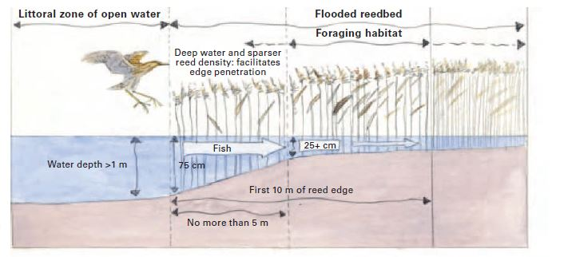
Figure 2: Ideal profile and configuration of wetland edge for matuku based on information on overseas bittern species. Taken from White et al. (2006).

Increasing areas with reed/open water edge habitat
Aside from managing water levels, it is also likely sites should be managed to provide ideal vegetation for matuku to breed and feed. Most overseas bittern studies emphasise the importance of maintain a balance between reed and open water, particularly at breeding sites. For example, in Europe, reed-beds are often cut or burnt outside of the Eurasian bittern breeding season to thin the reeds and maintain a convoluted (or scalloped) edge. Such an edge is preferred because it provides a greater interface of reed/open water, which is thought to be better for bittern feeding (White et al. 2006). (White et al. 2006). In New Zealand, some duck hunters manage wetlands in this way to encourage ducks to shelter close to their shooting platforms (J. Cheyne, pers. Comm.).
  - Specific enhancements for breeding

Maintain water level height and stability throughout the breeding season
Matuku require high and relatively stable water levels in the reed/rush beds to breed. There are two advantages to this: 1) access to food on or close to the nest, and 2) increased protection from predators. What is known about ideal water level requirement for matuku is already outlined in section 3.1 (above). There is some evidence to suggest water level stability is particularly important in early spring. Abundance of booming male Eurasian bittern is known to increase with water levels and the area of inundation in spring (White et al. 2006). One study in Selbjerg Vejle, Denmark, showed that when water levels remained stable, male bitterns remained present throughout the breeding season. However, if water levels fell quickly during this time, the abundance of male booming bitterns also decreased (i.e. a 77 % reduction in numbers of booming males observed after a 40 cm drop in water in 2000) (Nielsen, 2006 In: White et al. 2006). The same has been observed for matuku at Whangamarino wetland, Waikato (Williams 2018).

Time water level modifications so that breeding conditions are ideal for as long as possible
The optimum length of time to manage water levels for matuku is also a pressing question that warrants further investigation. Overseas, a suite of structures, such as bunds, dams and sluices, are used specifically to provide and prolong periods when water levels are ideal for breeding to improve breeding success (e.g. Tyler 1994, Tyler et al. 1998; Hawke & Jose 1996; Gilbert et al. 2005; Poulin et al. 2005; White et al. 2006). There has also been some evidence that bitterns can double clutch, suggesting a management regime that can raise water levels in late winter and hold them for longer periods would significantly improve overall productivity and assist the species recovery (Mallord et al. 2000). Investigating these water level relationships remains an adaptive management need here in New Zealand (Box 1).

Box 1: Use existing opportunities to adaptively manage water levels
Wairarapa moana has several sites with artificially controlled water levels and suitable reed-beds (e.g. Boggy Pond). These represent opportunities to trial water level management regimes that specifically encourage matuku. The most pressing water level question to answer would be:

Can matuku breeding success be increased by raising and stabilising water levels to optimal depths (flooding sites to increase the area with water levels considered ‘ideal’ for matuku breeding) in early spring?

Two indicators could be used to monitor the outcome of this:
a) the number of booming males; or
b) the number of nests.

The expectation here would be that the indicator (number of booming males or number of nests) would increases at the flooded site and stay the same or decrease at the unflooded site. Cost effective methods for measuring numbers of booming males are available and outlined in O’Donnell & Williams (2015). Methods for measuring nests are currently not recommended for general practice due to the high likelihood that disturbance causes nest failures. This could change as low risk methods for monitoring matuku nest success are currently being trialled as part of the Arawai Kakariki’s national bittern research programme (National bittern/matuku technical advisory group 2017).

  - Specific enhancements for feeding
Given the threat of starvation, there is a need to focus management efforts on enhancing bittern food supplies and working towards the creation of healthy functioning natural freshwater habitats. For matuku to thrive, a healthy fish population structure is needed, so that medium sized fish are available, and productivity and recruitment are healthy. This can be achieved by:

Maintaining and encouraging the food sources of aquatic prey
Many food sources of makutu are also in decline, such as eels and whitebait (Galaxias spp.) (Goodman et al. 2014). Addressing the threats of these species will also help matuku. Common management interventions that address freshwater fish threats in New Zealand include:
- Installing fish passes and connecting waterways. This is particularly an issue for wetlands that have been enclosed as part of water level management regimes (i.e. bunded or stop-banked wetlands). In these circumstances it’s important to ensure that adequate provisions have been made to allow fish passage and migration.
- Enhancing stream and drain vegetation to encourage fish spawning, reduce nutrient run-off from farmland and improves fish survival.
- Ensuring healthy freshwater invertebrate populations by reducing sedimentation, improving water quality, water clarity.
- Removing pest fish to improve freshwater ecosystem health. Perch are known to increase sedimentation rates, which in turn can lead to toxic algal blooms (REF).

Managing pest fish species
It is important to note that many fish considered to be pest species in New Zealand are important food sources for overseas bittern species, i.e. perch, rudd (Scardinius erythrophthalmus), carp (Cyprinidae spp.) and tench (Tinca tinca) (Cramp & Simmons 1980, Gilbert et al. 2003, Polak & Kasprzykowski 2010), with one study reporting that perch represented 96 % of food items taken by Eurasian bitterns (White et al. 2006). Therefore, depending upon the availability of other food supplies, caution should be taken with removing these pest fish species on mass, especially in circumstances where native fish populations have declined significantly. Instead managers should consider removing pest species at a time when other matuku prey species are abundant; enhancing fish habitats so that native fish have a competitive advantage over non-natives; or reintroducing captively reared native fish immediately after non-natives have been removed.

Optimise the profile of the wetland to provide feeding and breeding requirements of aquatic prey (as well as matuku)
In Europe, wetlands and reed-beds are not just managed for the needs of bitterns but also to manage the specific needs of their preferred food sources. For example, rudd, a favoured prey item of Eurasian bittern, commonly feed along the littoral edges of ponds, which is a key foraging area. Like in New Zealand, wetlands are often managed to increase these littoral pond edges so that bitterns have frequent opportunities to encounter their prey (White et al. 2006). However, electro-fishing studies have also shown that rudd require areas of deeper water within the reeds, and in open water areas (White et al. 2006). Indeed, Noble et al. (2003, 2004) were able to show that water depths of > 60 cm are required elsewhere in ponds for prey availability in the littoral zones to be high. Little is known about which prey species matuku prefer in New Zealand, let alone the biological and life cycle requirements of these preferred prey items. Investigating predator-prey relationships, and life-history requirements of these species remains an adaptive management need here in New Zealand (Box 2).

Box 2: Use existing opportunities to adaptively manage the effect of pest fish removal on matuku
Wairarapa moana already has an exotic fish removal programme, i.e. at Barton’s lagoon (McEwan 2016). If this work continues it presents an opportunity to trial the effect of pest fish removal on matuku. The most pressing question to answer would be:

How does removal of pest fish affect the availability of fish prey for Australasian bitterns?

Two indicators could be used to monitor the outcome of this:
- Abundance of assessible aquatic prey items, of a correct size class for matuku, before and after pest fish removal
- Movements of radio-tagged matuku
- The number of booming male bitterns

The expectation here would be that the indicators increase after pest fish are removed.

Encouraging prey accessibility within reed-beds
Overseas the accumulation of detritus that occurs at the base of the reeds as it dies-back is also managed (removed). If left, fallen debris raises the reedbed and prevents fish from infiltrating reedbeds to feed (White et al. 2006). Similar die-back and detritus accumulation occurs in some matuku habitats i.e. Typha orientalis beds (Plate 4) and therefore management of this warrants further investigation.
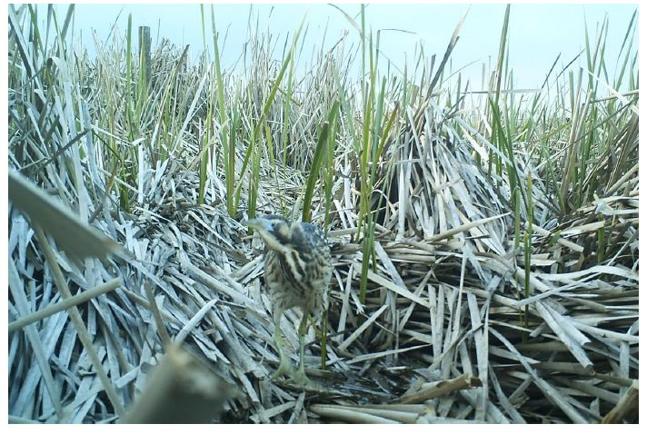
Plate 4. Matuku in a Typha orientalis bed. Like in European reedbeds, the die back of Typha raises the vegetative bed and prevents fish from infiltrating and feeding around the base of the vegetation.
  - Habitat outside of core breeding areas (wintering sites)
Recent cases of starvation nationally suggest having good matuku habitat networks outside core breeding areas is important. National radio-tracking studies have shown that matuku utilise a complex mosaic of sites outside of the breeding season (January to July; E. Williams, unpubl.). Ten radio-tagged matuku in the Hawkes Bay visited >9 wetlands within a c.20 km radius of their breeding site, Lake Whatumā, feeding in habitats that included spring creeks, swamps, and farm dams, often with raupō present (E. Williams, unpubl.). Similarly, radio-tagged matuku have even moved beyond very the large wetlands at Whangamarino (c. 7000 ha) and Te Waihora/Lake Ellesmere (c. 10,000 ha) post breeding (E. Williams, unpubl.). Similar behaviours are observed with wintering Eurasian bitterns (Puglisi et al. 2003). Indeed, overseas bitterns are reported to be in “rank waterside vegetation at gravel pits, fish farms, riversides, sewerage ponds, ditches, reservoirs and other small wetlands” outside of the breeding season (White et al. 2006). Thus, it is important that sites like these are identified, managed and protected.
  - Managing problem weeds
In general, it is preferable to encourage the re-establishment of native flora and fauna as part of matuku-focused restoration programmes. However, in the severely altered habitat that currently exist, matuku do not distinguish between native and non-native species, but instead choose their environment based on their hydrological needs, food availability and a plant community’s ability to satisfy these needs. As such, there will be several non-native weed species that, in the absence of a native alternative, are essential to matuku survival and persistence. These plant species present a dilemma because their removal is required for natives to re-establish, yet mass removal from a wetland ecosystem can threaten matuku populations. In these cases, a staged approach is recommended, so that plants are removed from small areas at a time and at a rate that allows native replacement species to establish and continue to meet the needs of the resident matuku population, before removal of the non-natives has been completed. An example of such a situation is given below (Section 5.3.1).

Managing floating weed mat species to minimise negative effects on matuku foraging
Weed species that form floating mats are particularly important in this regard, as feeding from them allows matuku access to fish in deeper waters than they normally can access. In degraded systems, floating mats of species such as reed sweet grass (Glyceria maxima) and mercer grass (Paspalum distichum) provide foraging opportunities for matuku at certain times of the year that could potentially buffer a matuku population from starvation. Floating mats are particularly important when: (a) water levels remain particularly high over long periods; (b) conversely, when wetlands dry out and the usual aquatic food sources of matuku become contained in deep inaccessible drains; (c) disturbance forces matuku to feed in areas dominated by deep drains. Under these circumstances, fish and small aquatic fauna species feed along the edges of floating mats or shelter beneath it. During this time, the mat itself provides a platform for the matuku to patiently sit a stalk its prey. The removal of reed sweet grass and mercer grass is commonly desired because these species also smother preferred marginal plant species, block waterways potentially causing flooding, and prevent the establishment of less aggressive natives through competition (Champion et al. 2013, Weedbusters 2018). Mercer grass is already recommended for removal as part of the Lake Onoke Freshwater Improvement Fund Project (Graeme & Dahm 2018).

Managing weed encroachments, including willows
Eradication, or management to sustained very low levels of willows and other woody weeds in matuku habitats is essential. Given that there has already been considerable control of willows at Wairarapa moana, it is important to maintain control, halt reinvasion as well as controlling new areas within the 14 key sites identified in Figure 1. Surveillance for other problem weeds should also be maintained. For example, common pampas (Cortaderia selloana) and yellow flag iris (Iris pseudacorus) are becoming problem weeds at Whangamarino wetland, and alligator weed (Alternanthera philoxeroides) is on a watch list for eradication.

Controlled pulse grazing as a tool
Grazing is commonly used, combined with water levels control, as a tool in to manage invasive plants in wetlands overseas, and help diversify and create wetland mosaic habitats (WallisDeVries et al. 1998). New Zealand is currently going through a process of excluding stock from waterways, something that is wise given that almost all wetland grazing regimes were for the purposes of feeding and watering stock through dry winters rather than with wetland health as the objective. Despite the negative impacts of grazing and consequent adding of nutrients to wetlands, there may be a case for careful, targeted and controlled grazing as a wetland conservation tool to manage willow reinvasion around wetland margins. If such a tool were to be proposed, the outcomes should be carefully monitored, and it should be ensured that any stock do not gain access to more sensitive reed-beds or other habitats.
  - Predator control
Restoring wetlands to a healthy functioning state to sustain matuku requires control of invasive predators. Control should focus at least on the predators primarily thought to impact on matuku: mustelids and feral cats. The role of rats as predators of matuku eggs and nestlings is less certain and it is unlikely that hedgehogs are major predators because of their aversion to crossing waterways (Pascoe 1995). There is also uncertainty about the intensity and duration of control required to recover matuku populations, how to effectively manage the large number of predator species and the variability in their abundance in space and time, and the large scale of the control required to protect matuku at the population level. However, effective predator control is likely to benefit all wetland birds at Wairarapa moana, not just matuku (O'Donnell et al. 2015). Recommendations for predator control are:
- Continue and improve existing predator control programmes at Onoke Spit, Boggy Pond and Sheep Hill Lagoon.
- Review existing captures and evaluate whether trapping design is optimal for target predators; in particular:
- Consideration of the mix of DOC 150, 200 and 250 traps to optimise capture of small weasels and female stoats up to large ferrets;
- Expansion of feral cat control beyond Timms traps (which have limited effectiveness for cats) to include use of new cat trap designs, periodic night-shooting sessions, and leg-hold trapping sessions 1-2 times per year, all of which can be effective for cat control (Cruz et al. 2013).
- Consider expanding predator control into surrounding buffer areas – to reduce the risk of predators arriving at, and reinvading, the wetlands;
- Include some level of control of Australasian harriers;
- Expand predator control operations over time into other key matuku habitats. Consider an adaptive management approach – monitoring bittern numbers and productivity before and after control is initiated;
- Investigate costs and benefits of rat control for enhancing matuku populations;
- Investigate whether indirect methods such as habitat modification, land-use management or manipulating prey abundance can reduce predation risk. For example, possibilities include:
- Sustained rabbit and hare control to low levels by ground hunting and ground application of toxic baits to reduce food supplies for predators;
- Physical manipulation of islands and channels in wetlands to maintain a protective moat around bird breeding sites (e.g. see Zoellick et al. 2004).

  - Managing recreational disturbances
Many wetland habitats are also valued recreational areas. Recreational disturbances include duck hunting (with or without dogs), recreational boating, biking (cycleways), disturbance from walkers (with or without dogs) and other human associated activities that either involve people in or around the wetland or involve a lot of noise.
Mitigating and managing the potential negative effects resulting from human-wildlife interactions will be a continual challenge for wildlife conservation and human recreation as populations of humans increase and encroach on wildlife habitat (Nix et al. 2018). Matuku generally live in habitats that are harder to access than many areas where disturbance is a direct problem (e.g. beaches etc; see section 4.6 above). However, disturbance from boats, hunters and walkers is an issue that requires careful consideration and management. In the context of matuku habitats at Wairarapa moana, consideration should be given to:
- Minimising access to sensitive nesting/booming habitats and re-routing humans to less sensitive areas. Where possible, divert potential disturbances such as walkways or cycleways around the wetland/breeding habitats rather than through the wetland. If a cycleway is planned through a wetland, consider screening parts of the route so matuku have places to forage while remaining hidden from view i.e. screens used at Waimea inlet (Nelson City Council et al. 2010). If recreation close to breeding areas is allowed, traffic rates should be monitored, and if high, restrictions during matuku breeding seasons considered;
- Excluding dogs, or at a minimum only allow dogs on a lead, from key matuku sites;
- Designate key matuku sites that are duck hunting-free reserves/areas, so that matuku have places to forage free of disturbance during the hunting season;
- Consider use of fencing to channel people away from sensitive areas.
- Limiting access of motorised boats to bittern habitats.
- While interactions by the public with wetlands is desirable, careful consideration of when and where to provide facilities can lead to reducing potential disturbance significantly (Bennett et al. 2011). For example, providing bird watching facilities but being careful to ensure that the proximity and orientation will not affect matuku foraging or breeding.
- Relocating 4WD vehicles and motor bikes away from the Barton’s Lagoon/Tauherenikau river mouth wetlands to less sensitive areas, i.e identifying, and/or creating, alternative areas where these recreational activities can occur but will have minimal impact.
- Provision of specific, clearly identified parking areas with signs to educate wetland users about flora and fauna including matuku – in particular, helping users to recognise and move away from disturbed breeding or feeding birds.
  - Advocacy for matuku
Protecting and sustaining matuku habitats will also need to involve education and advocacy with statutory bodies and the Wairarapa moana community to reduce risks of human impacts. Advocacy actions include:
- Ensuring fish passage and wetland connectivity, including using statutory advocacy and working with other management agencies and neighbours;
- Protecting small pockets of wetlands in the surrounding catchment to encourage habitat linkages in the regional wetland network;
- Developing drain maintenance guidelines to maintain values in surrounding habitat matrix;
- Undertaking advocacy with adjoining landowners regarding sediment and nutrient management;
- Working with regional and district planning authorities to ensure appropriate biodiversity protection rules in local plans;
- Making appropriate RMA submissions if necessary regarding developments that impact on water and habitat quality;
- Working with partners/neighbours/volunteers regarding riparian plantings and pest control and encourage development of a local wetland care group.
- Developing a long-term land purchase strategy to grow the size of management areas and buffer from external effects.

  - Future considerations: Anticipating sea level changes, climate change and natural disasters
The phenomenon of climate change, and the fact that it will have an impact, is something that is now internationally recognised and [almost entirely] accepted globally. However, the consequences are less clear, as predictions rely on complex climate models and algorithms, with high uncertainties. What is clear is that most credible models predict that New Zealand is at high risk of sea level change and extreme weather events (Church et al. 2013). As such the following should be considered when planning site restorations for matuku populations:
- Avoid focusing long-term efforts on the restoration of sites < 1 m above sea level. In saying this, nationally the rate of decline in matuku populations has been shown to be slower in coastal wetlands compared to inland lakes, suggesting many sites < 1 m above sea level may now contain strong-hold populations of matuku (O'Donnell & Robertson 2016). As such, these sites may need protection in the short-term to prevent further declines, however long-term provisions should also be made elsewhere.
- Protect, plant and encourage the growth of raupō in areas unlikely to affected by sea level rises.
- Develop a long-term land purchase and management strategy to grow the size of reserves > 1 m above sea level. This process could be started by identifying areas where maximum matuku population gains can be made with minimum resources at existing sites. Several sites already stand out for the latter based on vegetation profiles given by Wildlands Consultants (2013). These include: Papatahi Neville Davies wetland and the Tauherenikau Delta.
- Where possible, develop multiple sites for matuku across different catchments and hydrological systems. This will be challenging in the case of large isolated catchments, such as Wairarapa moana but can be done by linking into national initiatives.

Monitoring population response to management actions

There are many approaches to monitoring wildlife populations, and the choice of which method to use must be matched carefully with project aims and objectives. Typically, there are three reasons to monitor wildlife populations, these are as follows (Greene 2012):
- “To understand what we have got in our area of interest.
- To discover whether there has been any change in population size and, if so, what processes were driving that change.
- Determine the effectiveness of management actions and whether any changes to those actions affected population size”.
In the context of a cryptic species, such as matuku, very little is known about the processes driving population changes and, as the species is already Nationally critical, there is a need to manage populations at the same time that causes of decline are being identified. As such, Reason 2 (drivers of population changes) and Reason 3 (effectiveness of management practises) are best addressed together as a series of management experiments.
  - Monitoring tools currently available
Current monitoring practices available for use on matuku, are based on call-count methodology and involve counting the number booming calls (or ‘boom trains’) produced by male matuku during the breeding season (O'Donnell & Williams 2015). For the purposes of these monitoring tools, one boom train is defined as a sequence of individual booms uttered by a single bird; Gilbert et al.(1994).
Current call-count methods of matuku fall into four categories: presence/absence (inventory tool); close approaches to estimate and accurately locate number of male’s present (index and inventory tool), acoustic triangulation to estimate and approximate locations of the number of male’s present (index and inventory tool), use of Acoustic Recording Devices (ARDs) to estimate numbers of calls/calling males present (index and inventory tool). The choice of which method to use depends on monitoring objectives, costs, values and site characteristics (O'Donnell & Williams 2015, Williams et al. 2018b). Counts of booms should be standardised across years, and take optimum times and conditions into consideration (i.e. conducted at times outlined in Williams et al., 2018a).
  - Limitations of current methods
Currently male booming matuku are monitored at five sites at Wairarapa moana: three sites yearly (Boggy Pond, Mathews Lagoon and Wairio wetland); and two sites biennially (Barrage gates and Sheep Hill Lagoon) (Cheyne 2015). Historical records show that all five of these sites have the highest reporting rates for matuku records, suggesting they may be sites with the highest matuku densities within the region (Figure 1). Annual survey work will provide long-term trends in male matuku abundance across time, and therefore should be continued. Biennial surveys have a much lower power to show changes across time, and so it would preferable to increase monitoring at the two biennial sites so that these are also annual. Current methods used to monitor matuku at Wairarapa moana are based on O’Donnell & Williams (2015) and have several limitations; these are as follows:
- Current sampling at Wairarapa moana only measures a subset of matuku sites. Over time, it’s expected that matuku populations will increase at Wairarapa moana in response to management practices. Indeed, there is some evidence to suggest a population increase is already occurring (Cheyne 2015). However, increases in matuku populations are likely to be difficult to demonstrate unless the whole population is being monitored. This has become more apparent now that radio-tracking studies have shown home ranges are large and matuku use multiple sites.

- Consider increasing the number of sites monitored to include low density sites such as Barton’s lagoon, Tauherenikau Delta and Alsops bay.

- Current monitoring methods only provide information about male matuku during the breeding season. This is currently the most pressing limitation of current national standard practices and is a focus of the Department of Conservation’s national matuku research programme (National bittern/matuku technical advisory group 2017). Methods to detect females and chicks trialled to date, or currently being trialled, include:
  - Detecting nests by looking for female foraging flights (directional flights conducted by female matuku as they come and go from their nests to forage). These methods have been used successfully overseas (Gilbert 2006) but do not work under all circumstances. Success appears to depend upon the availability and locality of key food sources with respect to the nest (Puglisi et al. 2003, Adamo et al. 2004).
  - Detecting birds by scent (dogs). One dog has been trained to detect matuku to date (a female Labrador called Kimi). A lot more practise is required, but she has so far shown great promise, helping to recapture radio-tagged matuku at Lake Whatumā (Williams 2016) and to date has helped find at least one matuku nest.
  - Detecting birds by heat/infra-red (Thermal imagery). Two attempts have been made to trial hand held thermal imagery cameras to date (one at Lake Whatuma and the other at Little Waihi) both suggested matuku were difficult to detect because of vegetation but could be seen in the open or in flight. This highlighted a research need to trial thermal imagery from the air (John Sumich pers comm; Williams 2016). A trial looking for the heat signatures of radio-tagged matuku started at Little Waihi estuary in June 2018 and so far, shows promise.

- Consider linking in to Department of Conservation’s national matuku research programme so that the latest capture and monitoring methods are trialled at Wairarapa moana.

  - Using a surrogate species
Monitoring of cryptic, sensitive species is always likely to be a challenge and, in some cases, it may be necessary to use a surrogate/indicator species instead. For methods using surrogate/indicator species to work it is important that they are strongly ‘objective specific’ (i.e. they must link to specific management objectives and interventions being measured) but do not need to be limited to direct measures. At Wairarapa moana this may involve continuing or expanding existing spotless crake (Porzana tabuensis; hereafter puwetō) monitoring practises to show progress with specific management interventions for matuku. For example, both matuku and puwetō have several threats in common, but puwetō are thought to respond much faster to management interventions than matuku (particularly in the case of predators, O'Donnell et al. 2015). Recent research on puwetō home range sizes also suggest puwetō population changes may be more informative for circumstances where management is being being applied a localised, site-specific scale (Williams 2017a, Williams 2017b) i.e. one management intervention is being applied to Boggy pond but another is being trialled at Wairio wetland.

References

Adamo, M. C., Puglisi, L. & Baldaccini, N. E. 2004. Factors affecting bittern Botaurus stellaris distribution in a Mediterranean wetland. Bird Conservation International, 14: 153-164.
Ausseil, A.-G. E., Chadderton, W. L., Gerbeaux, P., Stephens, R. T. T. & Leathwick, J. R. 2011. Applying systematic conservation planning principles to palustrine and inland saline wetlands of New Zealand. Freshwater Biology, 56: 142-161.
Ausseil, A.-G. E., Gerbeaux, P., Chadderton, W. L., Stephens, R. T. T., Brown, D. & Leathwick, J. R. 2008. Wetland ecosystems of national importance for biodiversity. Criteria, methods and candidate list of nationally important inland wetlands. In Landcare contract report LC0708/158. Lincoln. New Zealand: Landcare Research.
Beadel, S., Perfect, A., Rebergen, A. & Sawyer, J. 2000. Wairarapa Plains Ecological District. In Survey report for the Protected Natural Areas Programme. pp. 203. Wellington: Department of Conservation.
Bennett, V. J., Fernández-Juricic, E., Zollner, P. A., Beard, M. J., Westphal, L. & Fisher, C. L. L. 2011. Modelling the responses of wildlife to human disturbance: an evaluation of alternative management scenarios for black-crowned night-herons. Ecological Modelling, 222: 2770-2779.
BirdLife International. 2014. Species factsheet: Botaurus poiciloptilus. Vol. 2014.
Buchanan, K. L. 2009. Wetland conservation in the Murray-Darling Basin-is it going down the drain? Emu, 109: i-iv.
Champion, P., Rowe, D., Smith, B., Wells, R., Kilroy, C. & de Winton, M. 2013. Freshwater pests of New Zealand. National Institute of Water and Atmospheric Research. Available: https. www. niwa conz/sites niva co nz/files pest guide port feb.
Cheyne, J. 2015. Bittern and spotless crake survey eastern and southern wetlands Wairarapa moana, Spring 2015. In Prepared for the Wairarapa moana project. Waipukurau: Wetlands Works.
Church, J. A., Clark, P. U., Cazenave, A., Gregory, G. M., Jevrejeva, S. A., Levermann, A., Merrifield, M., Milne, G. A., Nerem, R. S., Nunn, P. D., Payne, A. J., Pfeffer, W. T., Stammer, D. & Unnikrishnan, A. S. 2013. Sea Level Change. In The Physical Science Basis. Contribution of Working Group 1 to the Fifth Assessment Report of the Intergovernmental Panel on Climate Change. (eds. T. F. Stocker, D. Qin, G. K. Plattner, M. Tignor, S. K. Allen, J. Bosschung, A. Nauels, Y. Xia, V. Bex & P. M. Midgley). New York, NY, USA: Cambridge University Press.
Clark, A. B. & Wilson, D. S. 1981. Avian breeding adaptations: hatching asynchrony, brood reduction, and nest failure. The Quarterly Review of Biology, 56: 253-277.
Cramp, S. & Simmons, K. E. L. 1980. Birds of Europe, the Middle East and North Africa, Vol. II Hawkes to bustards. Oxford University Press, Oxford.
Cromarty, P. & Scott, D. (eds.) 1995. A Directory of Wetlands in New Zealand, Wellington, New Zealand: Department of Conservation.
Cruz, J., Pech, R. P., Seddon, P. J., Cleland, S., Nelson, D., Sanders, M. D. & Maloney, R. F. 2013. Species-specific responses by ground-nesting Charadriiformes to invasive predators and river flows in the braided Tasman River of New Zealand. Biological Conservation, 167: 363-370.
Dowling, B. & Weston, M. A. 1999. Managing a breeding population of the Hooded Plover Thinornis rubricollis in a high-use recreational environment. Bird Conservation International, 9: 255-270.
Drew, S. H. 1896. Art. XXV. - Natural History Notes. Transactions and Proceedings of the Royal Society of New Zealand, 29.
Felton, S. K., Pollock, K. H. & Simons, T. R. 2017. Response of beach-nesting American Oystercatchers to off-road vehicles: An experimental approach reveals physiological nuances and decreased nest attendance. The Condor, 120: 47-62.
Gilbert, G. 2006. A review of European bittern Botaurus stellaris research techniques and results: their potential application to Australasian bittern Botaurus poiciloptilus ecology and conservation. In Wetlands of the Murrumbidgee River Catchment: Practical Management in an Altered Environment. (eds. I. R. Taylor, P. A. Murray & S. G. Taylor), pp. 117-126. Leeton, NSW, Australia: Fivebough and Tuckerbil Wetlands Trust.
Gilbert, G., Brown, A. F. & Wotton, S. R. 2010. Current dynamics and predicted vulnerability to sea-level rise of a threatened Bittern Botaurus stellaris population. Ibis, 152: 580-589.
Gilbert, G., McGregor, P. & Tyler, G. 1994. Vocal individuality as a census tool: practical considerations illustrated by a study of two rare species. Journal of Field Ornithology, 65: 335-348.
Gilbert, G., Tyler, G. & Smith, K. W. 2003. Nestling diet and fish preference of bitterns Botaurus Stellaris in Britain. Ardea, 91: 35-44.
Gilbert, G., Tyler, G. & Smith, K. W. 2005a. Behaviour, home-range size and habitat use by male great bittern Botaurus stellaris in Britain. Ibis, 147: 533-543.
Gilbert, G., Tyler, G. A., Dunn, C. J., Ratcliffe, N. & Smith, K. W. 2007. The influence of habitat management on the breeding success of the great bittern Botaurus stellaris in Britain. Ibis, 149: 53-66.
Gilbert, G., Tyler, G. A., Dunn, C. J. & Smith, K. W. 2005b. Nesting habitat selection by bitterns Botaurus stellaris in Britain and the implications for wetland management. Biological Conservation, 124: 547-553.
Goodman, J., Dunn, N. R., Ravenscroft, P. J., Allibone, R. M., Boubee, J. A., David, B. O., Griffiths, M., Ling, N., Hitchmough, R. A. & Rolfe, J. R. 2014. Conservation status of New Zealand freshwater fish, 2013: Publishing Team, Department of Conversation.
Graeme, M. & Dahm, J. 2018. Lake Ōnoke Freshwater Improvement Fund Project - Restoration Plan. In Prepared for Wairarapa District Office, Department of Conservation by the Focus Resource Management Group. (ed. F. R. N. 18/128.).
Greater Wellington Regional Council. 2018. Wairarapa moana wetlands: Sea of Glistening Waters. (ed. G. W. R. Council), Vol. GW/BD-G-16/22.
Greene, T. 2012. A guideline to monitoring populations. Version 1.0. In Biodiversity Inventory and Monitoring Toolbox. (eds. T. Greene & K. McNutt). Wellington, New Zealand: Department of Conservation.
Hawke, C. & José, P. 1996. Reedbed management for commercial and wildlife interests. Sandy, UK: Royal Society for the Protection of Birds vii, 212p. ISBN, 903138816.
Hayes, J. W., Rutledge, M. J., Chisnall, B. L. & Ward, F. J. 1992. Effects of elevated turbidity on shallow lake fish communities. Environmental biology of fishes, 35: 149-168.
Henley, W., Patterson, M., Neves, R. & Lemly, A. D. 2000. Effects of sedimentation and turbidity on lotic food webs: a concise review for natural resource managers. Reviews in Fisheries Science, 8: 125-139.
Hill, R. 1963. The vegetation of the Wairarapa in mid-nineteenth century. Tuatara, 11: 83-89.
Kalinkat, G., Cabral, J. S., Darwall, W., Ficetola, G. F., Fisher, J. L., Giling, D. P., Gosselin, M. P., Grossart, H. P., Jähnig, S. C. & Jeschke, J. M. 2017. Flagship umbrella species needed for the conservation of overlooked aquatic biodiversity. Conservation Biology, 31: 481-485.
Keller, V. 1989. Variations in the response of great crested grebes Podiceps cristatus to human disturbance—a sign of adaptation? Biological Conservation, 49: 31-45.
Kushlan, J. A. 1976. Feeding behavior of North American herons. The Auk, 93: 86-94.
Kushlan, J. A. 2007. Conserving herons, a conservation action plan for the herons of the world, Arles, France: Heron Specialist Group and Station Biologique de la Tour du Valat.
Lee, K. N. 1999. Appraising adaptive management. Conservation Ecology, 3: 3-26.
Longshore, K., Lowrey, C. & Thompson, D. B. 2013. Detecting short-term responses to weekend recreation activity: desert bighorn sheep avoidance of hiking trails. Wildlife Society Bulletin, 37: 698-706.
Mallord, J. W., Tyler, G. A., Gilbert, G. & Smith, K. W. 2000. The first case of successful double brooding in the great bittern Botaurus stellaris. Ibis, 142: 672-675.
Martin, J. G. A. & Réale, D. 2008. Animal temperament and human disturbance: implications for the response of wildlife to tourism. Behavioural Processes, 77: 66–72.
McEwan, A. 2016. Restoration of native fish communities in Barton's Lagoon, Wairarapa Moana: evaluation of a 2-year exotic fish control programme. Riverscapes Freshwater Ecology.
McGregor, P. K. & Byle, P. 1992. Individually distinctive bittern booms: potential as a census tool. Bioacoustics, 4: 93-109.
McMillan, C. 1959. Salt tolerance within a Typha population. American Journal of Botany: 521-526.
National bittern/matuku technical advisory group. 2017. Australasian bittern/matuku research plan, 2017 - 2022. In DOC-3146130. Christchurch: Department of Conservation.
Nelson City Council, Tasman District Council, Departmetn of Conservation & Nelson-Marlborough Fish and Game Council. 2010. Waimea inlet management strategy. Nelson.
Nix, J. H., Howell, R. G., Hall, L. K. & McMillan, B. R. 2018. The influence of periodic increases of human activity on crepuscular and nocturnal mammals: Testing the weekend effect. Behavioural processes, 146: 16-21.
Noble, R., Harvey, J. & Cowx, I. 2003. Management of cyprinid fish populations as an important prey group for the endangered piscivorous bird, bittern, Botaurus stellaris. Interaction between fish and birds: implications for management: 151-164.
Noble, R. A. A., Harvey, J. P. & Cowx, I. G. 2004. Can management of freshwater fish populations be used to protect and enhance the conservation status of a rare, fish-eating bird, the bittern, Botaurus stellaris, in the UK? Fisheries Management and Ecology, 11: 291-302.
O'Donnell, C. F. J. 2011. Breeding of the Australasian bittern (Botaurus poiciloptilus) in New Zealand. Emu, 111: 197-201.
O'Donnell, C. F. J. 2014. Statement of evidence in chief of Colin Francis John O’Donnell for the Director General of Conservation in the matter of the Resource Management Act 1991 ("the Act") and In the matter of a review of conditions of Resource Consent 101727 held by Waikato Regional Council. Hamilton, New Zealand: Department of Conservation.
O'Donnell, C. F. J., Clapperton, B. K. & Monks, J. M. 2015. Impacts of introduced mammalian predators on indigenous birds of freshwater wetlands in New Zealand. New Zealand Journal of Ecology, 39: 19-33.
O'Donnell, C. F. J. & Robertson, H. A. 2016. Changes in the status and distribution of Australasian bittern (Botaurus poiciloptilus) in New Zealand, 1800s− 2011. Notornis, 63: 152-166.
O'Donnell, C. F. J. & Williams, E. M. 2015. Protocols for the inventory and monitoring of populations of the endangered Australasian bittern (Botaurus poiciloptilus) in New Zealand. DoC technical Series 38. In Department of Conservation Technical Series. Wellington, New Zealand: New Zealand Department of Conservation.
Parliamentary Commissioner for the Environment. 2017. Taonga of an island nation. In Saving New Zealand’s birds. Wellington: PCE.
Pascoe, A. 1995. The effects of vegetation removal on rabbits (Oryctolagus cuniculus) and small mammalian predators in braided riverbeds of the Mackenzie Basin. Masters thesis. University of Otago.
Pierce, G. J., Spray, C. J. & Stuart, E. 1993. The effect of fishing on the distribution and behaviour of waterbirds in the Kukut area of Lake Songkla, Southern Thailand. Biological Conservation., 66: 23-34.
Polak, M. 2006. Booming activity of male bitterns Botaurus stellaris in relation to reproductive cycle and harem size. Ornis Fennica, 83: 27-33.
Polak, M. 2007. Nest-site selection and nest predation in the Great Bittern Botaurus stellaris population in eastern Poland. Ardea, 95: 31-38.
Polak, M. & Kasprzykowski, Z. 2010. Reproduction parameters of the great bittern botaurus stellaris in the fish ponds of eastern Poland. Acta Ornithologica, 45: 75-81.
Porteous, T. 2017. Wairarapa Moana Wetlands Project: approval of terms of reference. Greater Wellington Regional Council.
Poulin, B. & Lefebvre, G. 2003. Variation in booming among great bitterns Botaurus stellaris in the Camargue, France. Ardea, 91: 177-181.
Poulin, B., Lefebvre, G. & Mathevet, R. 2005. Habitat selection by booming bitterns Botaurus stellaris in French Mediterranean reed-beds. The International Journal of Conservartion, 39: 265-274.
Puglisi, L., Adamo, C. & Baldaccini, N. E. 2003. Spatial behaviour of radio-tagged Eurasian bitterns Botauras stellaris. Avian Science, 3.
Puglisi, L. & Bretagnolle, V. 2005. Breeding biology of the great bittern. Waterbirds, 28: 392-398.
Reischek, A. 1885. On the habits of New Zealand birds. Transactions of the New Zealand Institute, 18: 97-107.
Robertson, H. A., Baird, K., Dowding, J. E., Elliott, G. P., Hitchmough, R. A., Miskelly, C. M., McArthur, N., O’Donnell, C. F. J., Sagar, P. M., Scofield, R. P. & Taylor, G. A. 2017. Conservation status of New Zealand birds, 2016. New Zealand Threat Classification Series 19. pp. 23. Wellington: Department of Conservation.
Rowe, D. K. 2007. Exotic fish introductions and the decline of water clarity in small North Island, New Zealand lakes: a multi-species problem. Hydrobiologia, 583: 345-358.
Ruhlen, T. D., Abbott, S., Stenzel, L. E. & Page, G. W. 2003. Evidence that human disturbance reduces Snowy Plover chick survival. Journal of Field Ornithology, 74: 300-304.
Ryan, P. A. 1991. Environmental effects of sediment on New Zealand streams: a review. New Zealand journal of marine and freshwater research, 25: 207-221.
Simberloff, D. 1997. Flagships, umbrellas, and keystones: Is single-species management passe in the landscape era? Biological Conservation, 83: 247-257.
Soper, M. F. 1958. A Bittern's nest. Notornis, 8: 45-51.
Stidolph, R. 1939. Birds of the Wairarapa Lake district. Emu-Austral Ornithology, 38: 344-355.
Storer, R. W. & Nuechterlein, G. L. 1993. Western grebe (Aechomophorus occidentalis) and Clark’s grebe (Aechomophorus clarkia). In The birds of North America No. 26. (eds. A. Poole, P. Stettenheim & F. Gill). Academy of Natural Sciences, Philadelphia; American Ornithologists Union, Washington DC.
Teal, P. J. 1989. Movement, habitat use and behaviour of Australasian bittern (Botaurus poiciloptilus) in the lower Waikato wetlands. pp. 1-265. Hamilton, New Zealand: Waikato University.
Tyler, G. 1994. Management of reedbeds for bitterns and opportunities for reedbed creation. RSPB Conservation Review, 8: 57-62.
Tyler, G. A., Smith, K. W. & Burges, D. J. 1998. Reedbed management and breeding bitterns Botaurus stellaris in the UK. Biological Conservation, 86: 257-266.
Van Aalst, M. K. 2006. The impacts of climate change on the risk of natural disasters. Disasters, 30: 5-18.
Van Winkle, W. 1975. Comparison of several probabilistic home-range models. The Journal of Wildlife Management: 118-123.
WallisDeVries, M. F., Bakker, J. P., Bakker, J. P. & van Wieren, S. 1998. Grazing and conservation management: Springer Science & Business Media.
Wanyonyi, S. N. 2016. Effects of Habitat Disturbance on Distribution and Abundance of Papyrus Endemic Birds in Sio Port Swamp, Western Kenya. Masters Thesis. Nairobi.: University of Nairobi.
Weedbusters. 2018. Weed information. (ed. www.weedbusters.org.nz).
Weston, M., McLeod, E. M., Blumstein, D. & Guay, P.-J. 2012. A review of flight-initiation distances and their application to managing disturbance to Australian birds. Emu-Austral Ornithology, 112: 269-286.
White, G. C., Purps, J. & Alsbury, S. 2006. The bittern in Europe: a guide to species and habitat management, Sandy, United Kingdom: Royal Society for the Protection of Birds.
Whiteside, A. J. 1989. The behaviour of bitterns and their use of habitat. Notornis, 36: 89-95.
Wildlands Consultants. 2013. Extent and significance of Wairarapa moana wetlands and Lake Pounui. In Prepared for Greater Wellington Regional Council. Contract Report No. 3105. Hamilton/Rotorua.
Williams, E. M. 2016. Developing monitoring methods for cryptic species: A case study of the Australasian bittern, Botaurus poiciloptilus. Doctorate thesis in Ecology. Manawatu, New Zealand: Massey University.
Williams, E. M. 2017a. Long-term wetland bird monitoring at Lakes Ruatuna, Rotomanuka and Areare in response to restoration efforts: Year 2 (2016-17) results and comparisons with Year 1. Christchurch, New Zealand.: Matuku Ecology.
Williams, E. M. 2017b. Trial attachment of transmitters to spotless crakes at Lakes Ruatuna and Rotomanuka: some preliminary results. Christchurch, New Zealand: Matuku Ecology.
Williams, E. M. 2018. Seasonal water levels and habitat requirements of Australasian bitterns at Whangamarino wetland: A summary of Year 3 (Sept to Dec 2017) results and comparisons with Year 1 and 2 (2015 – 2017). Christchurch: Matuku Ecology.
Williams, E. M., Armstrong, D. P. & O'Donnell, C. F. J. 2018a. Modelling variation in calling rates to develop a reliable monitoring method for the Australasian Bittern Botaurus poiciloptilus Ibis, 0: 0.
Williams, E. M. & Cheyne, J. 2017. Seasonal water levels and habitat requirements of Australasian bitterns at Whangamarino wetland: October 2015 – June 2017. In Contract Report to Department of Conservation. Christchurch & Waipukurau, New Zealand: Matuku Ecology and Wetland Works.
Williams, E. M., O'Donnell, C. F. J. & Armstrong, D. P. 2018b. Cost-benefit analysis of acoustic recorders as a solution to sampling challenges experienced monitoring cryptic species. Ecology and Evolution.
Zedler, J. B., Paling, E. & McComb, A. 1990. Differential responses to salinity help explain the replacement of native Juncus kraussii by Typha orientalis in Western Australian salt marshes. Austral Ecology, 15: 57-72.
Zoellick, B. W., Ulmschneider, H. M., Cade, B. S. & Stanley, A. W. 2004. Isolation of Snake River islands and mammalian predation of waterfowl nests. Journal of wildlife Management, 68: 650-662.

Appendices
Appendix 1: Map showing matuku are found at Wairarapa moana through a range of seasons. Records taken from the national matuku database. Note: records shown in Figure 1 but are absent from this map had insufficient information to determine season (# out of # records).
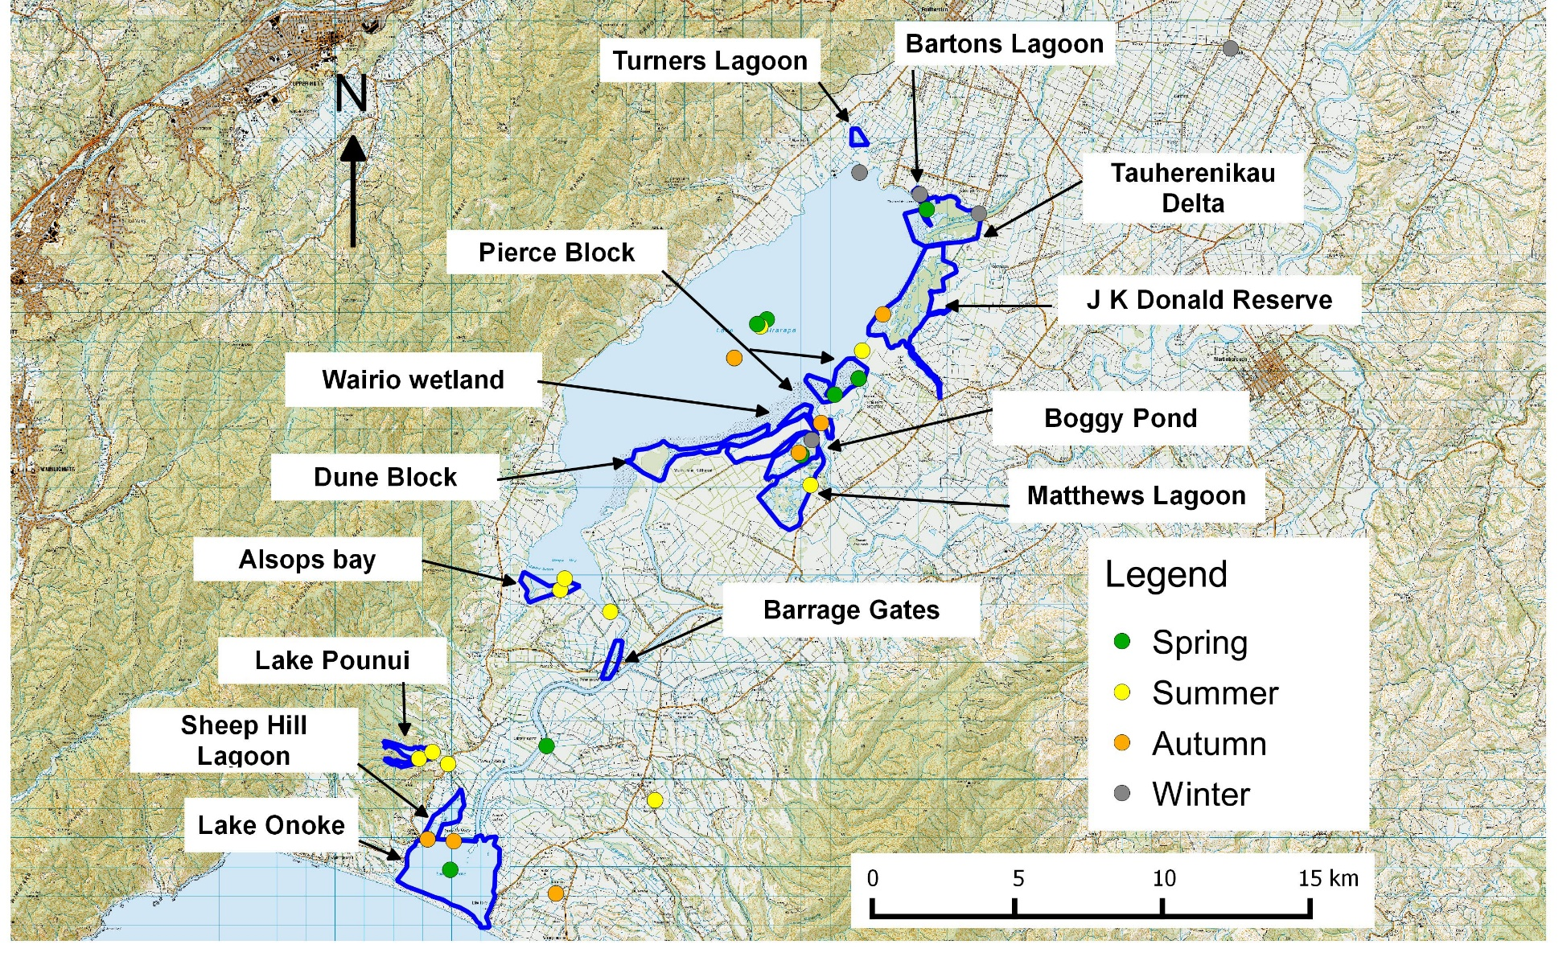
Appendix 2: Historical matuku records in and around Wairarapa moana wetlands. Taken from the National bittern/matuku database. Note A breeding record is one documented during the period defined as the breeding season by O’Donnell 2011 (September to January) and a non-breeding record is one documented outside of the breeding season. All other seasons are defined as standard austral seasons for New Zealand, so that Sp = Spring (September to November); Su = Summer (December to February); Au = Autumn (March to May); Wn = Winter (June to August). Unk = records where seasonal data is not recorded.
Location (Figure 1) | Site name (Wildlands 2013) | Vegetation and habitat types (Wildlands 2013) | Species present (Wildlands 2013) | Total Records | Number of Matuku records grouped by season
 |  |  |  |  | Br | NB | Sp | Su | Au | Wn | Unk
Lake Wairarapa - Pierce Block | Eastern Lake Wairarapa | Open water; reedland; herbfield; sedgeland; rushland and herbfield; grassland; alder/willow forest; kahikatea treeland; scrub; wet pasture. | Typha orientalis; Myriophyllum spp; Isolepis spp.; Carex spp.; Salix sp.; Alnus sp.; Glyceria maxima; Oenanthe sp.; Festuca arundinacea; Crassula sp.; Lepilaena sp.; Leptinella sp.; Stuckenia sp.; Ranunculus sp.; Bolboschoenus fluviatilis; Schoenoplectus spp.; Apodasmia similis; Epilobium insulare; Lobelia spp.; Urtica linearifolia. | 11 | 4 | 4 | 3 | 4 | 0 | 1 | 3
Boggy Pond Lagoon | Matthews Lagoon/Boggy Pond | Open water; Reedland; alder/willow treeland; sedgeland; Juncus spp.; Manuka scrubland; grassland. | Typha orientalis; Isolepis prolifer; Juncus spp.; Carex spp.; Salix sp.; Alnus sp.; Leptospermum scoparium; Amphibromus fluitans; Urtica linearifolia; Centipeda aotearoana; Festuca arundinacea; Potentilla anserinoides; Ranunculus sp,; Schoenoplectus spp.; Epilobium pallidiflorum; Urtica linearifolia. | 8 | 4 | 2 | 4 | 0 | 1 | 1 | 2
Lake Wairarapa | N/A | Not available | Not available | 7 | 5 | 1 | 3 | 2 | 1 | 0 | 1
Lake Wairarapa - Wairio wetland | Eastern Lake Wairarapa | Open water; reedland; herbfield; sedgeland; rushland and herbfield; grassland; alder/willow forest; kahikatea treeland; scrub; wet pasture. | Typha orientalis; Myriophyllum spp; Isolepis spp.; Carex spp.; Salix sp.; Alnus sp.; Glyceria maxima; Oenanthe sp.; Festuca arundinacea; Crassula sp.; Lepilaena sp.; Leptinella sp.; Stuckenia sp.; Ranunculus sp,; Bolboschoenus fluviatilis; Schoenoplectus spp.; Apodasmia similis; Epilobium insulare; Lobelia spp.; Urtica linearifolia. | 7 | 0 | 0 | 0 | 0 | 0 | 0 | 7
Tauherenikau Delta | Tauherenikau Delta | Open water; reedland; alder/willow treeland; Herbfield; Sedgeland; gravel field; turf vegetation; grassland; wet pasture. | Typha orientalis; Myriophyllum propinquum; Isolepis prolifer; Carex sp.; Salix sp.; Alnus sp.; Glyceria maxima; Oenanthe sp.; Festuca arundinacea; Phormium tenax (Harakeke/Flax); Lilaeopsis novae-zelandiae and Limosella lineata. | 7 | 1 | 1 | 1 | 0 | 0 | 1 | 5

Location (Figure 1) | Site name (Wildlands 2013) | Vegetation and habitat types (Wildlands 2013) | Species present (Wildlands 2013) | Total Records | Number of Matuku records grouped by season
 |  |  |  |  | Br | NB | Sp | Su | Au | Wn | Unk
Lake Onoke | Lake Onoke | Open water; scrubland; rushland; tall grassland; turf vegetation. | Plagianthus divaricatus; Apodasmia similis; Juncus sp.; Selliera radicans; Samolus repens; Puccinellia stricta; Festuca arundinacea. | 6 | 3 | 2 | 2 | 1 | 2 | 0 | 1
Allsops Bay | Western Alsops Bay | Open water; shrub-sedgeland; reed flaxland; mixed herbfield; pature; ferns scrub; grasses scrub; willow forest. | Isolepis prolifer; Carex spp.; Salix sp.; Leptospermum scoparium; Cordyline australis; Kunzea ericoides; Phormium tenax (Harakeke/Flax); Melicytus ramiflorus; Coprosma spp.; Austroderia sp.; Machaerina spp.; Typha orientalis; Lobelia spp.; Myriophyllum votschii; Gunnera prorepens; Isachne globosa; Potentilla anserinoides; Epilobium spp.; Urtica linearifolia. | 4 | 2 | 1 | 1 | 2 | 0 | 0 | 1
Lake Pounui | Lake Pounui | Open water; reedland; sedgeland; scrubland; turf vegetation. | Typha orientalis; Schoenoplectus tabernaemontani; Carex spp.; Cordyline australis; Phormium tenax (Harakeke/Flax); Freycinetia sp.; Glossostugma cleistanthum; Lilaeopsis sp.; Elatine sp.; Crassula sinclairii; Isoetes kirkii. | 4 | 2 | 2 | 0 | 3 | 0 | 1 | 0
Lake Wairarapa - J K Donald Reserve | J K Donald/Tairoa | Open water; reedland; willow forest; herbfield; sedgeland; rushland; flax scrubland; grassland; exotic pasture. | Typha orientalis; Myriophyllum propinquum; Isolepis prolifer; Juncus spp.; Coprosma propinqua; Carex spp.; Salix sp.; Festuca arundinacea; Crassula sp.; Lepilaena sp.; Stuckenia sp.; Urtica linearifolia; Amphibromus fluitans. | 4 | 0 | 1 | 0 | 0 | 1 | 0 | 3
Lake Wairarapa - northern shore | Northern Lake Wairarapa | Open water; turf vegetation; tall fescue grassland. | Turf species; Eleocharis sp.; Juncus sp.; Carex sp. | 3 | 1 | 1 | 1 | 0 | 0 | 1 | 1
Lake Onoke area | N/A | Not available | Not available | 2 | 1 | 1 | 1 | 0 | 1 | 0 | 0
Lake Pounui - floodgates - Western Lake Road | Lake Pounui | Open water; reedland; sedgeland; scrubland; turf vegetation. | Typha orientalis; Schoenoplectus tabernaemontani; Carex spp.; Cordyline australis; Phormium tenax (Harakeke/Flax); Freycinetia sp.; Glossostugma cleistanthum; Lilaeopsis sp.; Elatine sp.; Crassula sinclairii; Isoetes kirkii. | 2 | 1 | 1 | 0 | 2 | 0 | 0 | 0
Pirinoa | N/A | Not available | Not available | 2 | 2 | 0 | 0 | 2 | 0 | 0 | 0

Location (Figure 1) | Site name (Wildlands 2013) | Vegetation and habitat types (Wildlands 2013) | Species present (Wildlands 2013) | Total Records | Number of Matuku records grouped by season
 |  |  |  |  | Br | NB | Sp | Su | Au | Wn | Unk
Matthews Lagoon | Matthews Lagoon/Boggy Pond | Open water; Reedland; alder/willow treeland; sedgeland; Juncus spp.; Manuka scrubland; grassland | Typha orientalis; Isolepis prolifer; Juncus spp.; Carex spp.; Salix sp.; Alnus sp.; Leptospermum scoparium; Amphibromus fluitans; Urtica linearifolia; Centipeda aotearoana; Festuca arundinacea; Potentilla anserinoides; Ranunculus sp,; Schoenoplectus spp.; Epilobium pallidiflorum; Urtica linearifolia. | 2 | 0 | 1 | 0 | 1 | 0 | 0 | 1
Lake Onoke - Ruamahanga River plain with canal between lakes | N/A | Not available | Not available | 1 | 1 | 0 | 0 | 1 | 0 | 0 | 0
Lake Wairarapa - South Access Road | N/A | Not available | Not available | 1 | 1 | 0 | 0 | 1 | 0 | 0 | 0
Lake Wairarapa - south east shore - lake channel | Eastern Lake Wairarapa | Open water; reedland; herbfield; sedgeland; rushland and herbfield; grassland; alder/willow forest; kahikatea treeland; scrub; wet pasture. | Typha orientalis; Myriophyllum spp; Isolepis spp.; Carex spp.; Salix sp.; Alnus sp.; Glyceria maxima; Oenanthe sp.; Festuca arundinacea; Crassula sp.; Lepilaena sp.; Leptinella sp.; Stuckenia sp.; Ranunculus sp,; Bolboschoenus fluviatilis; Schoenoplectus spp.; Apodasmia similis; Epilobium insulare; Lobelia spp.; Urtica linearifolia. | 1 | 1 | 0 | 0 | 1 | 0 | 0 | 0
Lake Wairarapa Domain/ Bartons Lagoon | Lake Domain reserve | Open water; herbfield; alder/willow forest; reedland; sedgeland; wet pasture. | Typha orientalis; Myriophyllum propinquum; Isolepis prolifer; Carex sp.; Juncus spp.; Salix sp.; Alnus sp.; Glyceria maxima; Oenanthe sp.; Ceratophyllum demersum (Hornwort); Festuca arundinacea. | 1 | 0 | 1 | 0 | 0 | 0 | 1 | 0
Martinborough | N/A | Not available | Not available | 1 | 0 | 0 | 0 | 0 | 0 | 0 | 1
Morrisons Bush | N/A | Not available | Not available | 1 | 0 | 1 | 0 | 0 | 0 | 1 | 0
Oparua Spillway | N/A | Not available | Not available | 1 | 0 | 1 | 0 | 1 | 0 | 0 | 0
Oporua Floodway | Opurua Spillway Backwater | Open water; sedgeland; reedland; willow treeland. | Carex spp.; Typha orientalis; Salix sp.; Cordyline australis; Bolboschoenus sp.; Isolepis prolifer. | 1 | 0 | 0 | 0 | 0 | 0 | 0 | 1
Ruamahanga Cut-Off | N/A | Not available | Not available | 1 | 0 | 0 | 0 | 0 | 0 | 0 | 1
Grand Total |  |  |  | 78 | 29 | 21 | 16 | 21 | 6 | 7 | 28

A suitable site is any site that is known to be used by matuku across the year and/or has habitat that fits current perceptions of matuku requirements based on movements of radio-tagged matuku nationally.
In this report I use the terms “reeds” or “reedbeds” to collectively describe matuku habitats that include reed-like species (e.g. reeds, sedges, rushes: raupo, Carex spp. tall Juncus spp., Apodasma, Bolboschoenus etc…),
Measured as the mean 95 % Utilisation distribution, which is defined as the area that has a 95 % probability of containing the bird (UD; Van Winkle 1975). Values presented here are based on six radio-tagged males at Lake Whatumā, Hawkes bay (8 ha ± 2.83; Williams 2016), and two radio-tagged matuku from Whangamarino wetland, Waikato (12.46 ha, ± 10.16; Teal 1989).
Standard measures for salinity are ppt or parts per thousand.
A suitable site is any site that is known to be used by matuku across the year and/or has habitat that fits current perceptions of matuku requirements based on movements of radio-tagged matuku nationally.
Note this recommendation was made on vegetation types. Sea level data was not available at the time.

