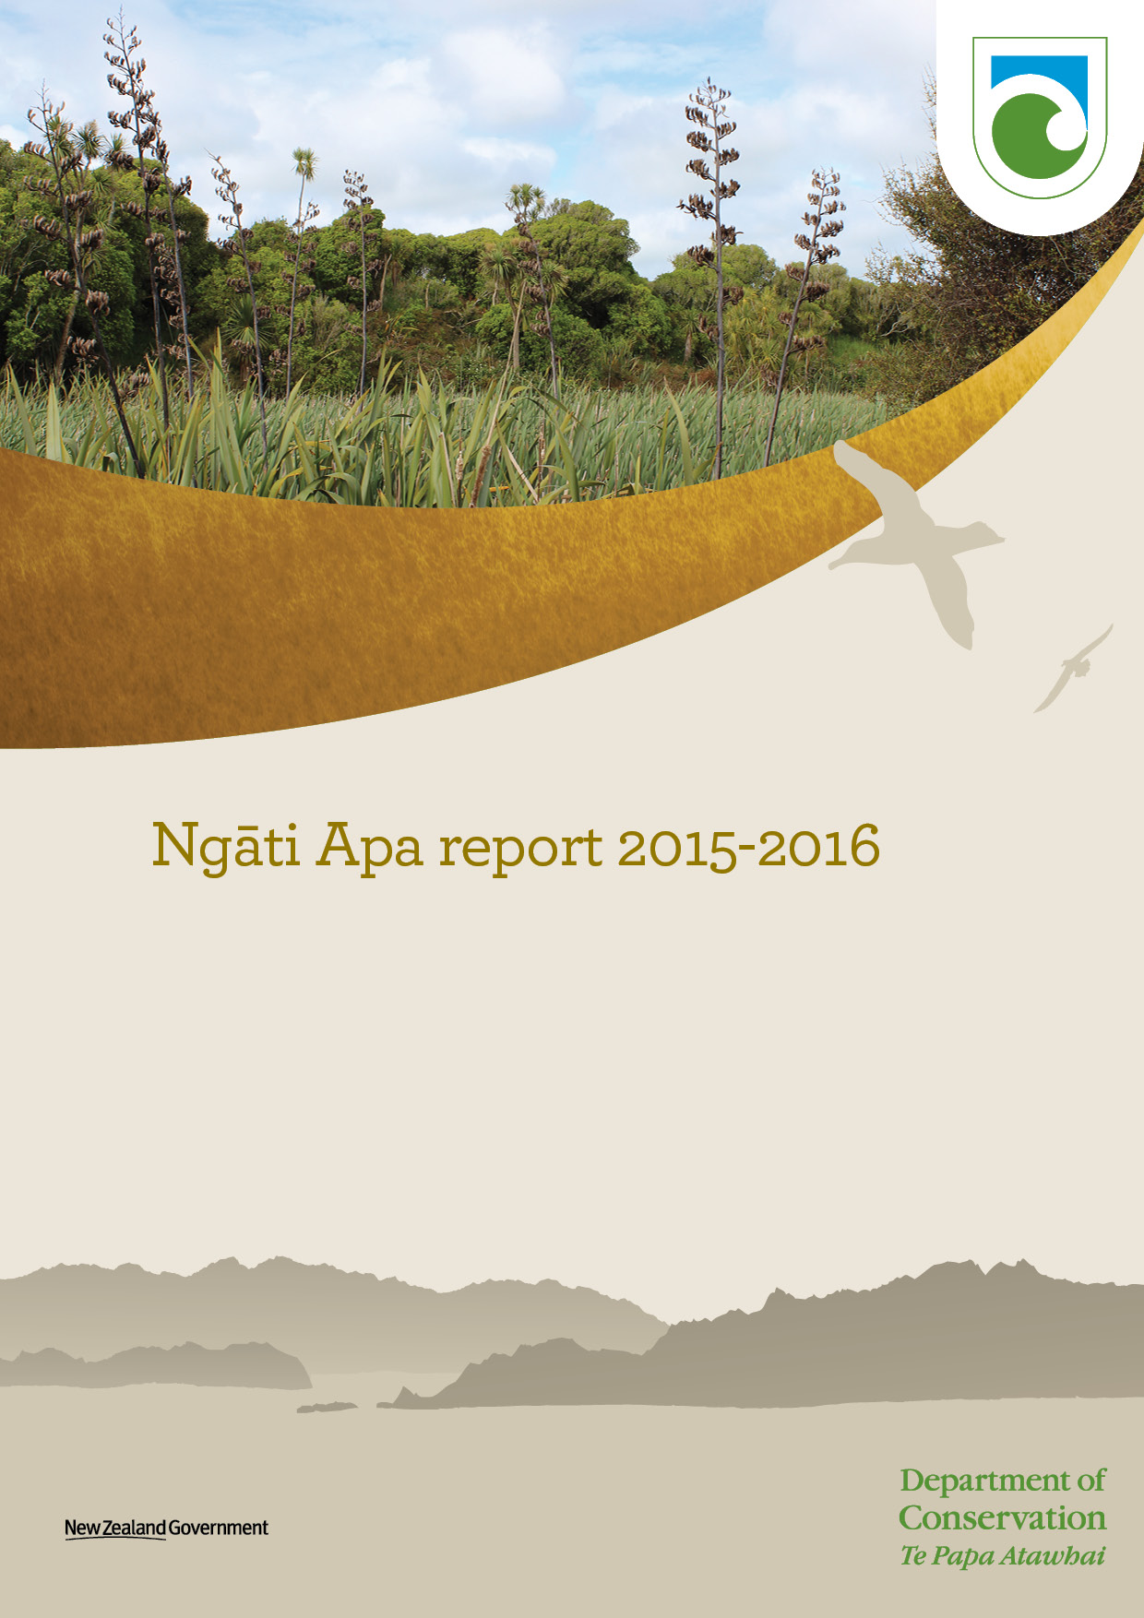
Contents

Message from the Department of Conservation??
Introduction 4
Ngāti Apa (North Island) DOC Protocol 6
3.1 Implementation and communication 7
Draft Wellington Conservation Management Strategy 7
Tamariki Taiao Programme Error! Bookmark not defined.
Reserves administration Error! Bookmark not defined.
3.2 Business planning 8
3.3 Historic resources – Wāhi tapu 9
3.4 Natural heritage 9
Prioritising ecosystems and threatened native species 10
3.5 Marine mammals 10
3.6 Pest control 11
3.7 Concession applications 12
4.
4. Sites managed by the Department in Ngāti Apa (North Island) DOC protocol area of interest 14
5.1 Omarupapako/Round Bush Scenic Reserve (Omarupapako) 14
5.2 Pukepuke Lagoon Conservation Area (Pukepuke) 15
5.3 Rangitikei River Mouth Coastal Reserves and Conservation Areas 16
5.4 Simpson Scenic Reserve 17
5.5 Whitiau Scientific Reserve (Whitiau) 18
5.6 Taukoro Conservation Area 19
5. Treaty Implementation work 16/17
5.1 Nga Wairiki/Tamariki Taiao programme
Input into reserve management plan and reserve training (Koitiata, Pakiki and Motu Karaka)
5.2 Pukepuke Lagoon Natural Heritage Plan and Geomorphological survey report

List of figures
List of tables

List of figures
Figure 1: Ngāti Apa (North Island) DOC Protocol Area. Source: Schedule to the
Deed of Settlement of the Historical Claims of Ngāti Apa. 6
Figure 3: Pukepuke Lagoon Conservation Area Error! Bookmark not defined.
Figure 4: Omarupapako/Round Bush Scenic Reserve 14
Figure 6: Pukepuke Lagoon Conservation Area Error! Bookmark not defined.
Figure 7: Rangitikei River Mouth Coastal Reserves and Conservation Areas 16
Figure 9: Simpson Scenic Reserve 17
Figure 11: Whitiau Scientific Reserve 18
Figure 12 Taukoro Conservation Area 19

List of tables

Introduction
The purpose of this report is to report back to Te Rūnanga o Ngā Wairiki Ngāti Apa (the Governance Entity) on the Department of Conservation’s (the Department) work:
- In response to the Ngāti Apa (North Island) DOC Protocol issued by the Crown;
- Lands managed by the Department in the Ngāti Apa (North Island) DOC Protocol Area.
- Treaty Settlement implementation work in the Ngāti Apa (North Island) DOC Protocol Area.
The Department is the Crown agency responsible for managing and promoting conservation of New Zealand’s historic natural heritage on behalf, and for the benefit, of present and future New Zealanders.
As part of the Ngāti Apa (North Island) Claims Settlement Act 2010, the Crown has issued, through the Minister of Conservation, a DOC Protocol. This protocol sets out a framework to enable the Department and the Governance Entity to establish a constructive working relationship that gives effect to Section 4 of the Conservation Act 1987. Matters specified in the DOC Protocol and reported on herein are:
- Implementation and communication
- Business planning
- Cultural materials
- Freshwater fisheries
- Historic resources (wāhi tapu)
- Natural heritage
- Marine mammals
- Pest control
- Resource Management Act 1991
- Visitor and public information
- Concession applications
- Consultation
Ngāti Apa statutory areas managed by the Department are Omarupapako/Round Bush Scenic Reserve, Pukepuke Lagoon Conservation Area, and Simpson Scenic Reserve. There are also deeds of recognition between Te Rūnanga o Ngāti Apa and the Minister of Conservation for these reserves, as well as Whitiau Scientific Reserve (south of Mōtū Karaka) and Taukoro Conservation Area. Other lands managed by the Department in Ngāti Apa’s DOC Protocol Area include: at Tangimoana – Tangimoana Dunes Recreation Reserve, Tawhirihoe Scientific Reserve, and Moanaroa Conservation Area; and near Hunterville – Bruce Park Scenic Reserve, Silverhope Scenic Reserve and Glenmorven Scenic Reserve.
There are currently two iwi settlements that are legislated and require implementation in the Manawatu DOC operational district one of these is Ngāti Apa (North Island). In mid-January 2017, a Treaty Implementation Ranger was appointed to implement and support Treaty Settlement work with the Governance Entity.
The Department acknowledges Kaitiaki Taiao – General Manager: Lands and Environment Chris Shenton; Grant Huwyler Group Manager and Mark Pirikahu Environmental Officer Te Runanga o Ngāti Apa; Albert Thompson, Katarina Hina, Mike Paki, and whanau, hapu, iwi of Ngāti Apa.
Heoi anō rā, he mihi miharo ki a koutou katoa a Ngāti Apa.

The Ngāti Apa (North Island) DOC Protocol
The purpose of this Protocol is to achieve, over time, the conservation policies, actions and outcomes sought by both the Department and the Governance Entity. The Protocol sets out a framework that enables the Department and the Governance Entity to establish a constructive working relationship. It provides for the Governance Entity to have meaningful input into certain policy, planning and decision processes in the Department’s management of conservation lands, and its fulfilment of statutory responsibilities, within Ngāti Apa (North Island) DOC Protocol Area.

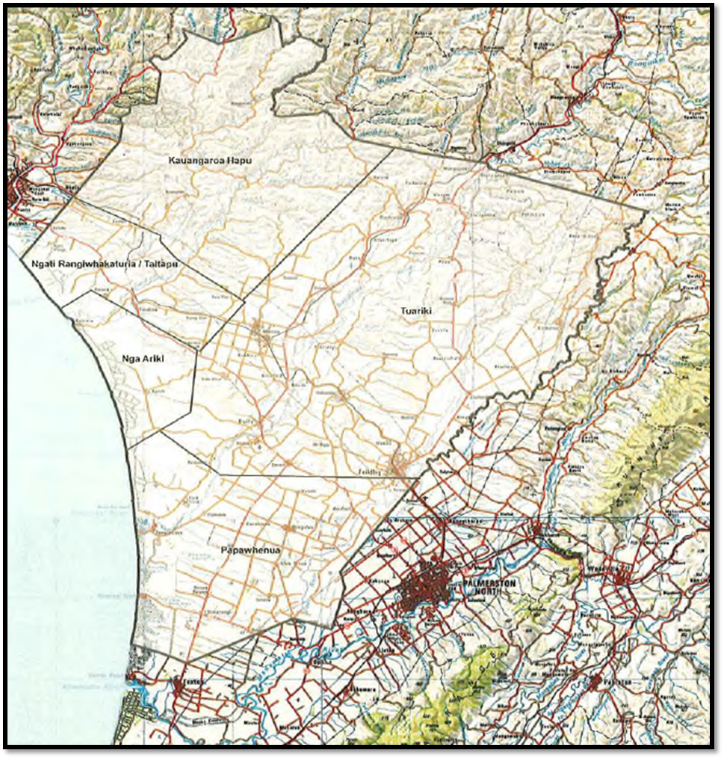
Figure 1: Ngāti Apa (North Island) (herein the DOC Protocol Area). Source: Schedule to the Deed of Settlement of the Historical Claims of Ngāti Apa

2.1 Implementation and communication
The Department’s primary contact for the Governance Entity is: Chris Shenton, Kaitiaki Taiao - General Manager: Lands and Environment. The Department also has contact details and meets annually at business planning meetings with Nga Wairiki Ngati Apa Group Manager Grant Huwyler, and has contact details for the Runanga office in Bulls.
The Department and the Governance Entity are often in contact including regular meetings between Department offices and the Governance Entity’s office. Matters discussed during these meetings includes reserve management, education and engagement. This year the Departments Lower North Island Operations Director Reg Kemper joined one of these meetings, during which Reg shared current and future work and potential opportunities for the Department to support the Governance Entity to grow conservation.

The new generation Wellington Conservation Management Strategy
The draft Wellington Conservation Management Strategy (CMS) (2016-2026) will replace the Wellington CMS 1996-2005. The draft Wellington CMS region’s boundaries have changed to include:
- some of the Manawatū-Rangitikei area, covered by the Whanganui CMS (1997-2008), and
- the Ruahine Forest Park and adjoining land, covered in the Hawke’s Bay CMS (1994-2004).
The draft Wellington CMS is simpler, shorter, more concise and Place-based. It is consistent with the other newly reviewed CMSs, and integrates the Department’s national priorities with local priorities, that have been identified with tangata whenua, the community, and others.
At the Governance Entity and Department’s regular and business planning meetings feedback was sought on their submission to the CMS.
Submissions on the draft CMS closed on 4 April 2017. Hearings were held in May for submitters who wished to be heard. The Department’s responses to submissions and the Revised draft Wellington CMS was referred to the Wellington Conservation Board (Board).
The next steps of the process are:
The Board will consider the changes the Department has made in the revised draft CMS and how submissions have been responded to. Should the Board wish to make changes, it may request the Department to further revise the draft CMS
Once the Board has completed its review, the draft CMS will be forwarded to the NZCA for its consideration and approval. They may require further changes to the CMS before approval
The draft CMS is then referred to the Minister of Conservation for comment
Finally, the NZCA approves the CMS and the strategy is notified as operative

Ngā Wairiki – Ngāti Apa Tamariki Taiao Program
Enabling whānau and especially tamariki to be involved in and engaged with the environment at significant sites is critical to growing conservation in Aotearoa. The Department is pleased to have provided a grant to the Nga Wairiki-Ngati ApaTamariki Taiao Program. The Department is excited to learn about successes of the program for tamariki this year with tuna and pingao.

Pukepuke Lagoon Conservation Area work
The Department co-ordinated a meeting with Nga Wairiki Ngāti Apa, independent consultants, a local landowner, Horizons Regional Council (Horizons) and Manawatu District Council (MDC) to talk about the history and work at Pukepuke.
Te Runanga o Wairiki – Ngāti Apa are Maori land owners near Lake Kaikopu which is close to Pukepuke.
Peter Barber and his family have farmed the area for decades, he has local knowledge and has worked with DOC.
Marianne Watson has been contracted by Horizons and has collected data from Pukepuke which will feed into the report Jacobs has been commissioned to do by Horizons looking at a catchment waterbased model using data from the 1970s.
DOC has commissioned Wildlands to complete a natural heritage plan for Pukepuke looking at the current state and future aspirations to manage and enhance the area. Roger Shand from Coastal Systems has been commissioned by DOC to do a geomorphological survey describing what’s there, hydrology, naturally occurring changes and predicting future changes.

2.2 Business planning
The Department’s annual business-planning process determines its conservation work priorities. On the 23rd February 2017, the Department and the Governance Entity met and discussed business planning for the 2017/18 year. The Department took this opportunity to inform the Governance Entity of work at Ngāti Apa’s Statutory Acknowledgement areas and other lands managed by the Department in the DOC Protocol Area.

2.3 Cultural materials
Cultural materials are defined in the Ngāti Apa (North Island) DOC Protocol as plants, plant materials, and materials derived from animals, marine mammals or birds for which the Department is responsible within the DOC Protocol Area and which are important to Ngāti Apa (North Island) in maintaining and expressing its cultural values and practices.
Current legislation means that some form of concession or permit is required for any gathering and possession of cultural materials from public conservation lands. The Department welcomes the opportunity to enable practical ways in which Ngāti Apa can exercise kaitiakitanga on public conservation lands in the Manawatu district.

2.4 Freshwater Fisheries
Freshwater fisheries are managed under two sets of legislation: The Fisheries Act 1983 and 1996 (administered currently by Ministry of Primary Industries) and the Conservation Act 1987 (administered by the Department). The Departments functions include the preservation of indigenous freshwater fisheries and habitats. The Department welcomes the opportunity to work with Ngāti Apa in the conservation, management and research of customary freshwater fisheries and freshwater fish habitats.

2.5 Historic resources – Wāhi tapu
Some of Ngāti Apa (North Island) sites of significance are raised by the settlement legislation. The Department has a statutory role to conserve historic resources in protected areas and manages some of these sites. The Department also accepts that Ngāti Apa (North Island) may choose non-disclosure to preserve the wāhi tapu nature of certain places.

2.6 Natural heritage
The Department’s intermediate outcome for natural heritage is: The diversity of our natural heritage is maintained and restored. Six objectives sit under this outcome, specifying where effort will be directed. Some of these objectives are based on technical and scientific knowledge, and are about ensuring more species survive and more ecosystems remain intact. Others are concerned with improving the species and places most valued by New Zealanders for environmental, social, cultural or economic reasons. The Department plans work to ensure progress towards each of the six objectives. These are:
- A full range of New Zealand's ecosystems is conserved to a healthy functioning state
- Nationally threatened species are conserved to ensure persistence
- Nationally iconic natural features are maintained or restored
- Nationally iconic species are managed to ensure their populations are maintained or restored
- Locally treasured natural heritage is maintained or restored through partnerships
- Public conservations lands, waters and species are held for now and future generations.
The Department is implementing this more systematic approach to manage New Zealand's natural heritage while working with others. This helps to better target effort at the places and species that will deliver the best conservation outcomes for New Zealanders.

Prioritising ecosystems and threatened native species
The first objective is to preserve and restore a full range of New Zealand ecosystems to a healthy, functioning state. To do this, the Department looks at where it could be working and prioritises locations to best meet this objective. Biodiversity specialists from the Department and the wider community have identified about 1,000 potential work locations around New Zealand that, together, represent a comprehensive range of New Zealand's terrestrial and freshwater ecosystems. These locations are known as 'ecosystem management units' (EMUs). EMUs vary in size from 1 ha to over 50,000 ha, and often include several ecosystem types within one location. The selection includes high-quality examples of ecosystems, previously-identified sites with high ecological value, and places where work is already being done (to ensure previous gains are not lost).
EMUs in the Ngati Apa (North Island) DOC protocol area currently:
- Omarupapako/Round bush
- Lake Koputara
- Himatangi Beach
- Pukepuke Lagoon
- Tangimoana
- Lake Alice
- Koitiata
- Whitiau
- Lake Pauri
- Mangara Stream
- Lake Ngaruru
- Lake Namunamu
Note: These EMU’s cover Whanganui and Manawatu DOC districts

2.7 Marine mammals
All species of marine mammal occurring within New Zealand and New Zealand’s fisheries waters are protected under the Marine Mammals Protection Act 1978. Under this Act the Department is responsible for the protection, conservation and management of all marine mammals, including their disposal and the health and safety of staff and volunteers under its control.
In the event of a marine mammal stranding in the DOC Protocol Area, the Department is to notify the Ngāti Apa’s key contact people as authorised by the Governance Entity. The Department believes there are opportunities to meet the cultural interests of Ngāti Apa (North Island) and to facilitate the gathering of scientific information. The on-site recovery of bones raises public safety risks, such as potential infection from dead and decaying tissue. It should therefore be attempted by informed and skilled persons only. If Ngāti Apa (North Island) does not wish to recover the bones (or participate in any other way), the Governance Entity will notify the Department.
The Operational Plan for Marine Mammal Incidents for the Manawatu District has recently been updated. The plan sets out the process the Department will follow when there is a stranding in those areas.
    - In the event of a marine mammal stranding where there is an overlapping interest, all Iwi will be contacted and the lead iwi will be determined through turnabout. An iwi will notify the Department if there is a swap, pass or allocate their ‘lead’ turn to another iwi.
In the plan, the indicative rohe captures the area within the Manawatu Operations District only. The Marine Mammal Stranding Plans for the Whanganui Operations District capture where iwi interests extend into those districts. The plan also notes the indicative rohe will need to be updated in the future, as a result of treaty settlement processes. The plan can also be updated if other details change for different reasons, eg. contact point or if Ngāti Apa (North Island) decide they would like to be contacted for specific strandings i.e seal strandings. If details do change, an amended version of the plan will be sent out to the Governance Entity.

2.8 Pest control
A key objective and function of the Department is to prevent, manage and control threats to natural, historic and cultural heritage values from animal and weed pests. This is to be done in a way that maximises the value from limited resources. Where appropriate, the Department will consider co-ordinating its pest control programmes with those of the Governance Entity when the Governance Entity is an adjoining landowner.
Sites managed by the Department in the Ngāti Apa (North Island) DOC Protocol Area have received various degrees of pest control in the 2016/2017 operating year; some of this work is addressed later in this report

2.9 Concession applications
A concession is an official authorisation to operate in an area managed by the Department. It may be in the form of a lease, licence, permit or easement. Activities that require a concession include: accommodation facilities; water, air or land transport services; commercial education or instruction activities; guiding; attractions such as bungy jumping; and services such as shops, tearooms, restaurants, garages, or hire services. They are also required for grazing, baches, telecommunication facilities, filming and beehives. Sometimes concession opportunities are publicly offered (tendered) by the Department; most concessions, however, are initiated by an individual or firm that approaches the Department seeking permission for an activity.
The Department consults with the Governance Entity regarding any concession applications or renewals of applications within the Ngāti Apa (North Island) DOC Protocol Area. This allows the Governance Entity to indicate whether applications affect Ngāti Apa (North Island) cultural, spiritual and historic values. Following consultation, and prior to issuing a concession, a concessionaire is advised of any impacts on Ngāti Apa (North Island) values. Communication between the concessionaire and the Governance Entity is encouraged, if appropriate.
Permits that apply generally to the Ngāti Apa (North Island) DOC Protocol Area are in Table 1; each of these is subject to special conditions, which might include: period of notification to District Operations Manager prior to proceeding with activity; period required for iwi consultation; and type of activity. Any active permits specific to a site can be found under that site in this report.
During the 2016/2017 year DOC received x number of concessions application for activity in the Ngāti Apa area of interest, the status of these are detailed below.

Table 1: Active concessions on Public Conservation Land (PCL), some with exclusions

Permit Number | Permit Type | Sites | Activity | Term
35196-FAU | Wildlife Act Permit – Low Impact | Excluding: scientific and ecological reserves, wildlife sanctuaries, and special ecological areas. | Capture, hold, transfer, release and take samples of all lizard species. | 31/12/2012 to 31/12/2018
35818-FAU | Wildlife Act Permit – Low Impact | All PCL | National authorisation for trapping (leghold, kill and live capture) possums. | 1/3/2013 to 28/2/2018
WC-27582-LAN | Concession Permit - Conforming | All PCL with some exclusions not relevant here. | National permit for driving, parking and embarking/disembarking passengers on PCL throughout New Zealand (with some exclusions). | 1/7/2010 to 30/6/2020
CA-31615-OTH | Concession Permit Non-Notified Reissue | Entry to nature and scientific reserves, and wilderness and specially-protected areas, subject to entry permits. Other exclusions not relevant here. | Low impact scientific study. | 1/11/2011 to 31/10/2021
36927-DAM | Wildlife Act permit– high impact | All PCL | Hunt/trap ferrets (mustela furo). | 1/7/2013 to 28/2/2018
50560-FAU | Wildlife Act permit– high impact | All PCL | Capture, handle and survey of frog and lizard species. | 22/08/2016 to 30/11/2022
48320-FAU | Wildlife Act permit – low impact | All public and private land in New Zealand | Nationwide authority under the Wildlife Act to capture, band and release birds on public conservation and non-public conservation land. Note - The Authority will only be for the capture, measurement and recording, banding and subsequent release of birds. | 01/03/2016 to 28/02/2026
WA-28308-DOA | Wildlife Act permit – low impact | Marton | Authority to hold mounted specimens of 1 Shining Cuckoo, 1 Long-tailed Cuckoo, 1 Kea, 2 Black Shags, and 1 Brown Kiwi | 28/05/1998 to 28/05/2048
WE-33581-FAU | Wildlife Act permit – low impact | Bulls | Permit to hold and release gamebirds | 14/03/2012 to 14/06/2201
WA-12183-DOA | Wildlife Act permit – low impact | Marton | Cultural use of feathers | 19/03/2003 to 18/03/2103
WA-14237-DOA | Wildlife Act permit – low impact | Hunterville | Hold feathers | 13/02/2004 to 13/02/2104
38895-FAU | Wildlife Act permit – low impact | Alll land within Manawatu District office boundary | Authority to band all seabirds, waders and passerines in the LOWER NORTH ISLAND region. | 01/06/2014 to 31/05/2024
38732-FAU | Wildlife Act permit – low impact | All land within Manawatu District office boundary | National authorisation to catch alive and mark gamebirds | 01/01/2017 to 31/12/2036
39991-FAU | Wildlife Act permit – low impact | All public and private land in New Zealand | To handle,weigh, measure and photograph (for ID purposes), protected species of herpetofauna at events organised by the 'Society for Research on Amphibians and Reptiles in New Zealand' (chiefly field trips). | 12/01/2015 to 11/01/2025
39635-MAR | Marine Mammal Research | Nationwide | Deceased marine mammals. | 10/08/2015 to 09/08/2025
39239-MAR | Marine Mammal Research | Nationwide | Deceased marine mammals. | 28/10/2014 to 27/10/2024
43176-MAR | Marine Mammal Permit | Nationwide | Oil spill seal rescue and rehabilitation permit | 29/10/2015 to 28/10/2020
HO/2009/02 | Marine Mammal Research | Nationwide | Research non invasive | 15/07/2008 to 14/07/2018
45780-MAR | Marine Mammal Research | Taranaki Bight | Investigation of blue whale ecology in the South Taranaki Bight | 16/11/2015 to 15/11/2025
39645-MAR | Marine Mammal Research | Nationwide | To take and possess specimens and biological samples from dead marine mammals for both scientific and display purposes. | 20/08/2013 to 19/08/2023
WA-247 | Concession Easement Non-Notified | Bruce Park Scenic Reserve | Right of Way | 26/09/1992 to 26/09/2022
WA-219 | Concession Easement Notified | Pukepuke Lagoon Conservation Area | Weir at Pukepuke Lagoon and ongoing raupo clearance. | 01/12/2000 to 30/11/2030
WA-22665-OTH | Concession Easement Non-Notified | Bruce Park Scenic Reserve | Right of Way | 01/09/2009 to 31/05/2039
WA-291 | Concession Easement Non-Notified | Tutaenui River Marginal Strip | Easement over Tutaenui Stream | 01/11/2003 to 01/11/2103
36991-OTH | Concession Easement Non-Notified | Tawhirihoe Scientific Reserve | Easement | 01/07/2013 to 30/06/2043
NM-29413-GUI | Concession Permit Non-Notified | All PCL | National Concession for ProGuides NZ and individual members of that organisation | 01/04/2012 to 31/03/2022
45646-OTH | Concession Easement Non-Notified | Rangitikei River No 5 Marginal Strip | Easement for retrospective wastewater discharge in Bulls. | 01/01/2016 to 31/12/2030
36225-GRA | Concession Permit Non-notified Re-Issue | Whale Conservation Area | Re-Issue of Grazing | 01/07/2013 to 30/06/2023
39191-RES | Research or Collection Permit - Low Impact | Nationwide | Authority for a Nationwide electric fishing authority for research purposes. | 01/01/2015 to 31/12/2024
43024-RES | Research or Collection Permit - Low Impact | Pukepuke Lagoon Conservation Area | Authority to collect up to 12 litres of water. | 08/05/2015 to 31/01/2025
WA-21375-RES | Research or Collection Permit - Low Impact | Lake Koitiata | Collecting data from monitoring to determine whether there are any impacts caused by ground water extraction on neighbouring farm. | 01/01/2008 to 31/12/2021
39095-GRA | Management Agreement | Bruce Park Scenic Reserve | Vegetation Management Agreement | 11/06/2014 to 10/06/2019

Sites managed by the Department in Ngāti Apa (North Island) DOC Protocol Area

Omarupapako/Round Bush Scenic Reserve (Omarupapako)
Omarupapako ranks as number 52 of New Zealand’s 1,000 EMUs previously addressed under ‘natural heritage’. Omarupapako covers 51.47 hectares and is located north of Foxton between Wiley Road and State Highway 1 (see Figure 4); the main access is from Wiley Road. The reserve is one of few remnants of coastal swamp forest on this west coast. The remnant consists of coastal forest and wetland vegetation growing on a sand dune and dune slack system. The forest is dominated by kahikatea, pukatea and tītoki, with some tawa and māhoe and various other broad-leafed species in the subcanopy. The swamp is dominated by flax, raupō and cabbage tree; and in drier parts are Olearia and Coprosma species. The swamp complements a population of the threatened swamp greenhood orchid Pterostylis micromega.
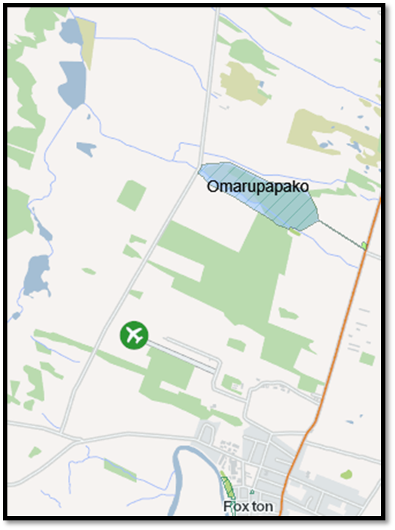 t
Figure 2: Omarupapako/Round Bush Scenic Reserve

Pest Control
Both weed and animal pests have been treated at Omarupapako. In the 2016/17 operating year weed work at Omarupapako focussed on periwinkle, pampas, Formoasa lillies and tradescantia.

The successful possum and rat control regime continues at Omarupapako. For rat control, 94 large philproof bait stations are placed at 50m intervals for the pesticide diphacinone (0.5g/kg). For possum control 2 or 3 feracol strikers (cholecalciferol 8g/kg) were positioned at bait stations; however, leg hold trapping was subsequently used to prevent possums consuming the diphacinone intended for rats. Uptake of the feracol strikers indicates a decrease in possum population, and Table x demonstrates the success of rat control. The Departments Manawatu rangers maintain and check these stations; data is provided in Table x below.

Table x Tracking rates of rats and mice
Tracking rate (%)
 | Oct 2012 (pre-bait) | Oct 2013 | Oct 2014 | Jul 2016 | Oct 2017
Rat | 13.3% (± 5.2%) | 0% (± 0%) | 0% (± 0%) | 0% (± 0%) | 0% (± 0%)
Mouse | 23.3% (± 7.5%) | 0% (± 0%) | 16.7 (±3.9%) | 16.7 (± 5.0%) | 33% (± 7.7%)

In addition to the possum and rat control regime at Omarupapako, also used are mustelid boxes for hedgehogs and mustelids to protect small forest birds and invertebrates. This program is monitored monthly by volunteers. Trap-kill records for 2016/17 are in Table x.

Table x Mustelid boxes trap-kill records 2016/17

 | Month/Year
Animal | 7/2016 | 8/2016 | 10/2016 | 11/2016 | 12/2016 | 1/2017 | 2/2017 | 4/2017 | 5/2017 | 6/2017 | Total
Hedgehog | 1 |  | 5 |  | 1 | 4 | 4 | 5 | 2 |  | 22
Mouse |  |  |  |  |  |  |  |  |  | 1 | 1
Ferret | 1 |  |  |  |  |  |  |  |  |  | 1
Rat |  |  |  | 3 |  | 2 |  | 2 |  | 2 | 9
Stoat | 2 | 1 | 2 | 1 | 4 |  | 2 |  |  |  | 12
Weasel |  |  | 1 |  |  |  |  |  | 2 | 1 | 4
Total | 4 | 1 | 8 | 4 | 5 | 6 | 6 | 7 | 4 | 4 | 49

Revegetation 2016
Planting took place at Omarupapako on August 4 2016. There was a total of 741 plants during this planting. Seeds of these plants were all eco-sourced from the site. Plant species and quantities are in Table x.

Table x Plant species and quantities planted at Omarupapako 2016.

Traditional Maori name | Latin Name | Quantity
Mahoe | Melicytus ramiflorus | 50
Mingimingi | Coprosma prop. Robusta | 13
Kahikatea | Dacrycarpus dacrydioides | 52
Wiwi | Ficinia nodosa | 66
Closest species: Maurea | Carex virgata | 34
Harakeke | Phormium tenax | 210
Toetoe | Austraderia toetoe | 68
Mingimingi | Coprosma propinqua | 33
Ti kouka | Cordyline australis | 33
Akeake | Dodonaea viscosa | 20
Kanuka | Kunzea ericoides | 50
Manuka | Leptospermum scoparium | 84
Ngaio | Myoporum laetum | 23
Closest species: Akeake | Olearia solandri | 5
Total |  | 741

Pukepuke Lagoon Conservation Area (Pukepuke)
Pukepuke covers 82.70 hectares and is located between Himatangi Beach and Tangimoana, approximately 5 km west of State Highway 1 (see Figure 5); the main access is from Pukepuke Rd off State Highway 1. Pukepuke Lagoon is a dune lake resulting from the formation of sand dunes along the coast near Tangimoana which prevented inland water run-off escaping out to sea. It is a shallow lake up to 2 metres deep that can dry up in summer droughts. The royal spoonbill (kōtuku-ngutupapa) and variable oystercatcher (tōrea pango) visit the wetland occasionally.
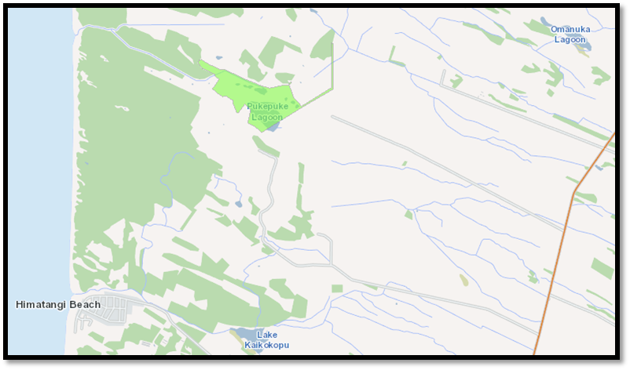

Figure 5: Pukepuke Lagoon Conservation Area

Pest Control

DOC 200/250 mustelid traps are used at this site to protect nationally threatened birds and migratory birds, rare plants and native fish. This programme is monitored monthly by volunteers. Trap-kill records for 2016/17 are in Table X
Table x: Mustelid boxes trap-kill records 2016/17
 | Month/Year
Animal | 1/2017 | 2/2017 | 3/2017 | 4/2017 | 5/2017 | 6/2017 | Total
Hedgehog | 6 | 3 | 3 | 3 | 2 | 4 | 21
Mouse |  |  |  | 1 |  |  | 1
Other | 1 |  |  | 1 – cat |  |  | 2
Rat | 3 |  |  |  | 2 | 1 | 6
Stoat | 3 | 2 |  | 4 |  | 2 | 11
Weasel |  |  |  |  | 4 | 4 | 8
Ferret |  |  |  |  | 1 |  | 1
Total | 13 | 5 | 3 | 9 | 9 | 11 | 50

Concessions
Active concessions at Pukepuke:
- WA-219 Manawatū District Council (MDC) for an easement to drain storm water. The concession is subject to special conditions for spraying, vegetation clearance, use of machinery, the existing weir, a spillway and water-level monitoring. The concession term is 30 years (1 December 2000 to 30 November 2030).
- 43024-RES Horizons Regional Council (Horizons) to collect up to 12 litres of water. Samples are taken to determine the lake’s health using the lake’s trophic lake index. Sampling is quarterly – most likely in June, September, December and March. The concession term is 8 May 2015 to 31 January 2025.

Rangitikei rivermouth coastal reserves and conservation areas
The Department manages sites on both sides of the Rangitikei rivermouth at Scotts Ferry and Tangimoana (see Figure 6). At Scotts Ferry are Moanaroa Conservation Area (covers 36.9 hectares) and Part Run 23 Conservation Area (covers 8 hectares); these sites are accessed via Bulls. At Tangimoana are Tawhirihoe Scientific Reserve (covers 152.42 hectares), Tangimoana Dunes Recreation Reserve (covers 6.65 hectares) and Tangimoana Beach Conservation Area (covers 9.82 hectares).
The Tangimoana dune system of foredunes, parabolic dunes, dune slacks and gravel plains is a significant dune area on the west coast of the North Island. The system provides important habitat for two extremely rare and threatened plants: a spiked sand sedge (Eleocharis neozelandica), and a species of sand daphne (Pimelea) (Singers, 1998). The seed of the sand daphne was collected from Turakina, propagated and later planted at Tangimoana in the early 1990s (Dawson, Rapson, Robertson, Fordham; 2005); it is sometimes referred to as Pimelea Turakina acknowledging its limited range (Tangimoana, Himatangi and Turakina). Work at these sites is in the interest of sand daphne.
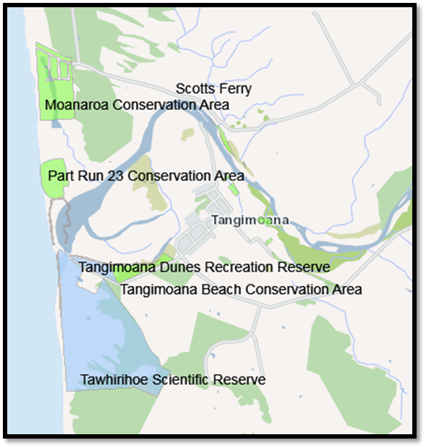
Figure 6: Rangitikei rivermouth coastal reserves and conservation areas

Weed control and maintenance at Tawhirihoe Scientific Reserve
Tawhirihoe Scientific Reserve is a 152 ha area of dune country that lies in the Foxton Ecological District, just south of the Tangimoana township. The reserve contains one of the last examples of a dynamic dune and ephemeral wetland system, that once stretched along the west coast from Levin to Hawera, as well as a population of North Island fernbirds, and was recommended for protection under the Protected Natural Areas Programme.

Weed control has been focused on reducing the spread of field horsetail as much as possible and reducing impacts of other weeds on threatened plant sites. Fencing is maintained at the site.

Concessions
Active concessions at 36991-OTH a right-of-way for farm stock, farm vehicles and farm staff. The concession term is 1 July 2013 to 30 June 2043.

Simpson Scenic Reserve (Simpsons)
Simpsons covers 36.3736 hectares (see Figure 7). Simpsons is north of Hunterville and entrance to the reserve is from Murimotu Road, left from State Highway 1 before crossing the train tracks. The south-eastern boundary of the reserve lies on recent river terraces, perhaps on what is now Porewa Stream. There is a clearing that is increasingly being used for camping activities. Around the clearing are good remnants of (predominantly) kahikatea, rimu and tawa forest. There is also evidence of miro, hīnau, māhoe, maire, black matipo and lacebark. Simpsons is known as Ruakiwi in the Ngati Apa (North Island) Statement of Association and Deed of Recognition.
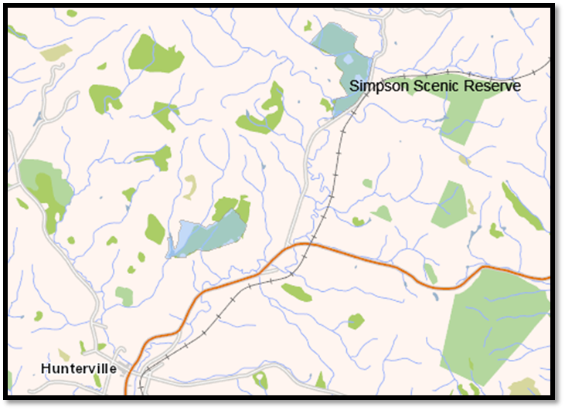
Figure 7: Simpsons Scenic Reserve

Seed collection with Manawatu District Council nursery
DOC and Manawatu District Council nursery manager and students collected seeds for the purpose of restoration at Simpsons and/or nearby sites.

Whitiau Scientific Reserve
Whitiau Scientific Reserve (Whitiau) (see Figure 8) is located between the true right of the Whangaehu rivermouth and Motu Karaka. Motu Karaka (35 ha) is one of three reserves vested in fee simple to Ngāti Apa (North Island) as part of the Treaty Settlement. Whitiau covers almost 243 hecatres; it was protected as a scientific reserve in 1991 as a rare example of a comparatively-natural dune ecosystems (Ogle, 1994). It accommodates healthy populations of spinifex and sand coprosma. Whitiau has also catered for Sebaea Ovata, an endangered annual herb found in only one other location in New Zealand. Other threated plants observed here include mīkoikoi, a sand iris (Libertia peregrinans), and a dwarf musk with large white flowers (Mazus novaezeelandiae).
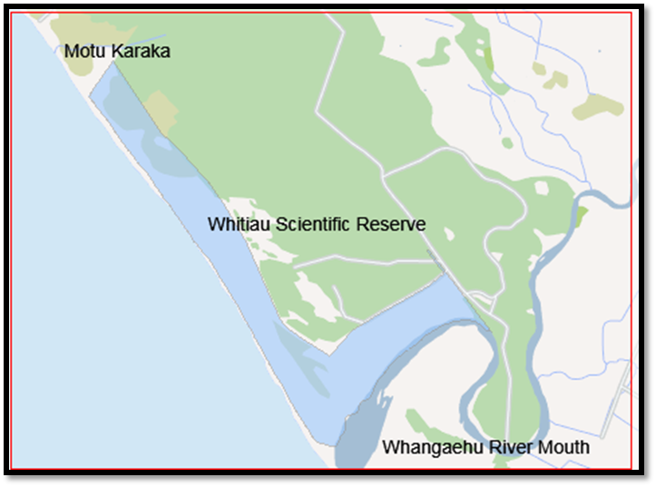
Figure 8: Whitiau Scientific Reserve

Taukoro Conservation Area
Taukoro Conservation Area (see Figure 9) is found north of Mangamahu near State Highway 4, south of Kakatahi. North of Mangamahu on Creek Road is Pākiki, another reserve vested fee simple to Ngāti Apa (North Island) as part of the Treaty Settlement. Taukoro Conservation Area is a distinctly different site to the adjacent Taukoro Forest Conservation Area – these two should not be confused. Taukoro Conservation Area covers almost 336 hectares with 300 hectares remaining in bush, predominantly lowland podocarp tawa forest.
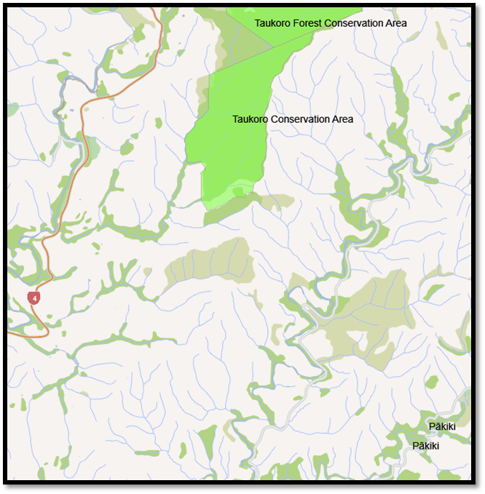
Figure 9: Taukoro Conservation Area

Concessions
Taukoro Conservation Area is subject to a perpetually-renewable lease issued under the Land Act 1948. Although the lease is over the entire block, only 25 hectares is in pasture and grazed; the remainder is protected from clearance by a clause in the lease. The lease expires on 30 June 2025. The lease means that the area is “landlocked” so there is no public access, because of this is very little to no active management of the site.

Progressing Treaty Settlement Implementation
In addition to the preceding report on the Deparments planned work, the Department was able to progress with additional work in Treaty Settlement Implementation as agreed between the Department and Te Rūnanga o Nga Wairiki-Ngati Apa. Initiatives achieved together in the 2016 – 2017 year include –
- Input to reserve management for three scenic reserves vested to Ngati Apa as part of the Treaty Settlement package;
- Automatic traps for Pākīkī Scenic Reserve;
- The development of a Natural Heritage Plan for Pukepuke Lagoon Conservation Area; and
- A geomorphological assessment for Pukepuke Lagoon Conservation Area.

Input into reserve management plan for Lake Koitiata, Mōtū Karaka and Pākiki
As part of the Ngāti Apa (North Island) Treaty Settlement, three sites were vested in fee simple to be administered as scenic reserves for the purposes specified in section 19(1)(a) of the Reserves Act 1977. : Namely Lake Koitiata, Mōtū Karaka and Pakīkī.
The purpose of scenic reserves under Section 19(1)(a) of the Reserves Act 1977 (Reserves Act) is for the purpose of protecting and preserving in perpetuity for their intrinsic worth and for the benefit, enjoyment, and use of the public, suitable areas possessing such qualities of scenic interest, beauty, or natural features or landscape that their protection and preservation are desirable in the public interest:
Section 40 of the Reserves Act addresses the functions of the administering body. It is a reserve administering body’s duty to administer, manage and control reserve/s under its control and management in accordance within the appropriate provisions of the Reserves Act and in terms of its appointment and the means at its disposal, so as to ensure the use, enjoyment, development, maintenance, protection, and preservation, as the case may require, of the reserve for the purpose for which it is classified.
Sections 42 to 64 address powers of the Minister of Conservation and the administering body, as well as other rights and responsibilities throughout the Act. There are three types of ‘powers, rights and responsibilities’ set out:
- Those the administering body can carry out independently
- Those that require the Minister’s prior consent and are subject to the Act
- Powers of the Minister.
For the Minister or the Ministers’ delegate to consider the transfer of a reserve from the Governance Entity to a new administrative body, the Department must receive a letter of request from Ngāti Apa’s Post Settlement Governance Entity.
A reserves administration training and presentation was held on Thursday 16th March 2017 at the Departments Whanganui local office to discuss scenic reserve classification, reserve administering bodies, and rights and responsibilities of the Minister and administering body. Matthew Kidd – the Departments Treaty Settlement solicitor; members of hapu and the Departments local staff from Palmerston North and Whanganui attended.
The reserve management plan process will take some time to complete. Wildlands Consultants Ltd (Wildlands) were successful in commissioning the reports for input into a reserve management plan for Lake Koitiata, Mōtū Karaka and Pākiki. Field surveys were completed to obtain information on the current state and threats to the sites. Hui with hapu were held in person and via email/phone where aspirations and management issues were discussed.
Recommendations were received from Wildlands:
- Restoration of Motu Karaka - pest animal and weed control and planting
- Restoration of Lake Koitiaia – ecosystem health and monitoring and protection of mahinga kai.
- Protection and preservation of Pakiki – pest animal and weed control
The Department would like to support the Governance Entity in any future work.
The Department would like to acknowledge:
- Albert Thompson and hapu Ngati Rangiwhakaturia trustees/whanau; Katarina Hina and hapu Nga Wairiki ki Uta trustees/whanau; Mike Paki representative for Turakina Marae for their input and commitment to this project.
- Wildlands for their commitment and professionalism to complete the reports.

Automatic traps for Pākiki Scenic Reserve
One of the restoration objectives out of the input to reserve management report for Pakiki Scenic Reserve was controlling pest animals and was rated as a medium-high priority.
The objective of pest animal control is to enhance and protect forest processes and populations of indigenous fauna species by lowering populations of introduced pest animals.
Careful consideration of the feasibility of meaningful control of each of the pest animal species is required. Effective, sustainable control will be hindered by the long, narrow shape of the reserve. Pest control within the surrounding areas will mean greater reductions in pest numbers.
The use of self setting traps Goodnature A24 traps controls rats and stoats, and Goodnature A12 traps controls possums. Each trap is equipped with a pressurised canister that allows the trap to deliver up to 24 kills before a new canister is required for rat traps and 12 kills for the A12 possum traps. Self setting traps are expensive to purchase but the theory is that less labour is required over time.
The Department of Conservation Manawatū purchased on behalf of Nga Wairiki ki Uta 15 units of A12 Goodnature traps and 15 units of A24 Goodnature traps for pest control at Pākiki Scenic Reserve.
  - The following conditions have been agreed to between Department Rangers and Nga Wairiki ki Uta chair by email:
  - DOC providing initial training for placement, installation and maintenance; and technical advice as requested and when available.
  - Wairiki ki Uta monitor the network ie monitor carcasses at least once a month (success rates of the traps)
  - Wairiki ki Uta nominate a leader to be ultimately responsible for this network of traps ie
  - o trap maintenance,
  - o gas canister replacement,
  - o bait replenishment,
  - o and a roster if applicable for monitoring and carcass recovery.

  - Pukepuke Natural Heritage Plan

Pukepuke Lagoon Conservation Area (Pukepuke) is a Stewardship Area under the Conservation Act and is managed for the Departments intermediate outcome ‘the diversity of our natural heritage is maintained and restored’. The Departments intermediate outcome objective for Pukepuke is ‘a full range of NZ’s ecosystems is conserved to a healthy functioning state’.
Pukepuke has very significant historic heritage values and is a significant site for Ngāti Apa (North Island). From a Ngāti Apa (North Island) perspective, an immense amount of work is required to fully restore this ecosystem to a healthy functioning site. The Governance Entity has expressed concern about weeds near one of their wāhi tapu sites at. The Department has offered support to enable this work. The site is also used for game bird hunting between May and August. Several of the bird species present are seldom found elsewhere in the Manawatū region, including New Zealand dabchick (Poliocephalus rufopectus) and Australasian bittern (Botaurus poiciloptilus). Threatened or At-Risk plant species have previously been recorded at the site and may still be present, including Zannichellia palustris and dwarf musk (Mazus novaezeelandiae subsp. novaezeelandiae). Fish species include a large population of shortfin eel (Anguilla australis), and longfin eel (A. dieffenbachii) and inanga (Galaxias maculatus) are also present.
There is no recently compiled, cohesive document for integrated management at Pukepuke; the last management plan was drafted in 1987 (Aviss 1987). There is now a desire to work in partnership to restore Pukepuke and the Department and Ngāti Apa (North Island) require a cohesive document for integrated management at Pukepuke.
The vision is for Pukepuke to be in a healthy functioning state by 2030. The report commissioned by Wildlands includes: a description of the site, background information and physical characteristics; ecological values and threats; an assessment of what a healthy functioning state of the Pukepuke site may look like; goals, objectives, and actions; and milestones and direction for day to day work.
In early 2017, field surveys were completed where information was obtained on the current state and threats to the sites. Subsequently, Wildlands met with the Governance Entity representative Chris Shenton where aspirations and management issues were discussed.
Recommendations were received from Wildlands on what a healthy functioning ecosystem would look like and management objectives and actions and the Department would like to support the Governance Entity in any future work.
The Department would like to acknowledge iwi local knowledge and input from Chris Shenton, Kaitiaki Taiao - General Manager: Lands and Environment Te Rūnanga o Ngā Wairiki Ngāti Apa and the Wildlands team for their commitment and professionalism to complete the report.

Pukepuke Geomorphological report
Geomorphological assessments underpin a range of environmental studies including defining the coastal environment, natural character assessments, outstanding landform and landscape identifications, hazard assessments, management investigations and Tangata whenua interests.
Geomorphological Assessments address the following:
- What is there – a description of the current landform and its geographical setting;
- Why is it there – an explanation of why the current landform is as it is, i.e. the formative processes;
- How will it change – prediction of how the landform may change in the future.
- Initial recommendations relating to restoration management
Pukepuke is the product of geomorphological processes that have been operating over the past several thousand years. Processes are still active in this area and physical characteristics can be expected to continue to change – both through natural and anthropogenic influences. Such knowledge is of fundamental importance when formulating and enacting future management.
Roger Shand from Coastal Systems Ltd was commissioned to complete a geomorphological assessment for Pukepuke.
The Department would like to acknowledge iwi local knowledge and input from Chris Shenton, Kaitiaki Taiao - General Manager: Lands and Environment Te Rūnanga o Ngā Wairiki Ngāti Apa.

Conservation Act 1987 Section 4: This Act shall so be interpreted and administered as to give effect to the principles of the Treaty of Waitangi.
This herb is listed as Nationally Critical, under the New Zealand Threat Classification System.

