SCHOOL OF SCIENCE

Using Historic Satellite and 3D UAV Imagery to Map the Dynamics of the Coast at Sites with Anthropogenic Debris in Southland, New Zealand
Cassandra Newman 2022

THESIS SUMMARY
See full thesis for all maps, data tables and more in-depth discussion of the research.

Abstract
The coast is a naturally active margin that forms an important barrier system subjected to the forces of both the terrestrial and marine environment. Coastal erosion has become a problem where infrastructure such as roads and anthropogenic debris like coastal landfill are being exposed and subsequently consumed by the ocean. The overall aim of this research was to investigate the ability of a generalised GIS (Geographical Information System) methodology to quantify coastal dynamics at different locations with anthropogenic debris. The GIS methodology used compares historic satellite imagery as well as 3D seasonal UAV (Unmanned Aerial Vehicle) imagery to see where and how changes are occurring. This study investigated four sites along the southern coast of the South Island, New Zealand: Monkey Island, Colac Bay, Fortrose, and Porpoise Bay. Historic satellite imagery was used to investigate coastal dynamics by assessing the magnitude and rate of change occurring from past shorelines. Patterns were interpreted to make predictions about where the shorelines will be in the future. 3D UAV imagery was collected to analyse volumetric change on a seasonal basis. The main findings illustrate the influence of human intervention, such as how rip rap or anthropogenic debris can change the patterns occurring along the coast compared to a natural coastline. Seasonal 3D UAV imagery and analysis highlights both the great deal of temporal and spatial change in these environments, as well as the complexity of understanding the dynamics of coastal areas. This study evaluates the validity of applying a generalised GIS methodology and makes recommendations for further research, which will, in turn, inform future monitoring and management of coastlines with anthropogenic debris.

Introduction
The coast is a naturally active margin that forms an important barrier system subjected to the forces of both the terrestrial and marine environment. Climate change, rising sea levels and anthropogenic strains are impeding the natural fluctuations of the coast (Nicholls & Cazenave, 2010; Romaine et al., 2021; Rouse et al., 2017). Coastal erosion has become an environmental and economic issue because of these strains as numerous communities and cities around the world are located along the coastal zone. Studies have investigated the dynamics of coastlines, how anthropogenic pressure has influenced changes and if these changes can be monitored and predicted (Addo, 2018; Bird, 2005; Pascucci et al., 2018; Walling, 2006). Geographical information systems (GIS) are a leading way to map land area changes with models, analysis techniques and systems to assist in monitoring and managing the natural and urban environment. Satellite imagery and 3D imagery from an unmanned aerial vehicle (UAV) could help solve temporal and spatial problems to revolutionise coastal monitoring and management as we adapt to a changing coastline.
The overall aim of this research was to investigate the ability of a generalised GIS methodology to quantify coastal dynamics at different locations with anthropogenic debris. The impact of anthropogenic debris along the coast needs to be addressed. Landfills, roads, urban areas, cemeteries, and debris along New Zealand’s coastlines are at risk of being consumed by the threat of rising seas, more extreme weather, and other climatic events causing erosion. The Southland region of New Zealand at the bottom of the South Island is known for its diverse coastlines and biodiversity. The shores host endemic penguin species including the Fiordland crested penguin and the yellow-eyed penguin, sea lions and seals as well as the southern populations of Hectors dolphin (Hamner et al., 2017; Presswell & Bennett, 2021; Seddon et al., 2013). Southland also has some of New Zealand’s most polluted estuaries (Lee & Partridge, 1983) which are essentially the kidneys of our rivers before water goes into the sea. Coastal erosion has become a problem along the southern coast where infrastructure and debris along the shore are being consumed by storms and the ocean. Adaptive management is the key for preventing the risk to wildlife and the natural environment so understanding the dynamics of the coast is important. Within this Southland coastal context, I will specifically address the following questions as my objectives:
- What GIS processes are applicable to characterising historic shorelines for understanding the past dynamics occurring at each site?
- Can the past trends characterised in (1) be used to predict where future shorelines will be?
- Does characterising the seasonal volumetric changes occurring along the coastline provide additional insight into the temporal and spatial patterns of shoreline change?

Methodology

Study Areas
Four sites along the southern coast of the South Island of New Zealand have been selected for this study because each have anthropogenic features susceptible to current or future erosion. All sites have unique factors that may affect the dynamics of the coastline to help contrast how a generalised method approach may work with specific coastlines. These sites are (from west to east) Monkey Island, Colac Bay, Fortrose, and Porpoise Bay (Fig. 2.1). Erosion and exposure of anthropogenic debris at these sites may result in negative effects on local species.Figure 2.1. Study areas shown throughout the southern coast in Southland, New Zealand. A. The study areas are Monkey Island, Colac Bay, Fortrose, and Porpoise Bay. B. The right-hand map shows where the research took place in relation to New Zealand.

Datasets and Acquisitions
Satellite imagery used for this thesis was either collected from the internet, shared by organisations, or purchased. Field trips to Southland to collect UAV imagery at the four site locations were undertaken during February, May, August, and December 2021. An overview of the process of collecting, analysing, and presenting the data is illustrated in figure 2.2.
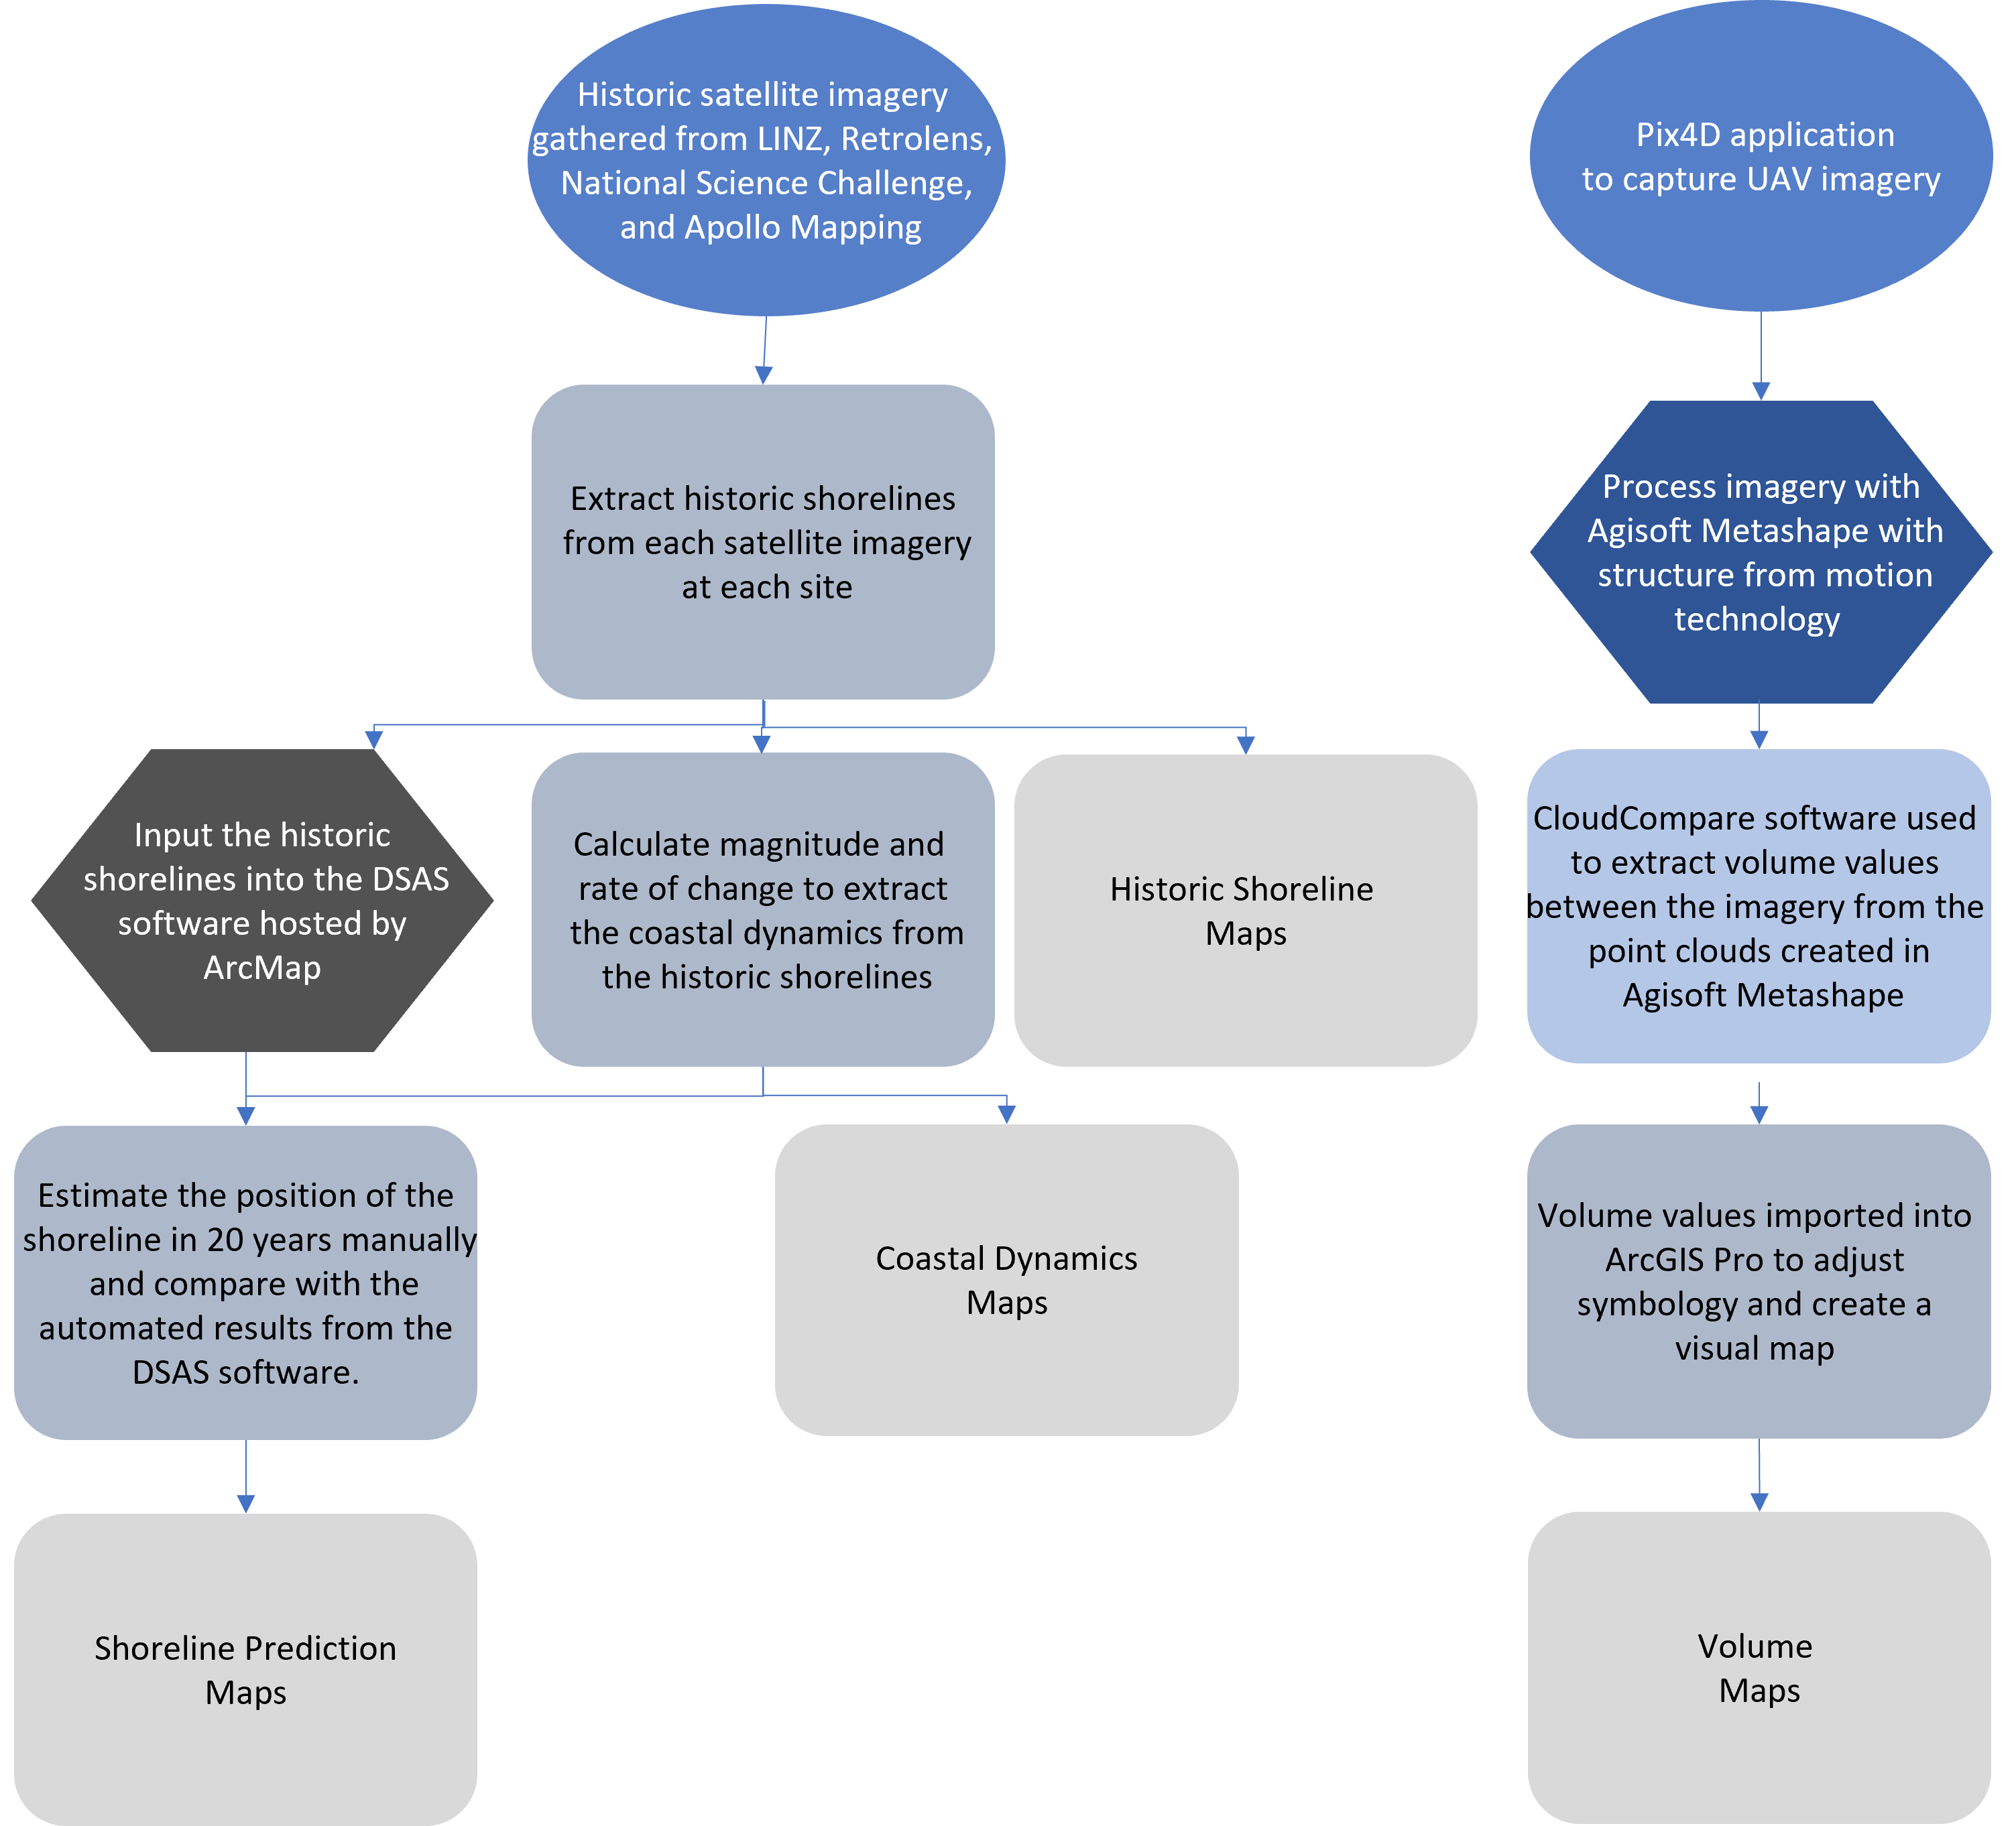
Figure 2.2. Overview of collecting, analysing, and presenting data for this research. The top blue icons indicate where the imagery came from. On the left workflow, the top grey step illustrates where the shorelines are extracted from the satellite imagery in ArcGIS Pro. The shorelines are used as an input for the DSAS (Digital Shoreline Analysis System) software (dark grey), the coastal dynamics (grey) and are illustrated as a final output in the results. The coastal dynamics are illustrated in a map as a final output and used along with the DSAS software to predict where the shoreline will in 20 years which is also a final output of the study. The dark blue on the right workflow shows the processing of the UAV imagery in the Agisoft Metashape application. The output from this went into the CloudCompare application to extract volume values shown in the light blue. The volume values were imported into ArcGIS Pro in grey to have the symbology changed and to be presented in a map. Light grey is the final output.

Results
Over the course of several months, historic satellite and 3D UAV imagery was collected and analysed to get a thorough understanding of the coastal dynamics of the locations studied. The results illustrate the success of a generalised GIS methodology used at different site locations with different factors affecting each shoreline. Comparison of the historic satellite imagery showed the changes to the position of the shorelines that have occurred over the past ~70 years. Transects were virtually generated 20 m apart and populated with the rate and magnitude of change occurring between the historic shorelines to produce coastal dynamics that were illustrated with a matrix.

Coastal dynamics
The four main dynamics were ‘eroding’, ‘accreting’, ‘stable’ and ‘unstable’. Monkey Island and Colac Bay both showed a mainly stable coastline with specific areas of erosion or mixes of dynamics (Fig. 3.1). Monkey Island has areas of slight erosion, notably up to 60 m to the north of the two stream mouths along the shoreline analysed. Colac Bay has two main areas of interest in this study. The first is between transect 65 – 75 with erosion occurring in front of the coastal landfill and from transects 109 – 119 where the vegetation line takes over from the hard engineering seen throughout most of the coastline. Whereas at Fortrose, major erosion and stable dynamics was shown along the shoreline in specific areas. The shoreline between transects 18 – 28 has stabilised from a major erosion pattern in recent years. The entire length analysed is of concern due to 34 out of the 49 transects showing a net change of over 10 metres of erosion. Porpoise Bay showed an unstable coastline because of extreme cycles of erosion then accretion extracted from the historic shorelines. This is shown with the dark transect lines along the entire length of the shore (Fig. 3.1). The most unstable area of this coastline is between transects 87 – 95 with transect 91 showing a rate of erosion averaging at ~2.63 m per year.
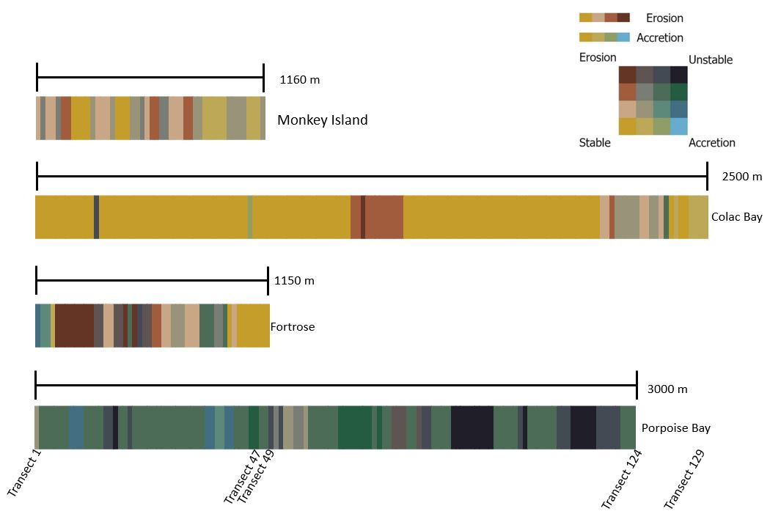
Figure 3.1. A summary of all the dynamics occurring along each coastline. Each vertical line represents a transect which are spaced 20 m apart on the survey site. A scale bar shows the distance the transect lines cover at each shoreline. Colac Bay is showing more transects in a smaller area than Porpoise Bay because of the profile of the shoreline. From left to right shows transects 1 to the end of the shoreline surveyed. Each transect was placed into a matrix based on what level of accretion and erosion it showed. If both these patterns are low, then the shoreline is stable resulting in a yellow transect line. If both are high, it is classed as unstable resulting in a black transect line. Brown shows a dominant erosion pattern and blue shows a dominant accretion pattern. The colours in between show a mix of dynamics.

Predicting future shorelines
Predictions were manually generated by hand and automatically generated with a DSAS (Digital Shoreline Analysis System) software for where the location of the shoreline in 20 years will be (Fig. 3.2, 3.3, and 3.4). These predictions were made based on the historic shorelines and coastal dynamics at each site. Monkey Island showed little change between the current shoreline and the predicted shoreline in 20 years. This was for both the manual and automated predictions. This was the same as the Colac Bay predictions apart from between transects 65 – 75 where the automated prediction only showed an average of 5 m of retreat whereas the manual prediction estimates an average of 15 m of retreat (Fig. 3.3).
Figure 3.2. Shoreline prediction in 20 years at Colac Bay derived from automated predictions with the DSAS software and manual predictions. The blue line is the DSAS shoreline prediction with an uncertainty margin spanning 20 m either side of the shoreline. Both manual and automated predictions are mostly the same as the 2021 shoreline except between transects 65 – 75 and 109 – 119 which are illustrated in figures 3.3 and 3.4.
Figure 3.3. Shoreline prediction in 20 years at Colac Bay close up 1 derived from automated predictions with the DSAS software and manual predictions. The blue line is the DSAS shoreline prediction with an uncertainty margin spanning 20 m either side of the shoreline. Both the manual and automated software shows further erosion of this area in the next 20 years shown by the dark brown and blue lines being shoreward of the 2021 shoreline (light brown). The manual prediction is further shoreward because it illustrates the pattern shown from the 2014 survey onwards where human intervention was stopped.
Figure 3.4. Shoreline prediction in 20 years at Colac Bay derived from automated predictions with the DSAS software and manual predictions. The manual prediction shows a similar shoreline to the 2021 shoreline and the automated shoreline (blue) shows accretion in some areas around transects 111, 113 - 114, 117 – 118, 121 and 125. The blue line is the DSAS shoreline prediction with an uncertainty margin spanning 20 m either side of the shoreline. The left hand of the close up shows the DSAS software predicted erosion on transects 107 and 108 where the manual prediction stayed the same as the 2021 shoreline.
The Fortrose automated prediction for the shoreline in 20 years is approximately the same as the current shoreline apart from between transects 7 – 10 where it is predicted to retreat 7 m (Fig. 3.5). At Fortrose, the manual prediction estimates the shoreline between 18 – 27 will retreat more than an average of 10 m in 20 years. Porpoise Bay has a mix of predictions which are dominated by the DSAS software predicting accretion for most of the shoreline (Fig. 3.5).
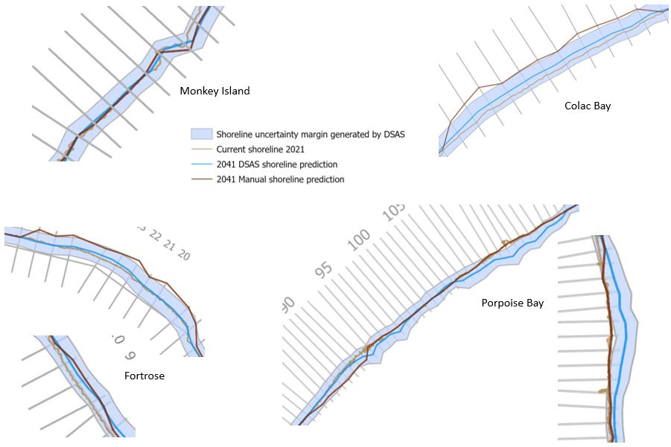
Figure 3.5. A summary of the main areas of interest where predictions are shown at each site. Monkey Island and Fortrose have the sea on the left-hand side of the shoreline and Colac Bay and Porpoise Bay have the sea on the right-hand side of the shoreline. Monkey Island showed little change between the current shoreline and the predicted shoreline in 20 years which is illustrated in the top left of the figure. This was the same as the Colac Bay predictions apart from between transects 65 – 75 where the automated prediction only showed an average of 5 m of retreat whereas the manual prediction estimates an average of 15 m of retreat shown in the upper right image. Transects 7 – 10 at Fortrose are predicted to retreat about 7 m on average shown on the lower left-hand corner of the figure. The manual prediction estimates the shoreline between 18 – 27 at Fortrose will retreat more than an average of 10 m in 20 years shown on the left middle picture of the figure. Porpoise Bay shoreline dominated by the DSAS software predicting accretion shown in the bottom right-hand images.

3D UAV seasonal data
3D UAV imagery was collected at the four sites to extract volumetric changes in sand and sediment from February to December 2021. These volumetric changes were calculated by overlaying point clouds of each survey with the other surveys taken. Empty cells were interpolated for the results. Table 1 illustrates the change in volume between the UAV surveys. The added and removed volume between each survey is standardised to 100m² to simplify comparisons between each site. Monkey Island and Colac Bay showed extremely similar results for the August to December comparison with 1.332 m³ and 1.710 m³ added, and 29.186 m³ and 29.951 m³ removed, respectively. This was also observed for the February to December surveys with 0.708 m³ and 0.928 m³ added, and 22.924 m³ and 21.688 m³ removed, respectively. Porpoise Bay showed the largest volume removed through the study period with the removal of 63.615 m³ between February and December. Most of that occurring between February and August while the added and removed volumes between August and December are more similar at 29.997 m³ and 37.718 m³ respectively. Overall, there was a larger volume removed than added at Monkey Island, Colac Bay, and Porpoise Bay. Fortrose showed the opposite pattern where, overall, more volume was added than removed during the course of the study.
Table 1. Removed and added volume (measured in m³) values between each survey and site. The added and removed volume between each survey is standardised to 100m² to simplify comparisons between each site.
Survey | Site | Standardised added volume  (100m²) | Standardised removed volume  (100m²)
February to August | Monkey Island | (+) 9.412 | (-) 3.792
 | Colac Bay | (+) 15.165 | (-) 6.823
 | Fortrose | (+) 0.590 | (-) 44.597
 | Porpoise Bay | (+) 9.231 | (-) 63.615
August to December | Monkey Island | (+) 1.332 | (-) 29.186
 | Colac Bay | (+) 1.710 | (-) 29.951
 | Fortrose | (+) 62.870 | (-) 2.142
 | Porpoise Bay | (+) 29.997 | (-) 37.718
February to December | Monkey Island | (+) 0.708 | (-) 22.924
 | Colac Bay | (+) 0.928 | (-) 21.688
 | Fortrose | (+) 27.904 | (-) 5.407
 | Porpoise Bay | (+) 4.634 | (-) 67.517

Discussion
This chapter is divided into three sections to evaluate the aim and questions addressed in this research. The first section holistically discusses the success and significance of this research. The second is the recommendations section and discusses how the methodology in this study can be improved and how it should be used for future research. Emphasis on the issues that Monkey Island, Colac Bay, Fortrose, and Porpoise Bay will face with future management reiterates how unique our coastlines are and are also discussed in this section. The final section discusses the uncertainty and limitations of the study that will support repetition of the research.

Success and significance of research
I analysed four sites along the southern coast of the South Island of New Zealand. Each site has unique characteristics that tested my methodology for monitoring our dynamic coastlines. Further development and a site-specific approach for the methodology used at these sites made this research unique compared with previous studies. Patterns in the shorelines, the method and success of predicting the future shorelines, as well as the importance of understanding human intervention and 3D UAV seasonal variability are evaluated below and illustrate the significance of this research.

Patterns in the shorelines
As the natural margin between marine and terrestrial environments, coastlines are naturally dynamic and have eroded, accreted, or stayed the same at a range of spatiotemporal scales. Many coastal patterns were illustrated in this study. Each site has unique geomorphological factors that contributed to the patterns occurring along the coast and the generalised methodology used, illustrated these patterns. The most important dynamic process to understand for coastline management is erosion (Kale et al., 2019). Lengths of shoreline in the four sites showed constant erosion where human intervention was the only barrier preventing that pattern from occurring due to waves or storm surges. Patterns of erosion caused by different water sources, as well as the unique pattern occurring at Porpoise Bay, are discussed below.

Water
Water sourced from inland such as from streams or rivers can have dramatic effects on the shoreline around the outlet. This was illustrated at Monkey Island, Fortrose, and Porpoise Bay. An example of this is at Fortrose, where the flow of the Mataura River is major cause for the erosion along the banks of the estuary. The curve of the estuary created by the river flow is susceptible to continuous erosion without human intervention. The rip rap and old building materials are being used to prevent erosion along the shore.

Fluctuations at Porpoise Bay
Porpoise Bay showed a unique pattern that was not described at the other three sites. Porpoise Bay demonstrated major fluctuations between erosion and accretion that occurred in ~10-year cycles that were evident along the north-eastern part of the beach. This pattern reiterates that the coast is naturally active and that there are many factors that affect the dynamics of the coast. Porpoise Bay is currently in an eroding phase where vast volumes of sand are being removed due to processes such as longshore sediment transport from waves and currents (Awad & El-Sayed, 2021). The shoreline is currently retreating at an alarming rate, but the history of this coastline shows an equal period of accretion will follow.

Predicting future shorelines
For predicting the future shoreline at each site, I compared my manual forecasting with that of the DSAS software. Through my research I learnt the DSAS software is significantly faster at presenting outputs for shoreline predictions, especially with large data inputs. A drawback of this software is that it cannot consider where human intervention had created a change in the shoreline pattern. An example of this is at Colac Bay. Colac Bay has had rocks and hard engineering placed along the shores since the 1930s to prevent erosion. In 2015, the coastal road had to be permanently closed as the reinforced engineering was discontinued in this area. Since then, the annual rate of erosion is estimated to be over 1 m where no human intervention is occurring. The DSAS software used multiple shorelines to predict where the coast will be in 20 years’ time. I made manual predictions using the estimated average since the cessation of human intervention (Fig. 3.3). This is significant for this area because it is in front of a coastal landfill.

Human Intervention
Coastal systems are resilient to many natural processes and pressures but added pressures from anthropogenic growth and human intervention have made these systems vulnerable (Sui et al., 2020). Throughout this research, human intervention has been a recurring factor for determining dynamics and predicting future shorelines. The human intervention at these study sites can be categorised into two sub sections: Hard engineering, and vegetation planting.

Hard engineering
The main hard engineering occurred along Colac Bay which has been reinforced for nearly a century after storms and inundation have caused major erosion events. Hard engineering has made it difficult to understand the dynamics of the coastline, which, in turn have made it hard to predict where the shoreline may be if engineering was to discontinue. Fortrose estuary has also had forms of riprap placed along its shoreline. Armouring the shoreline of an estuary can negatively influence bird communities as artificial structures lack refuge and complexity like a natural shoreline as well as reducing ecosystem services (Mishra et al., 2019; Prosser et al., 2018; Sui et al., 2020).

Vegetation planting
The vegetation line was used to measure the historic shorelines in this study. Removal or planting of vegetation along the shoreline would have major effects on the results of this study and the dynamics of the coast. This introduces the concept that many of the accretion events were not really accreting in the geomorphological sense but were planted to grow, restore, or reinforce the shoreline or increase ecological services to the coastal system. The dominant frontal dune species at Porpoise Bay is marram grass. Much of this has been planted in an attempt to stabilise the dune. However, marram is a shallow rooted, poor sand binding plant and can be a catalyst for a lot of the erosion shown throughout the shoreline. This study reiterates the impact of human intervention and how the dynamics of the coastline can be manipulated. This can make the use of this methodology as a prediction model much more difficult.

3D UAV seasonal data
3D UAV imagery was collected seasonally over the course of a year to understand two timescales that were occurring at each site (seasonally and annually). Seasonal changes have been noted at different beaches around the world and should be considered when attempting to understand the dynamics of the coast A winter coastline may remove large volumes of sand and therefore change the structure of the shoreline. Knowing where the shoreline sits throughout the year can aid in long-term studies where you can account for these changes throughout the research. Volume is an important variable for analysing how the coast changes because the 3D movement of sediment and sand is a major factor in shoreline positioning and dynamics. Although there were limitations with collecting the UAV data and analysing it, the results that were produced illustrate the importance of understanding different temporal patterns that can occur naturally in a coastline.

Recommendations
There are many coastlines around New Zealand that will face problems with coastal erosion at sites with anthropogenic debris and adaptive management is highly recommended. It is important to understand the nature of these sites with effective monitoring of the current state and the history of the coastlines.

Recommendations for the methodology
The methodology used in this study can be utilised for understanding different coastlines. Automating the methodology is recommended to reduce time spent analysing larger areas of interest. It will be prudent to keep in mind that sea level rise and frequencies of storms are expected to amplify erosion and negative effects to coastlines and this methodology should be adaptive to account for changes that may occur, specifically with future shoreline position predictions. The concept of comparing manual with automated shoreline predictions was to evaluate the success of large-scale predictions and personalised manual predictions. This part of creating a generalised GIS methodology was unique to this study and contributes qualitative analysis to predicting future shorelines and described drawbacks with automated shoreline prediction models. It is recommended that understanding where human intervention occurs along a shoreline is included into any automated prediction model to prevent inaccurate results that will be caused from this error.

Volume maps
Volume is an important variable with analysing how the coast changes because the movement of sediment is a major factor in shoreline positioning and dynamics. The UAV imagery I collected for this study was over a one-year time span which meant there was no baseline to compare the seasonal patterns with. To monitor where the sediment is high towards the shore or further out to sea, it is recommended that 3D seasonal drone imagery is collected for 3 years to create a baseline for further monitoring. This establishes if there were any anomalies that may occur in the data that was only collected in one year. There is very limited baseline information for coastlines in Southland. It is recommended that statistical evidence-based analysis measures the impacts of storm surges. 3D UAV Imagery at different locations should be captured as soon as possible. After the next major storm hits the coast or a king tide washes away a chunk of coastline, 3D UAV imagery can be captured afterwards. The impacts of this will be compared between the before and after imagery to create a baseline for the physical impacts that could occur during a storm surge. Storm surges are expected to become more frequent, and knowledge of their impacts can greatly benefit future management and planning of coastlines.

Site specific recommendations
This section discusses the recommendations specific for Monkey Island, Colac Bay, Fortrose, and Porpoise Bay.

Monkey Island
Upon further investigation along the shoreline there is a distinct layer of rubbish 40 cm below the surface along about 200 m of the coastline. This rubbish includes bailage wraps, bits of hard plastic and old food wrappers. Luckily, the shoreline has been mostly stable over the past 70 years. Despite this, rising seas and more frequent storm surges are eating away at the shoreline, unearthing the layer of small plastics and other rubbish into the sea. Small plastics can be transported by tides, winds and are now found in the most remote places of the ocean (Fischer et al., 2015). Studies have identified negative effects of small plastics in fish, marine invertebrates from filter feeding and seabirds (de Sá et al., 2018; Rochman et al., 2016; Setälä et al., 2018; Wilcox et al., 2015). Along the middle of Te Waewae Bay is the mouth of the Waiau River which the flow of water was diverted from the source when the Manapouri Dam was finished being built in 1972. Dams greatly reduce water flow of a river and therefore reduces the volume of sediment supply to a bay (Kale et al., 2019). Further investigation along the entire coast of Te Waewae Bay needs to be observed as erosion has been a dominant feature of the bay with coastal road closures at the western end and seaside property boundaries retreating. Rising seas and more frequent storm surges that are predicted will accelerate this.

Colac Bay
Transect lines show a stable dynamic for most of the coastline because coastal engineering has prevented major erosion at Colac Bay. Where the rock wall repairs had stopped, the shoreline has been retreating at an average of 1 m/y in front of a historic coastal landfill. It is recommended that monitoring the shoreline in front of the Colac Bay landfill is of the utmost importance as there have been accounts from the public of waste, car batteries, pesticides, and other physical rubbish strown throughout the area closer to the sea than is thought. Long term management at Colac Bay is recommended as refurbishing the rock wall after every storm surge will be uneconomical. The landfill is not the only site of interest along Colac Bay. Notably some major issues will arise with further coastal erosion at the urupā, marae and the rest of the coastal town which have experienced storm inundation over the past years. The Colac Bay township is very flat and very close to sea level, so these current problems are estimated to only get worse as the sea rises and the climate becomes more extreme.

Fortrose
From the results of this study, there is a clear pattern of erosion occurring along the shoreline at Fortrose estuary. This pattern has become stable due to human intervention with old building materials and driftwood being packed up along the shoreline to prevent further erosion. 3D models captured from UAV throughout the year show that this heavy debris can be mobile with enough water from king tides or high flows from the Mataura River, so this ad hoc management of the retreating shoreline is not a long-term solution. Estuaries have been manipulated globally because of their more sheltered characteristics making them suitable for anthropogenic development but have a higher rate of erosion than ocean beaches as river flows and tidal inputs creating persistent erosion patterns (Nordstrom, 1989; Prosser et al., 2018), Because of this, the erosion occurring along Fortrose estuary will be different than ocean facing shorelines.

Porpoise Bay
Porpoise Bay shows strong dynamic cycles of erosion and accretion on about a ~10-year cycle and vast volumes of sand and sediment are being moved around the coast. Because of this pattern cycle being identified in this research, there is no recommendations for monitoring or needing to manage most of this stretch of coast as it is predicted that it will right itself. The historic imagery shows large sections of vegetation growth or planting have occurred and resulted in some of the accretion pattern protruded.

Uncertainty and limitations
The final part of the discussion illustrates the difficulties that needed to be overcome with the uncertainty and limitations in this research. The uncertainty with the data was around image inaccuracy, sparce data and not being able to consider storm surges or sudden erosion events in this particular methodology. Limitations with the UAV data collection and analysis part of this research is discussed as well as how these limitations were overcome.

Imagery inaccuracy and sparce data
Like many monitoring techniques, using GIS can pose errors in accuracy. The imagery was manually georeferenced in ArcGIS Pro using virtually created control points between the satellite imagery to the New Zealand Imagery base map in ArcGIS Pro. Based on these margins, errors in georeferencing can be large enough to greatly affect the results. To reduce this error, minor manual adjustments were made to my inputs. Like any research, there can be trade-offs with quality, usability, and cost of data.

Storm surges
There is major uncertainty with the methods of estimating the average annual rate of change between the historic shorelines. Colac Bay shows a failure in my methods where the distance the shoreline moved between the years has been averaged at an annual rate, but most of the erosion that caused damage was recorded after storm surges, events that are likely to become more frequent. This reiterates how difficult the coastal system is to monitor and manage because it is unpredictable.

UAV data collection
There were a few challenges that needed to be overcome with collecting my UAV imagery. Data collection could only occur when there was no rain and wind speed was under 38 kph. A systematic error referred to as “doming” and “bowling” (James & Robson, 2012) occurred in my May surveys, making the imagery unusable. In August, I added a second flight at a different elevation which gave the processing software more information of the scope of the site. This edited methodology proved successful in increasing the number of tie points between distant images and resulted in usable data.

Conclusion
Maps illustrating the historic shorelines, coastal dynamics, future predictions, and volumetric changes of my four sites were created from a generalised GIS methodology. Our coastal systems are visible hosts for anthropogenic change. Urbanisation, industrialization, or historic landfills and dumping grounds now mark a majority of retreating coastlines throughout New Zealand. Mitigating the effects that this anthropogenic debris will have on the natural environment is important and investigating the ability of a generalised GIS methodology to quantify coastal dynamics at different locations with anthropogenic debris will result in better management for the future challenges our coastlines will face.

References
Addo, K. A. (2018). Assessing Ocean Wave Dynamics, Potential Sediment Transport, and Coastal Erosion along Accra Coast in Ghana. Journal of Coastal Research, 81(sp1), 86–91. https://doi.org/10.2112/SI81-011.1
Awad, M., & El-Sayed, H. M. (2021). The analysis of shoreline change dynamics and future predictions using automated spatial techniques: Case of El-Omayed on the Mediterranean coast of Egypt. Ocean and Coastal Management, 205. https://doi.org/10.1016/j.ocecoaman.2021.105568
Bird, E. (2005). Coastline Changes. Encyclopedia of Coastal Science, 323–327.
de Sá, L. C., Oliveira, M., Ribeiro, F., Rocha, T. L., & Futter, M. N. (2018). Studies of the effects of microplastics on aquatic organisms: What do we know and where should we focus our efforts in the future? In Science of the Total Environment (Vol. 645, pp. 1029–1039). Elsevier B.V. https://doi.org/10.1016/j.scitotenv.2018.07.207
Fischer, V., Elsner, N. O., Brenke, N., Schwabe, E., & Brandt, A. (2015). Plastic pollution of the kuril-kamchatka trench area (NW pacific). Deep-Sea Research Part II: Topical Studies in Oceanography, 111, 399–405. https://doi.org/10.1016/j.dsr2.2014.08.012
Hamner, R. M., Constantine, R., Mattlin, R., Waples, R., & Baker, C. S. (2017). Genotype-based estimates of local abundance and effective population size for Hector’s dolphins. Biological Conservation, 211, 150–160. https://doi.org/10.1016/j.biocon.2017.02.044
James, M. R., & Robson, S. (2012). Straightforward reconstruction of 3D surfaces and topography with a camera: Accuracy and geoscience application. Journal of Geophysical Research: Earth Surface, 117(3). https://doi.org/10.1029/2011JF002289
Kale, M. M., Ataol, M., & Tekkanat, I. S. (2019). Assessment of shoreline alterations using a Digital Shoreline Analysis System: a case study of changes in the Yeşilırmak Delta in northern Turkey from 1953 to 2017. Environmental Monitoring and Assessment, 191(6). https://doi.org/10.1007/s10661-019-7535-8
Lee, W. G., & Partridge, T. R. (1983). Rates of spread of spartina anglica and sediment accretion in the new river estuary, invercargill, new zealand. New Zealand Journal of Botany, 21(3), 231–236. https://doi.org/10.1080/0028825X.1983.10428555
Mishra, M., Chand, P., Pattnaik, N., Kattel, D. B., Panda, G. K., Mohanti, M., Baruah, U. D., Chandniha, S. K., Achary, S., & Mohanty, T. (2019). Response of long- to short-term changes of the Puri coastline of Odisha (India) to natural and anthropogenic factors: a remote sensing and statistical assessment. Environmental Earth Sciences, 78(11). https://doi.org/10.1007/s12665-019-8336-7
Nicholls, R. J., & Cazenave, A. (2010). Sea-level rise and its impact on coastal zones. In Science (Vol. 328, Issue 5985, pp. 1517–1520). https://doi.org/10.1126/science.1185782
Nordstrom, K. F. (1989). Erosion control strategies for bay and estuarine beaches. Coastal Management, 17(1), 25–35. https://doi.org/10.1080/08920758909362072
Pascucci, V., De Falco, G., Del Vais, C., Sanna, I., Melis, R. T., & Andreucci, S. (2018). Climate changes and human impact on the Mistras coastal barrier system (W Sardinia, Italy). Marine Geology, 395, 271–284. https://doi.org/10.1016/j.margeo.2017.11.002
Presswell, B., & Bennett, J. (2021). Diomedenema dinarctos n. sp. (Spiruromorpha: Desmidocercidae), a new species of lung nematode in Fiordland crested penguins (Eudyptes pachyrhynchus; Sphenisciformes), from South Island, New Zealand. Systematic Parasitology, 98(3), 285–290. https://doi.org/10.1007/s11230-021-09977-1
Prosser, D. J., Jordan, T. E., Nagel, J. L., Seitz, R. D., Weller, D. E., & Whigham, D. F. (2018). Impacts of Coastal Land Use and Shoreline Armoring on Estuarine Ecosystems: an Introduction to a Special Issue. In Estuaries and Coasts (Vol. 41, pp. 2–18). Springer New York LLC. https://doi.org/10.1007/s12237-017-0331-1
Rochman, C. M., Browne, M. A., Underwood, A. J., van Franeker, J. A., Thompson, R. C., & Amaral-Zettler, L. A. (2016). The ecological impacts of marine debris: unraveling the demonstrated evidence from what is perceived. Ecology, 97(2), 302–312.
Romaine, G., Balle, A., Mathieu, D., Ahouansou, M., Sintondji, L. C. O., Agbossou, E. K., & Assogba Balle, G. R. (2021). Analyses of Short- and Long-Term Shoreline Trends of the Southwest Benin Coast. Source: Journal of Coastal Research, 37(2), 316–325. https://doi.org/10.2307/27000335
Rouse, H. L., Bell, R. G., Lundquist, C. J., Blackett, P. E., Hicks, D. M., & King, D. N. (2017). Coastal adaptation to climate change in Aotearoa-New Zealand. In New Zealand Journal of Marine and Freshwater Research (Vol. 51, Issue 2, pp. 183–222). Taylor and Francis Ltd. https://doi.org/10.1080/00288330.2016.1185736
Seddon, P. J., Ellenberg, U., & van Heezik, Y. (2013). Yellow-eyed Penguin (Megadyptes antipodes). In: Pablo Garcia Borboroglu and P. Dee Boersma (Eds) Penguins: Natural History and Conservation. University Pf Washington Press, Seattle & London., 91–112.
Setälä, O., Lehtiniemi, M., Coppock, R., & Cole, M. (2018). Microplastics in Marine Food Webs. Microplastic Contamination in Aquatic Environments, 339–363.
Sui, L., Wang, J., Yang, X., & Wang, Z. (2020). Spatial-temporal characteristics of coastline changes in Indonesia from 1990 to 2018. Sustainability (Switzerland), 12(8), 1–28. https://doi.org/10.3390/SU12083242
Walling, D. E. (2006). Human impact on land-ocean sediment transfer by the world’s rivers. Geomorphology, 79(3–4), 192–216. https://doi.org/10.1016/j.geomorph.2006.06.019
Wilcox, C., Van Sebille, E., Hardesty, B. D., & Estes, J. A. (2015). Threat of plastic pollution to seabirds is global, pervasive, and increasing. Proceedings of the National Academy of Sciences of the United States of America, 112(38), 11899–11904. https://doi.org/10.1073/pnas.1502108112

